Residents Connect

CAPSTONE PROJECT

Submitted in partial fulfillment of the requirements of the

Post Graduate Certification Program

in

Full Stack Engineering

By

Rajeswari Subramanian

2020CFSE018

Under the supervision of

Professor.‘Chandra Shekar R K’

&

Professor. ‘Akanksha Bharadwaj’

Project work carried out at



BIRLA INSTITUTE OF TECHNOLOGY AND SCIENCE

Pilani (Rajasthan) INDIA

(Oct, 2021)

CFSE ZG571 CAPSTONE PROJECT

Residents Connect

Submitted in partial fulfillment of the requirements of the

PGP - Full Stack Engineering

By

Rajeswari Subramanian

2020CFSE018

Under the supervision of

Professor.‘Chandra Shekar R K’

&

Professor. ‘Akanksha Bharadwaj’

Project work carried out at

BIRLA INSTITUTE OF TECHNOLOGY AND SCIENCE

PILANI (RAJASTHAN)

(Oct, 2021)

Acknowledgements

First and foremost, I would like to thank our Professor.*‘Chandra Shekar R K’* & Professor*. ‘Akanksha Bharadwaj’* who guided us in doing this project. He/she provided us with invaluable advice and helped us in difficult periods. His/her motivation and help contributed tremendously to the successful completion of the project.

Besides, we would like to thank all the teachers who helped us by giving us advice and providing the equipment which we needed.

Also, I would like to thank my family and friends for their support. Without that support we couldn’t have succeeded in completing this project.

At last, but not in least, we would like to thank everyone who helped and motivated us to work on this project.

BIRLA INSTITUTE OF TECHNOLOGY AND SCIENCE, PILANI

CERTIFICATE

This is to certify that the Capstone Project entitled “Residents Connect”

is submitted by “Ms.Rajeswari Subramanian” ID No. “2020CFSE018”

in partial fulfillment of the requirements of CFSE ZG571Capstone Project, embodies the work

done by him/her under my supervision.

Place : ______________ Signature of the Supervisor

Date : _______________ Name : ________________

BIRLA INSTITUTE OF TECHNOLOGY & SCIENCE, PILANI

FIRST SEMESTER 2021-22

CFSE ZG571 CAPSTONE PROJECT

Project Title : _________________Residents Connect_____________________________

Name of Supervisor : ___Professor Chandra Shekar R K & Professor Akanksha Bharadwaj______

Name of Student : ____________Rajeswari Subramanian______________________________

ID No. of Student : ________________2020CFSE018__________________________________

**Abstract**

In the digital age we live in there are a plethora of options services and features that are offered through several applications and services. The selective integration of required features and services required by people within a select subgroup of society is lacking and it would feel great to have a one stop shop for all the necessary features required by the people within different communities. The idea behind this project is to bring together these services and provide this one stop shops of a vast majority of these services in one place where they can be accessed by the intended audience. With the above considerations in mind, we assessed that there is a requirement for the segregation of these features to present them to a subgroup audience here the audience we have chosen to provide this feature for are the residents of the apartments that we enrol within the application.

The objective here is to create a super app for apartment residents with all the features that are required by them to immediately tend to a crisis or solving simple problem in their apartment as well as getting in touch with the right people within the apartment

Table of Contents

1. Problem statement 2

2. Objective of the project 2

3. Literature Review 2

4. Challenges & Risks Involved: 2

5. Requirements 2

5.1. Functional Requirements 4

5.1.1. Registration & Login 4

5.1.2. Community Details 4

5.1.3. Dashboard 4

5.1.3.1. Admin-Dashboard 4

5.1.3.2. Residents-Dashboard 4

5.1.4. Events Management (Paid Service) 5

5.1.5 Buy and Sell 5

5.1.6. Car polling 5

5.1.7. Contacts Management 6

5.1.8. Maintenance Service (Paid Service) 6

5.1.9. Chat Room 6

5.1.10. Fee/Rent Payment 7

5.1.11. Announcements 7

5.1.12. Classifieds 7

5.1.13. Poll Service 8

5.1.14. Facility Booking (Paid service) 8

5.1.15. Visitor Management (Paid Service - Mobile Only) 8

5.2 Non-Functional Requirements 8

6. Resources 9

6.1 Back End 9

6.2 Front End 9

6.3 CICD & Deployment Pipeline: 9

6.4 Version Control Tool 10

6.5 Wireframe: 10

7. Data Models 10

7.1 Data Models 10

7.1.1 CommunityInfo & Apartment Info Collection: 10

7.1.2 UserInfo Collection 11

7.1.3 ContactInfo Collection: 12

7.1.4 AnnouncementInfo Collection: 12

7.1.5 CarpoolingInfo Collection 13

7.1.6 ChatRoomInfo Collection 13

7.1.7 ClassifiedsInfo Collection 13

7.1.8. EventsmgmtInfo Collection 14

7.1.9 MaintenanceInfo Collection 15

7.1.10. PaymentsInfo Collection 15

7.1.11. PollingInfo Collection 16

7.1.12. FacilityInfo Collection 16

7.2. MongoDB Atlas 16

7.3 Dynamo DB 17

7.4 Firebase authentication 17

7.5 Firebase live database 18

7.6 Firestore 18

8. Software Solution Architecture 18

9. Software components / services used 19

9.1 Registration Service 20

9.2 Login Service 21

9.3 Notification Service 21

10. Software development process flow 23

10.1 Registration and Login Flow 23

11. Detailed Plan 23

12. CI/CD Pipeline 24

12.1.1 CICD pipeline for microservices 24

12.1.1.1 AWS Code Pipeline 24

12.1.1.2 AWS Code Build 25

12.1.2 CICD pipeline for Frontend 26

13. Quality Assurance 28

14. Deployment Architecture 30

15.Code 32

15.1. Code Flow 32

15.1.1 Microservice framework 32

15. 1.2 Front end code 32

15.1.1. API Documents 32

15.2 Screenshots 33

16. Scope of improvements 64

17. Conclusions and/or Recommendations 65

18. References 65

19. Appendices 65

19.1 Deployment of microservices: 65

19.2 CICD Pipeline: 65

20. Checklist 66

# 1. Problem statement

In the digital age we live in there are a plethora of options services and features that are offered through several applications and services. The selective integration of required features and services required by people within a select subgroup of society is lacking and it would feel great to have a one stop shop for all the necessary features required by the people within different communities. The idea behind this project is to bring together these services and provide this one stop shops of a vast majority of these services in one place where they can be accessed by the intended audience. With the above considerations in mind, we assessed that there is a requirement for the segregation of these features to present them to a subgroup audience here the audience we have chosen to provide this feature for are the residents of the apartments that we enrol within the application.

# 2. Objective of the project

The objective here is to create a super app for apartment residents with all the features that are required by them to immediately tend to a crisis or solving simple problem in their apartment as well as getting in touch with the right people within the apartment.

The target customers using the application would be the apartment residents that can use our app so that they can cater to all of their immediate needs and requirements relevant to them within one place and also keep up to date with the changes, events and all that is trending around them in their immediate surroundings.

# 3. Literature Review

We have taken into consideration for our assignment works for reference to this project.

# 4. Challenges & Risks Involved:

1. As we tried to create super application which involves around 10 features, there is risk on completing on all services within project timeframe. We have completed minimum of 6 services from the specified one.

2. There are many tools and techniques are used in this project, code breaks / inconsistency are high in this project

# 5. Requirements

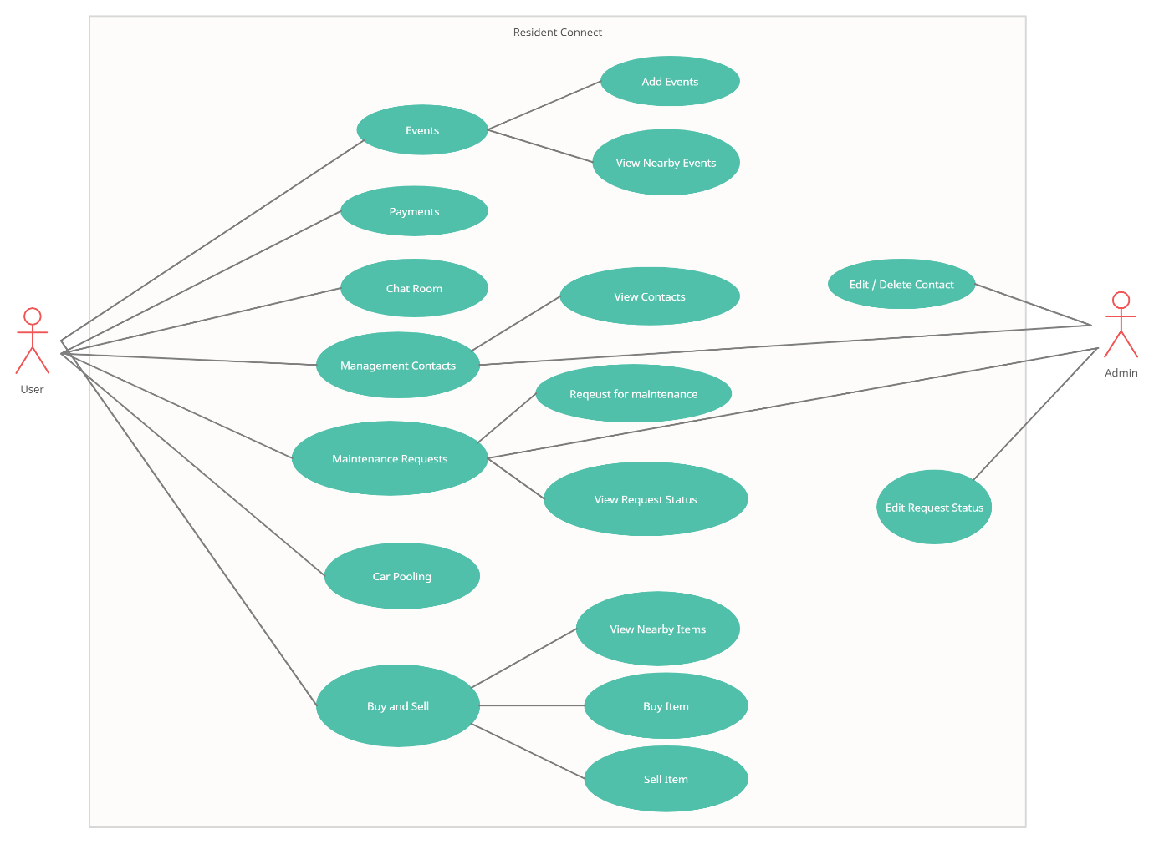

The key features we are offering are,

* **Registration /Sign in Service:** resident can register into this webapp using email.
* **Payment service:** Online Payment of the maintenance fees & Rent
* **Contact Service:** Provide all required contact numbers to all the apartment authorities ranging from the apartment secretary to the security guards that are stationed at the apartments. Provide emergency services nearby such as hospitals, police, fire and safety etc with their respective location data and contact numbers.
* **Classifieds Service:** Services Offered nearby in the flats such as plumbing, electricians etc.
* **Event Management:** Hosting new events in the area or browsing and joining the trending events in the nearby community
* **Buy & Sell service:** Buy and Sell goods and services nearby from cars, furniture, electronics to jobs and services listings
* **Chatroom Service:** Chatroom for internal communication between sections of residents within the apartment community.
* **Carpooling Service:** Car Pooling for riding to a common location etc.

## 5.1. Functional Requirements

### 5.1.1. Registration & Login

|  |  |  |
| --- | --- | --- |
| Requirement Number | Requirement Details | Status |
| 1.1 | Admin should able to register the application using email | Completed |
| 1.2 | Resident should able to register the application using email | Completed |
| 1.3 | Admin/Resident should able to login into application using email | Completed |
| 1.4 | Admin/Resident provides details like email, phone number, emergency contact details & blood group during first time login | Completed |
| 1.5 | Admin provides community details | Completed |
| 1.6 | Upon first time login, admin should able to free and paid service details. He can able to select required paid services | Completed |
| 1.7 | Maintenance, Events Management, Buy & Sell are paid services | Completed |
| 1.8 | Multiple login record (user) can be linked with one apartment | Completed |

### 5.1.2. Community Details

|  |  |  |
| --- | --- | --- |
| Requirement Number | Requirement Details | Status |
| 2.1 | Admin provides community details like community name, builders, location of community upon first time login | Completed |
| 2.2 | Admin registers details like Apartment modal, blocks, flats details upon first time login | Completed |
| 2.3 | Admin had ability to send email/mobile notification to residents to register application with unique token id (per flat) | Completed |
| 2.4 | Admin has ability to edit/delete the property details | Completed |

### 5.1.3. Dashboard

### 5.1.3.1. Admin-Dashboard

|  |  |  |
| --- | --- | --- |
| Requirement Number | Requirement Details | Status |
| 3.1 | Admin can view occupied/un-occupied flat details in dashboard | Completed |
| 3.2 | Overview of payment details would be displayed as graph in admin’s dashboard | Completed |
| 3.3 | Admin who moderator access can view overview of items flagged for moderations | Not Completed |
| 3.4 | Overview of announcement details displayed | Completed |
| 3.5 | Overview of upcoming events would be displayed | Not Completed |

### 5.1.3.2. Residents-Dashboard

|  |  |  |
| --- | --- | --- |
| Requirement Number | Requirement Details | Status |
| 4.1 | Resident can view announcement details in dashboard | Completed |
| 4.2 | He can view un-viewed chat details in dashboard | In Progress |
| 4.3 | Any upcoming payment due (or) ‘overdue’ would be displayed in dashboard | In Progress |
| 4.4 | Upcoming events would be displayed in their dashboard | Not Completed |
| 4.5 | Active poll displays in dashboard | Completed |
| 4.6 | Response to their Buy & sell would be displayed in notification area | Not Completed |

### 5.1.4. Events Management (Paid Service)

|  |  |  |
| --- | --- | --- |
| Requirement Number | Requirement Details | Status |
| 5.1 | Resident/admin can create event and have option to make event accessible to nearby communities. | Not Completed |
| 5.2 | Resident/admin can able to see events posted by them | Not Completed |
| 5.3 | Resident/admin can edit the events posted by them | Not Completed |
| 5.4 | Resident/admin can able to see the events enrolled by them in their timeline | Not Completed |
| 5.5 | Resident/admin able to see & enrol upcoming events in their community, nearby communities or their cities | Not Completed |
| 5.6 | Resident/admin have option to search events by type, name, timeline, locations | Not Completed |

### 5.1.5 Buy and Sell

|  |  |  |
| --- | --- | --- |
| Requirement Number | Requirement Details | Status |
| 6.1 | Resident can post ‘sell advertisement’ and have option to make advertisement visible to nearby communities in app. | In Progress |
| 6.2 | Residents can able to see all ads in Buy& sell page | Completed |
| 6.3 | Resident has option to search ads by type, category, location | Completed |
| 6.4 | Seller and buyer can chat in application | Not Completed |
| 6.5 | Buyer & seller can negotiate price through app | Not Completed |
| 6.6 | Resident can view their ads posted in past | Completed |
| 6.7 | Seller can update/delete their active ads | Completed |

### 5.1.6. Car polling

|  |  |  |
| --- | --- | --- |
| Requirement Number | Requirement Details | Status |
| 7.1 | Resident can view the list of car polling ads | Completed |
| 7.2 | Resident can post the car pooling with the details like start & end date with timing, source & destination location , any stop points in between, how many passengers can taken and any amount involved | Completed |
| 7.3 | Resident interested in car polling, they can contact car driver/owner by using phone number. If both are agreed, car polling request would be closed (or) seats would be reduced by owner in the request | Completed |

### Contacts Management

|  |  |  |
| --- | --- | --- |
| Requirement Number | Requirement Details | Status |
| 8.1 | Admins can create/edit contacts details like nearby police station, fire station, hospital, clinics;  Contact details of community secretary, presidents and security extension numbers. Etc | Not Started |
| 8.2 | Resident able to view the contact details in their app under ‘contacts’ menu | Not Started |

### 5.1.8. Maintenance Service (Paid Service)

|  |  |  |
| --- | --- | --- |
| Requirement Number | Requirement Details | Status |
| 9.1 | Resident can raise the maintenance request. Initial status of request should be ‘Open’ | Not Started |
| 9.2 | Resident can able to see list of maintenance requests raised by him and their current status | Not Started |
| 9.3 | After maintenance worker completes the work, status of the request should be changed to ‘completed’. | Not Started |
| 9.4 | Any charges related to ‘maintenance request’ should be calculated and paid by resident on monthly basis though application | Not Started |
| 9.5 | ‘Monthly Maintenance Fee’ receipt should be generated and should be visible in payments tab of application for resident. | Not Started |

### 5.1.9. Chat Room

|  |  |  |
| --- | --- | --- |
| Requirement Number | Requirement Details | Status |
| 10.1 | Resident can create chat room and approve other residents in the chat room | Completed |
| 10.2 | Creator of chat room should be marked as ‘Admin’ of the chat room | Completed |
| 10.3 | ‘Admin’ in the chat room can promote other people in the chat room as ‘Admin’ | Completed |
| 10.4 | Members in the chat room can send the messages, documents, audio and video files in the chat room | In Progress |
| 10.5 | Residents can see the list of all chat rooms | Completed |
| 10.6 | Resident can able to access the chat room where he is the member | Completed |
| 10.7 | Resident can raise the request to include him in a chat room. | Completed |
| 10.8 | Admin of the chat room can approve/decline ‘Add member request’ | Completed |
| 10.9 | Member can like other member’s messages | Completed |
| 10.10 | Chat room details (like name) can be changed by admin of the chat room only. | Completed |
| 10.11 | Any chat room which is inactive more than 35 days would be deleted | Not Started |
| 10.12 | Notification would be sent to admins of the chat room 5 days prior to deletion of the chat room | Not Started |
| 10.13 | All the messages in the chat room should be timestamped | Completed |
| 10.14 | Message would be deleted/edited by the member who created the message. Others can only view the messages | Completed |
| 10.15 | Any inappropriate content would be marked with flag and notification would be send to admins of the chat room and moderator assigned by community | Not Started |
| 10.16 | Admin can take appropriate action on flagged messages. If he didn’t take action, assigned moderator should take action. SLA would be 7 days | Not Started |
| 10.17 | Flagged message should be invisible until further action taken on that message | Not Started |

### Fee/Rent Payment

|  |  |  |
| --- | --- | --- |
| Requirement Number | Requirement Details | Status |
| 11.1 | Admin can generate Monthly (or) quarterly (or) annual maintenance fee receipts | Completed |
| 11.2 | When receipt is generated, mail notification would be sent to all residents | Completed |
| 11.3 | Admin can view payment details per apartment wise | Completed |
| 11.4 | Admin can send notification to residents separately, when there is a payment due | Completed |
| 11.5 | Fee incurred as part of maintenance and facility booking would be auto generated on monthly basis. Resident can pay them on monthly basis | Not Started |

### Announcements

|  |  |  |
| --- | --- | --- |
| Requirement Number | Requirement Details | Planned Release |
| 12.1 | Admin can create announcement related to ‘community meeting’, ‘Electricity outage’ etc.. | Completed |
| 12.2 | Resident can see this announcement in their dashboard page. | Completed |
| 12.3 | Only future, present-dated announcement should be visible in resident dashboard | Completed |
| 12.4 | Resident can view complete details of the announcement in pop-up on clicking announcement in their dashboard | Completed |

### Classifieds

|  |  |  |
| --- | --- | --- |
| Requirement Number | Requirement Details | Status |
| 13.1 | Trusted vendors for household related services would be listed under classifieds menu  (Example services: Electrician, plumber, vegetable/fruit shop, home food delivery, day care centre, pet care centre etc..) | Completed |
| 13.2 | Resident can add vendors details who offer household service details | Completed |
| 13.3 | Resident member can rate service of the vendor and add comments for each vendor | Completed |

### Poll Service

|  |  |  |
| --- | --- | --- |
| Requirement Number | Requirement Details | Status |
| 14.1 | Resident can create poll and gather opinions/options of other apartments residents on any issue or event | Completed |
| 14.2 | Created poll should have expired date & time | Completed |
| 14.3 | Result of poll can be shared with all the members of the community along with authority of the community | Not Started |
| 14.4 | Active poll should be shown in resident/admin dashboard | Completed |
| 14.5 | Resident can participate in poll. Any user can participate only one time. | Completed |

### Facility Booking (Paid service)

|  |  |  |
| --- | --- | --- |
| Requirement Number | Requirement Details | Status |
| 15.1 | Resident can book community facility for the particular day and time. Facilities like swimming poll, club house, Banquet Hall. etc | Not Started |
| 15.2 | Resident can able to see list of free slots on any particular day | Not Started |
| 15.3 | Booking can be cancelled 24 hrs prior to booked time | Not Started |
| 15.4 | While booking, resident can see the fee involved in booking. | Not Started |
| 15.5 | Any fee incurred due to using facility would be calculated and added as part of monthly maintenance Fee. | Not Started |

### Visitor Management (Paid Service - Mobile Only)

|  |  |  |
| --- | --- | --- |
| Requirement Number | Requirement Details | Status |
| 16.1 | Resident can approve visitor to enter community | Not Started |
| 16.2 | Resident can pre-approve visitor | Not Started |
| 16.3 | Resident can see the list of approved visitors in past (maximum upto last 6 months) | Not Started |
| 16.4 | Admin can view complete visitors list and can view visitors based on day (or) flat they visited | Not Started |

## 5.2 Non-Functional Requirements

|  |  |  |
| --- | --- | --- |
| Requirement Number | Requirement Details | Status |
| 17.1 | At any point of time maximum 1000 users can connect into application | Not Tested |
| 17.2 | Application should take less than 10 MB memory size while running | Completed |
| 17.3 | Response time to load any page should be less than 5 seconds | Completed |
| 17.4 | Maximum CPU allocation for this application should not exceed 5% | Completed |

# 6. Resources

## 6.1 Back End

* **Express JS:** It is backend javascript framework built on nodejs. It is used to build webservices/APIs for this project.
* **Firebase Authentication:** Google firebase authentication used for register & sign in the user in this application. Firebase Authentication is an extensible token-based auth system.
* **AWS serverless:**

Notification microservice developed using AWS serverless techonologies. Below AWS components are used in this service

* + AWS Lambda:
  + AWS Endpoint:
  + Dynamo DB:
  + SES:
  + SQS:
  + Dynamo DB:
* **Mongo Atlas:** MongoDB Atlas is a fully-managed cloud database developed by the same people that build MongoDB. Atlas handles all the complexity of deploying, managing, and healing your deployments on the cloud service provider of your choice (AWS, Azure, and GCP). In this project we have created database cluster with Mongo Atlas with AWS.
* **Firestore:** Goole firestore uses to stove images, files and videos. It act as non-string databases.
* **Firebase live database:** It is ‘no-sql’ database. Document is consider as unit of record. This database used to create chatroom service.
* **Google Map API:** Google Map API used in this project to show location of the given addess and show the route between locations in carpooling service.

## 6.2 Front End

**React JS:** React is a JavaScript library for building modern applications. React is used for handling the view layer and can be used for development of both web and mobile applications

**Material-UI:** It allows to import and use different components to create user interface in React application. This saves a significant amount of time, since we do not need to write everything from scratch

## 6.3 CICD & Deployment Pipeline:

**Travis:** Travis CI is a hosted continuous integration service used to build and test front end of this project hosted on GitHub.

**Docker:** Docker used to build image of microservice and front end.

**ECR:** Amazon Elastic Container Registry (Amazon ECR) is a fully managed container registry. It stores, manage, share, and deploy microservice container images

**EKS:** Amazon Elastic Kubernetes Service (EKS) is a managed service and certified Kubernetes conformant to run Kubernetes on AWS and on-premises. AWS EKS cluster is created with private EC2 node. Whenever code push happened ‘Backend CICD pipeline’

## 6.4 Version Control Tool

Github is distributed version control systema and used for manage the code. With the help of Github, developer can collaborate with each other and update code without conflict issues in file.

Github backend: <https://github.com/Capstone-BitsPilani/ResidentConnect-API>

Github Frontend: <https://github.com/Capstone-BitsPilani/ResidentConnect-FrontEnd>

## 6.5 Wireframe:

Figma is used for creating initial UI/UX designs. This project tries to adapt the design created in Figma. Around 60-70% front end design follows wireframes in Figma.

Figma: <https://www.figma.com/file/Z41Ggif8PV4WihLU1R0ALS/sample_project?node-id=1112%3A2219>

# 7. Data Models

Non-SQL databases are used for this project, as this application involves images, videos on various phases.

Below Non-SQL databases are used in this project

* 1. DynamoDB: Used by notification service, to store notification messages
  2. Firebase live database: This database will be used for chatroom service.
  3. Fire store: It is used to store the images
  4. Atlas MongoDB: All other services use mongo DB for storing their data.

## 7.1 Data Models

Please do refer below schema diagrams,

### 7.1.1 CommunityInfo & Apartment Info Collection:

CommunityInfo and ApartmentInfo collection has complete details of apartments like , address, flats, floors, block, etc..

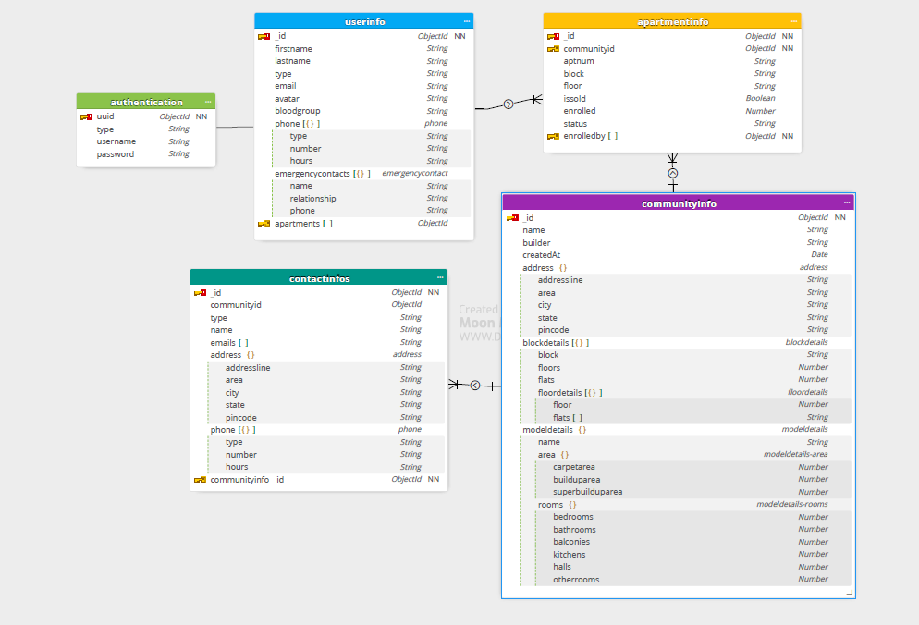

### 7.1.2 UserInfo Collection

UserInfo collection holds resident and admin details (role, name, email, phone number, blood group, etc) except credentials details



### 7.1.3 ContactInfo Collection:

This service uses contactinfo collection. One document per community id. Community id itself uses id for this collection



### 7.1.4 AnnouncementInfo Collection:

Announcement service uses ‘announcementinfo’ collection. It has one to many relationships with userinfo and communityinfo. Multiple announcements can be made by one person and same goes for community.

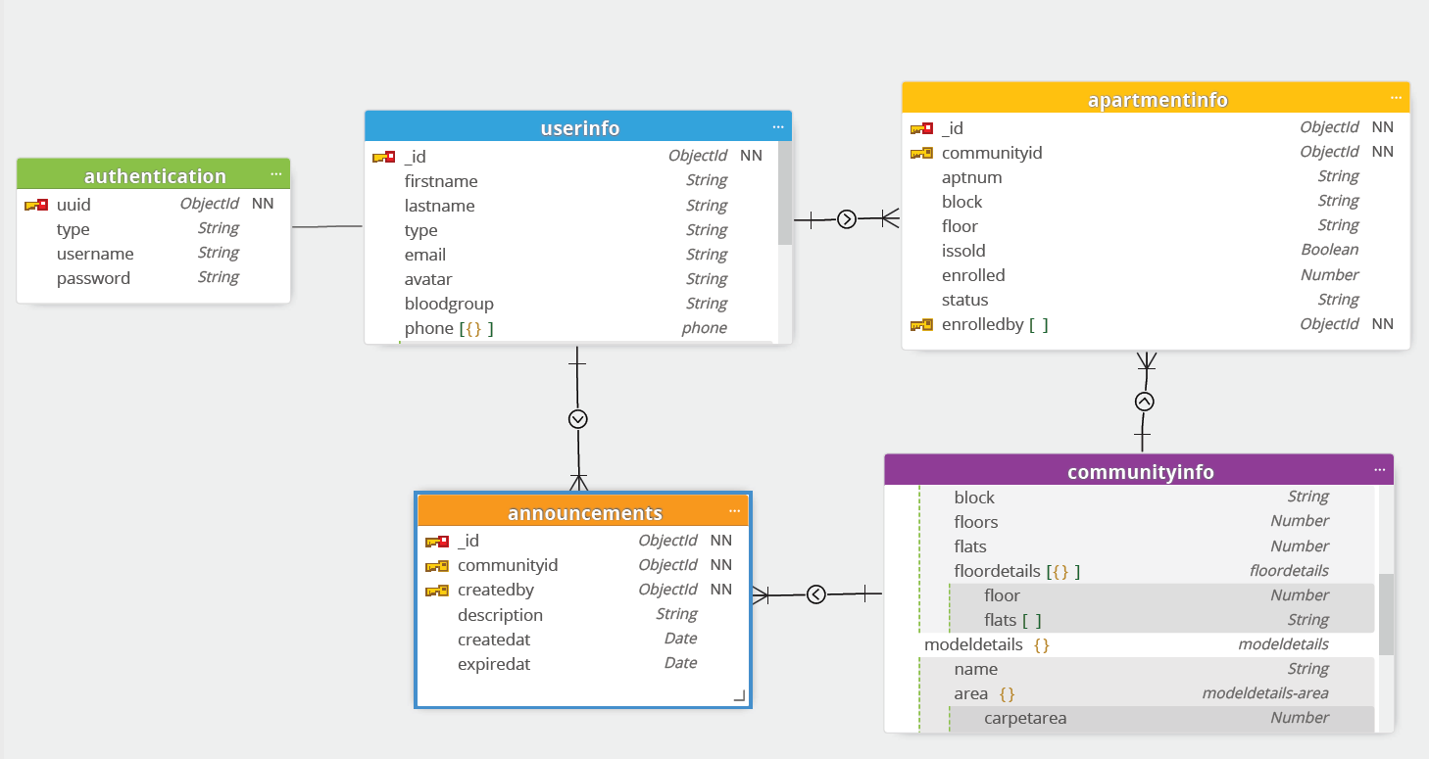

### 7.1.5 CarpoolingInfo Collection

Carpollinginfo collection used by carpooling service. It has one to many relationships with userinfo and communityinfo

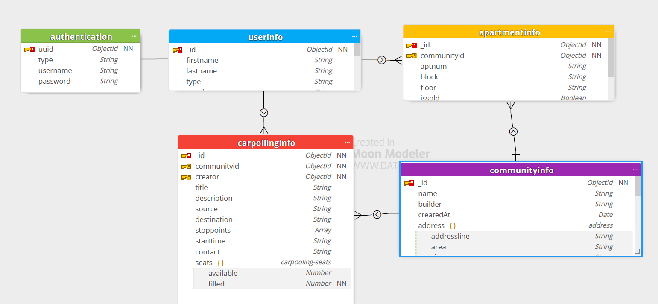

### 7.1.6 ChatRoomInfo Collection

chatroominfo collection – stores chatroom details

chatroom_messageinfo – stores each messages of the chat rooms

chatroom request - stores request details of each chatroom (not mentioned in below diagram)

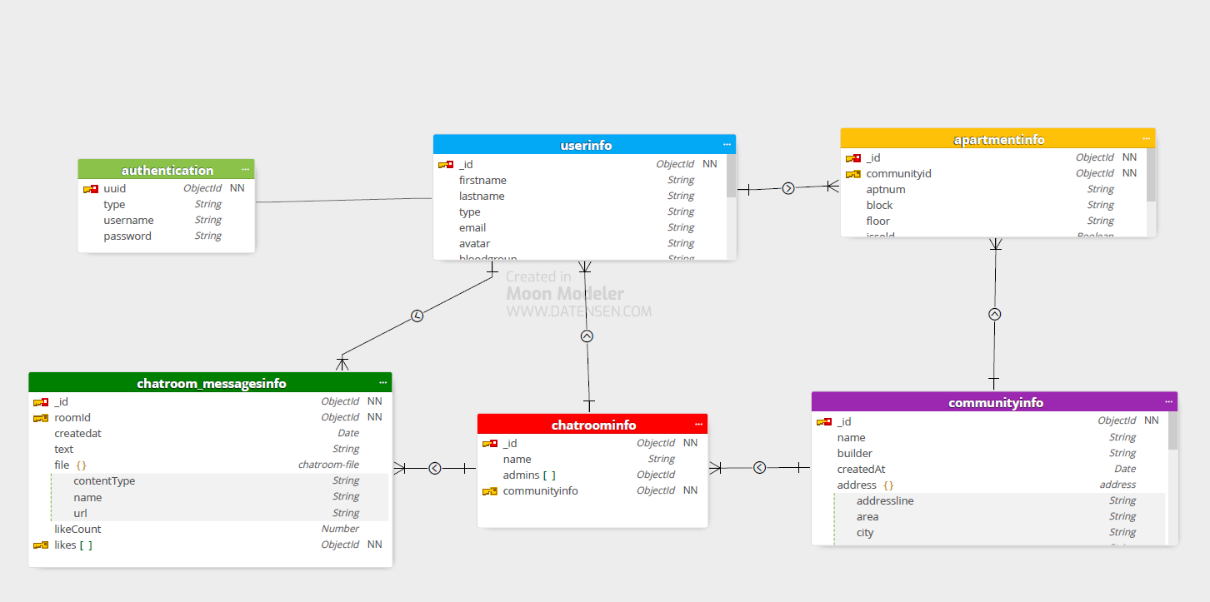

### 7.1.7 ClassifiedsInfo Collection

Classifiedsinfo and classifiedscomments collections are used by classifieds service. Classifiedscomments has details of each review comments provided for the classified.

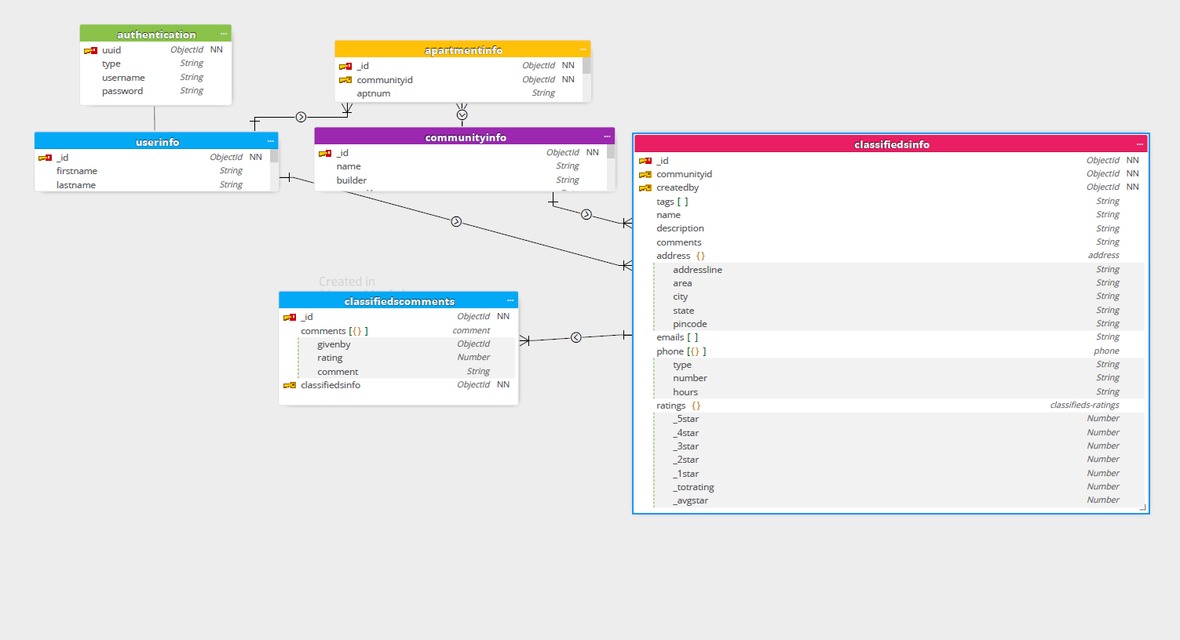

### 7.1.8. EventsmgmtInfo Collection

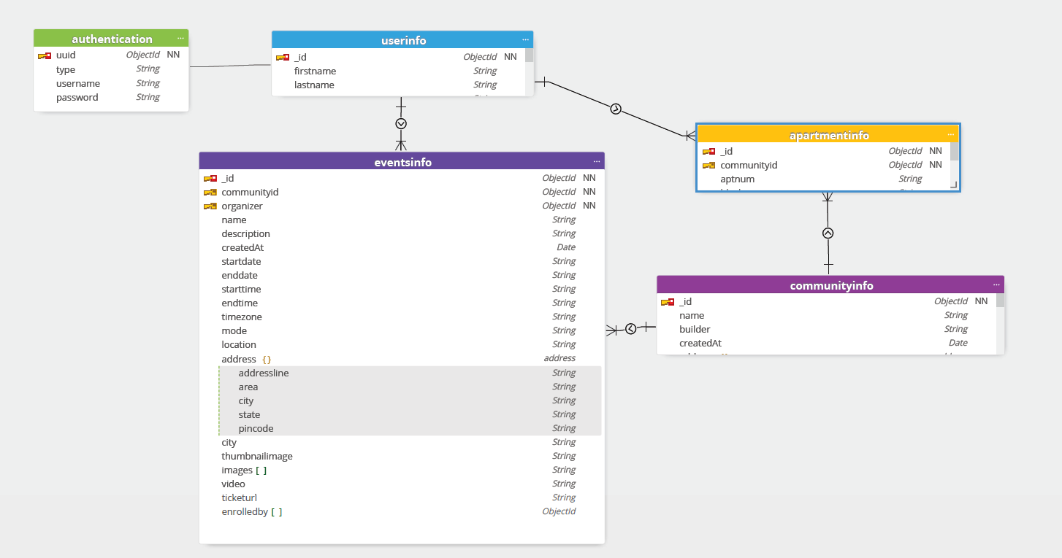

### 7.1.9 MaintenanceInfo Collection

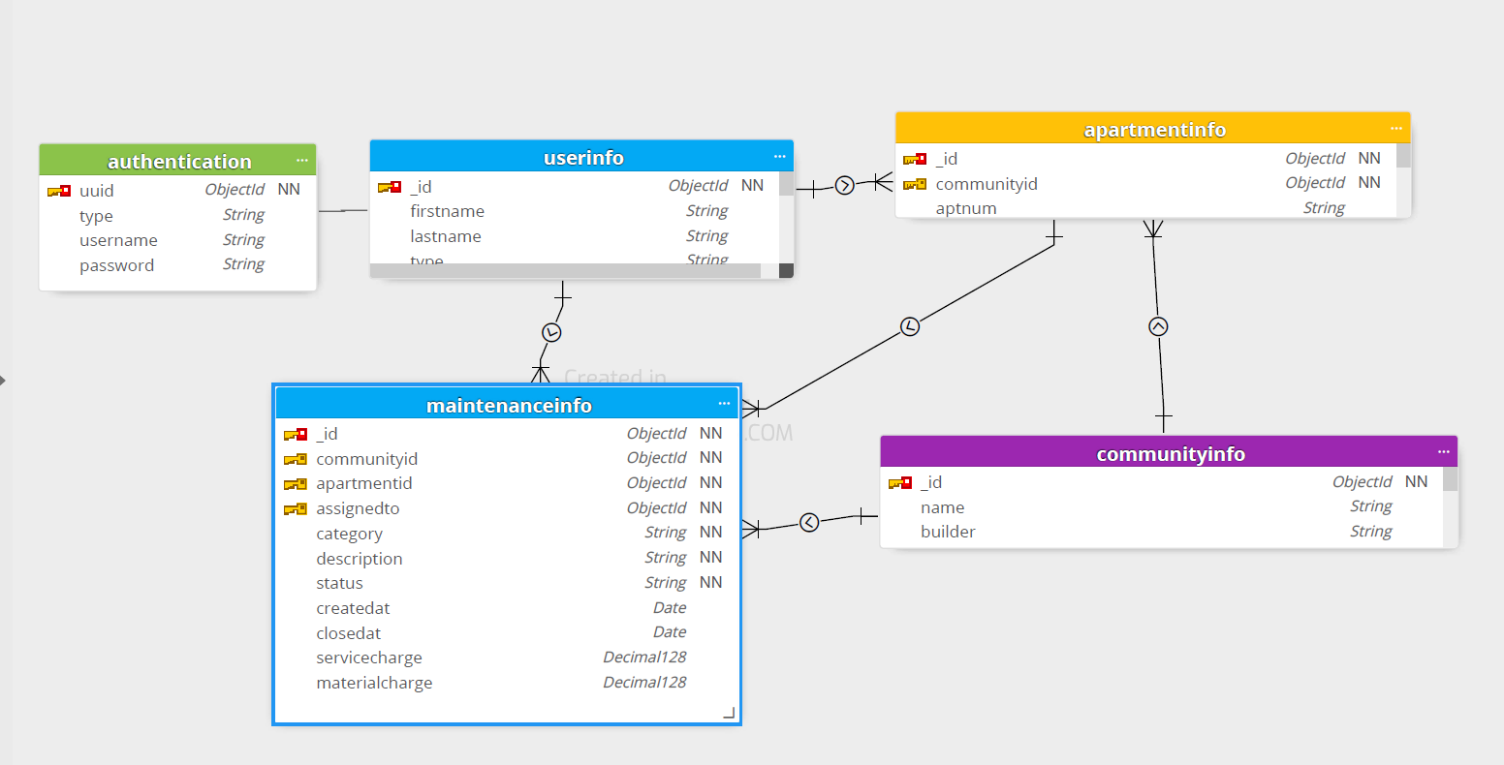

### 7.1.10. PaymentsInfo Collection

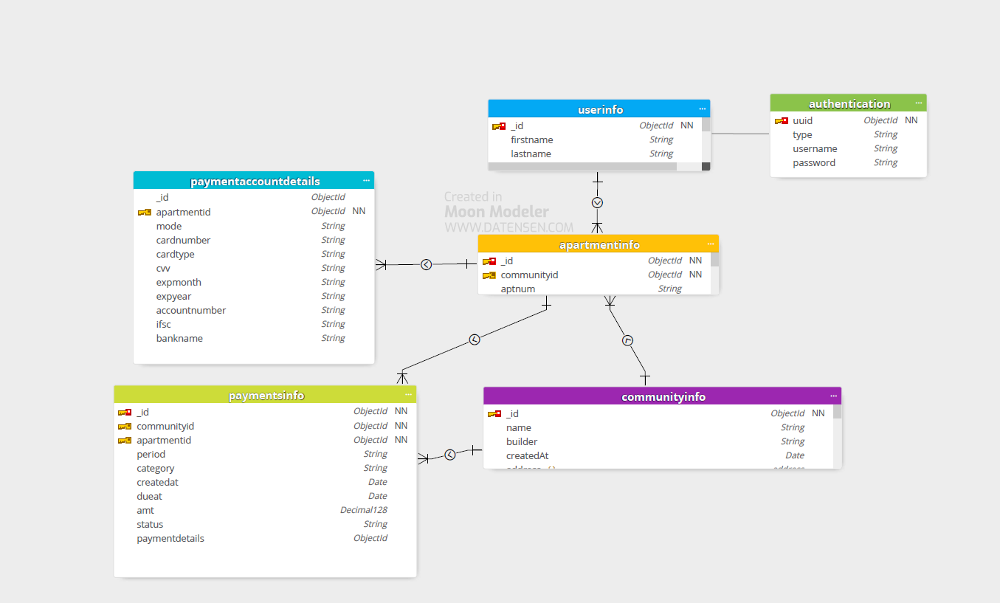

### 7.1.11. PollingInfo Collection

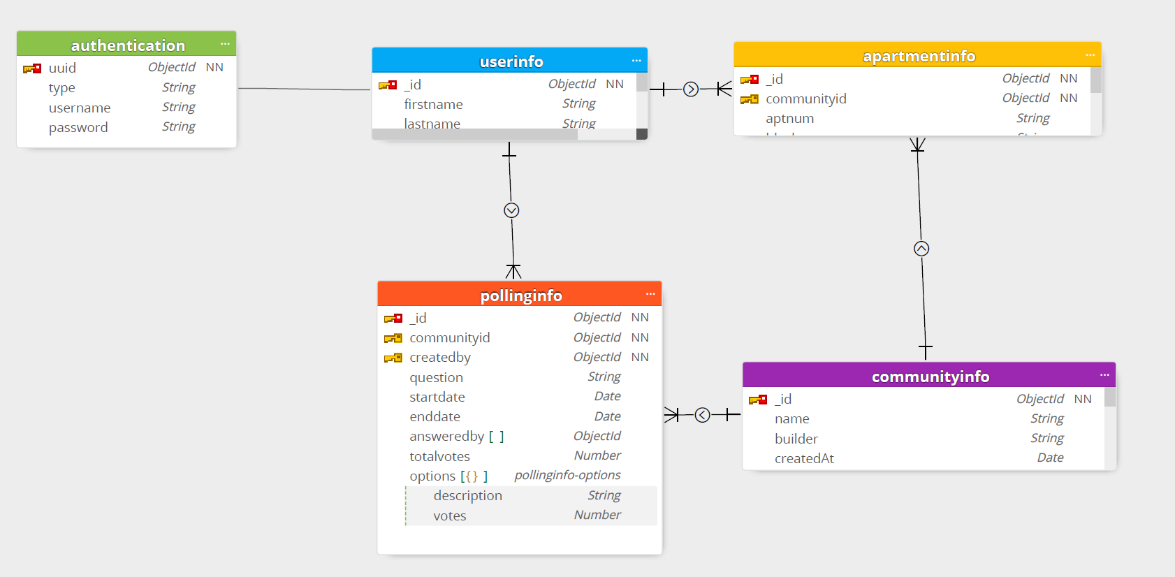

### 7.1.12. FacilityInfo Collection

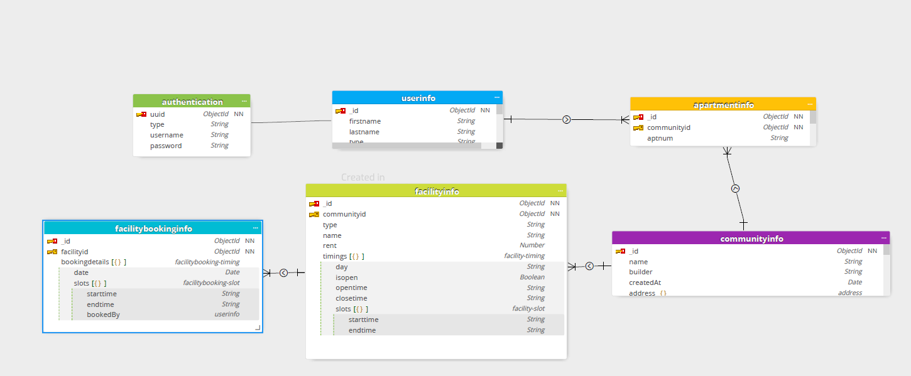

## 7.2. MongoDB Atlas

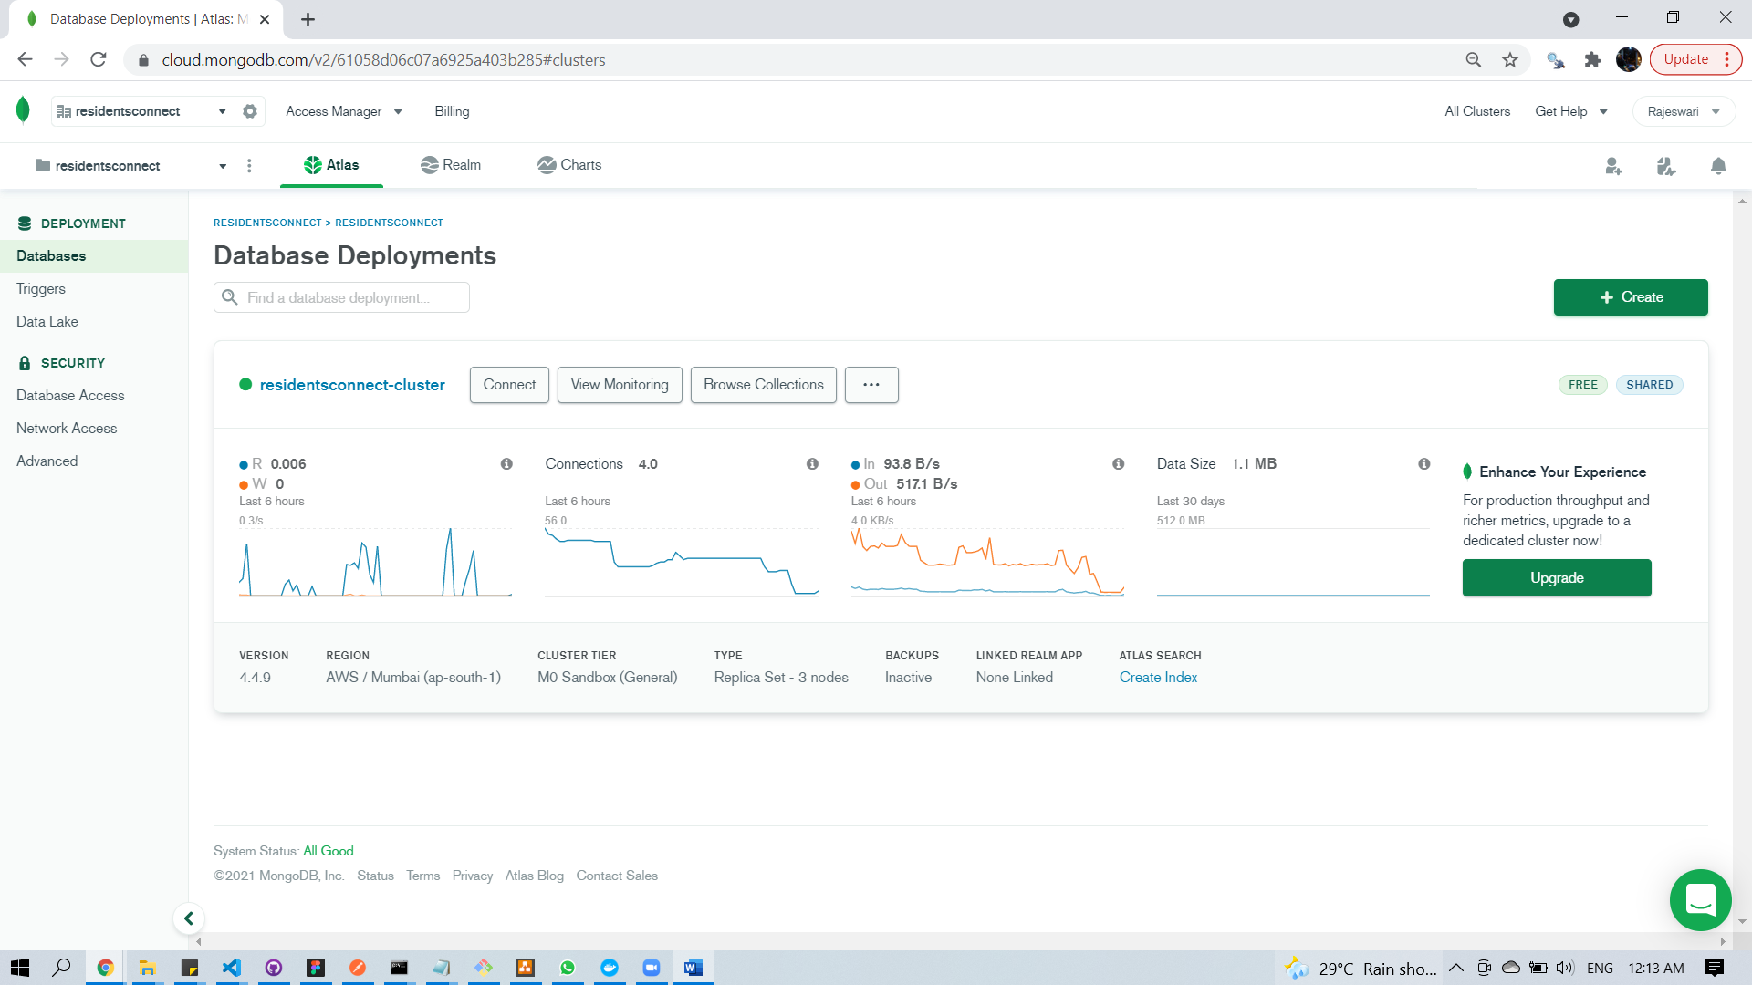

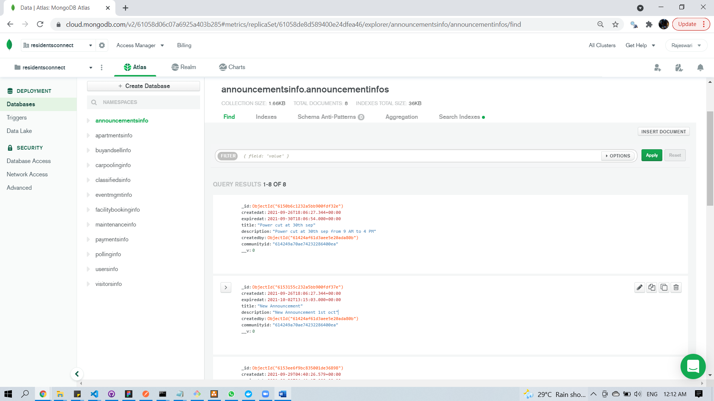

## 7.3 Dynamo DB

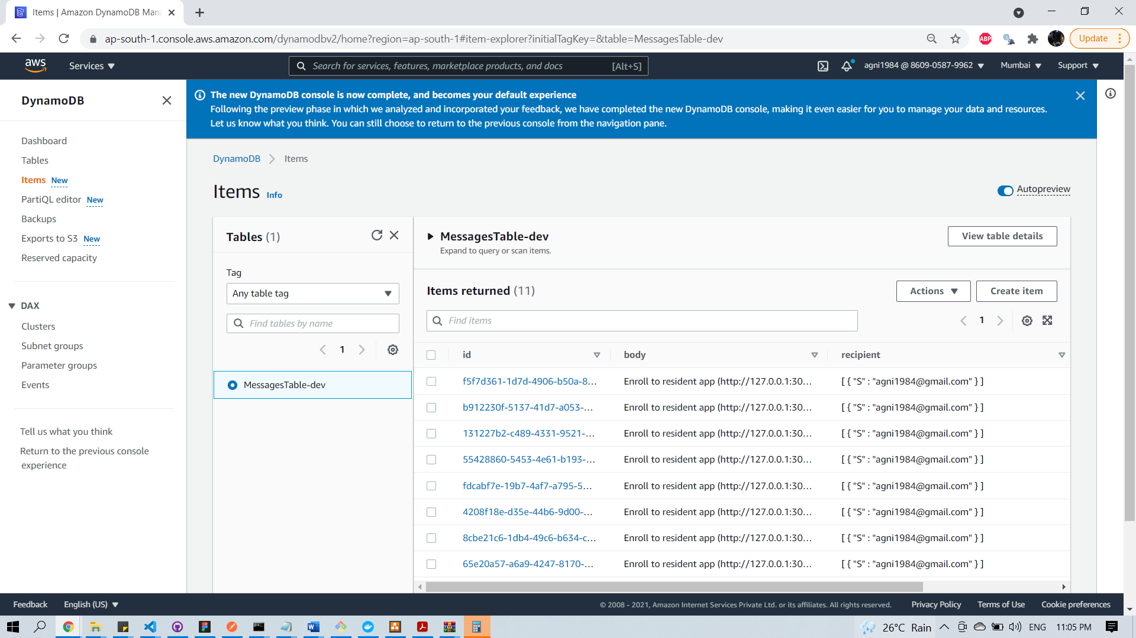

## 7.4 Firebase authentication

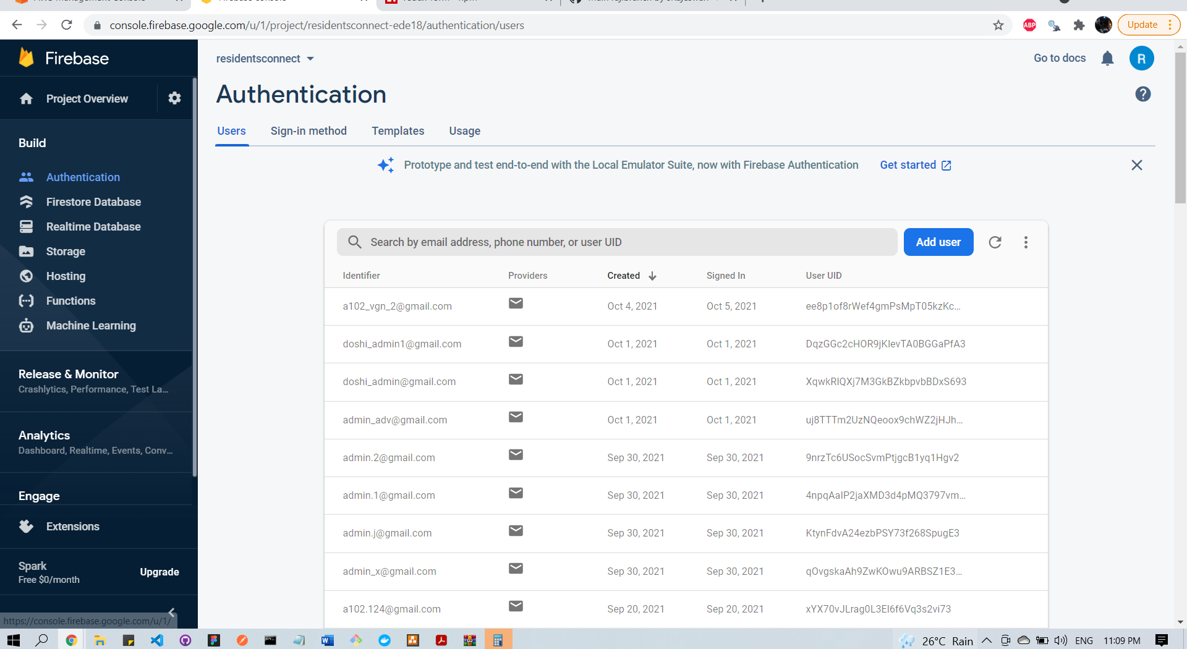

## 7.5 Firebase live database

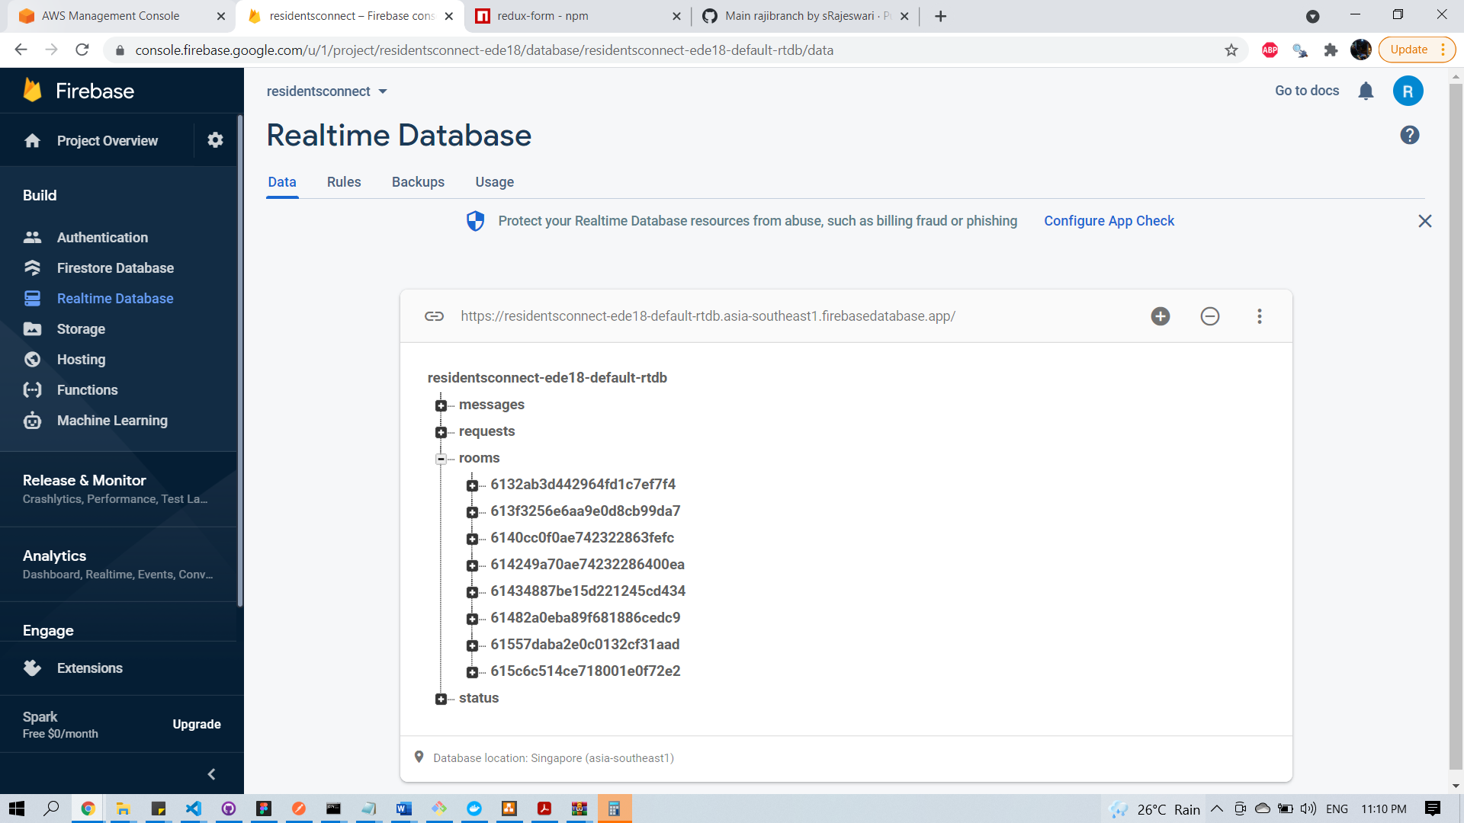

## 7.6 Firestore

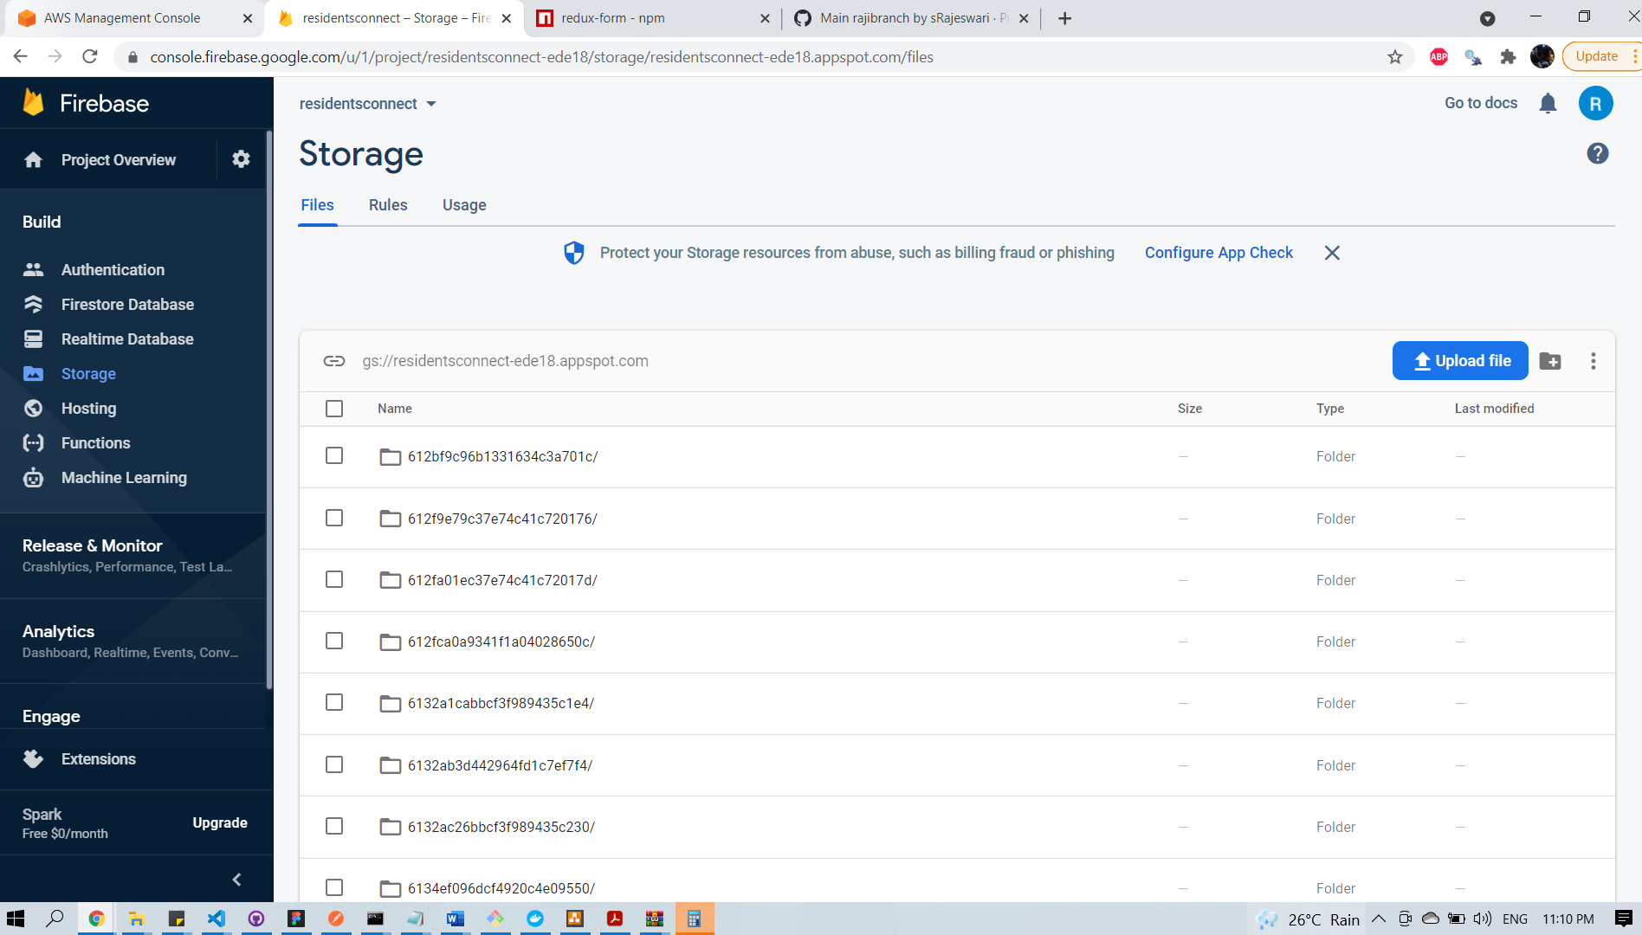

# 8. Software Solution Architecture

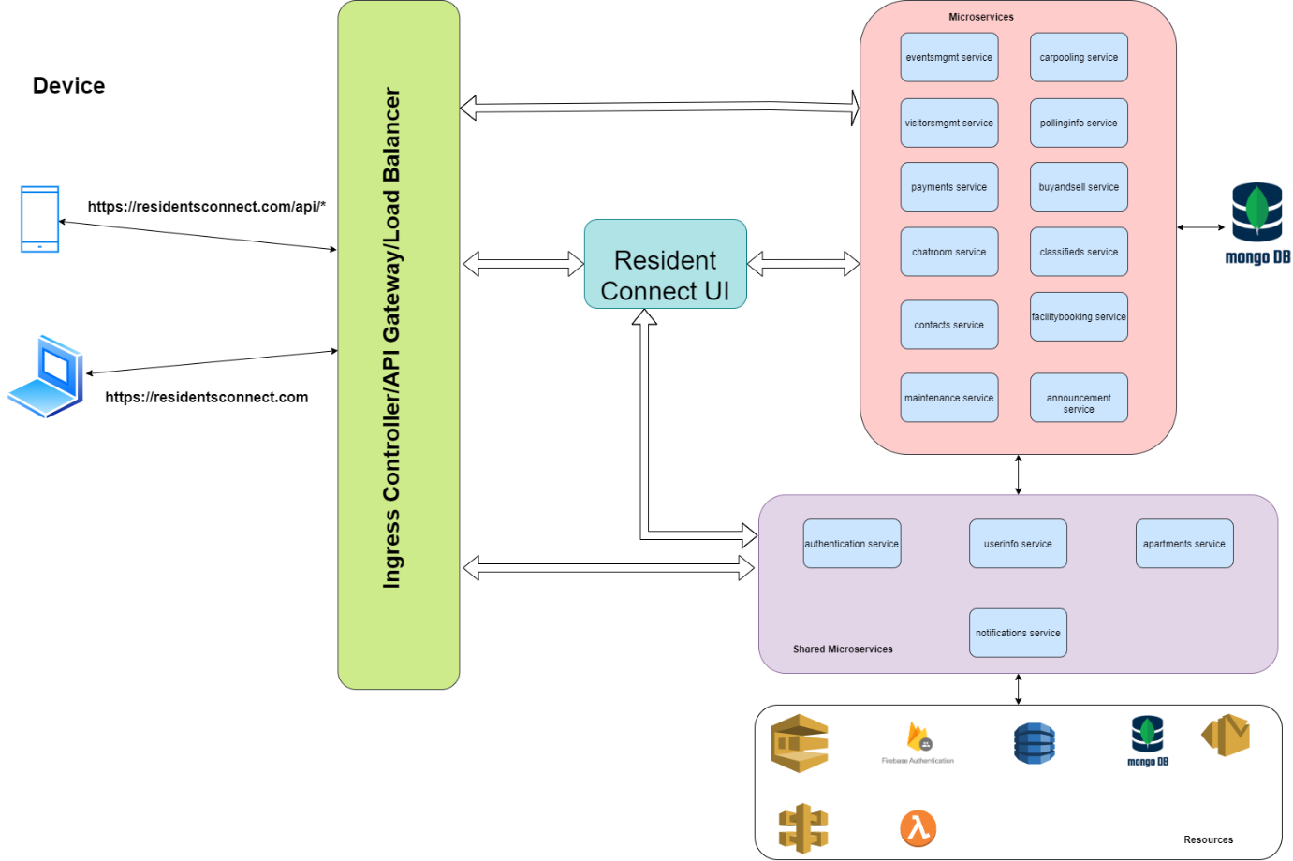

**Microservice Architecture:**

* Microservice -based architecture is considered for this project. Each and every functionality would be implemented as separate microservices. They are using databases present in mongodb cluster.

* Notification & Chat room services are planned to be implemented using serverless with the help of AWS and firebase accordingly.

**Application load balancer vs API gateway:**

* Application load balancer uses to manage the network traffic-based path routing. Based on api path, it routes to corresponding target EC2 node, where micro service is running.
* API gateway: Notification service creates ‘AWS Endpoint’ to send the Email notification, which will be used by other services.

# 9. Software components / services used

## 9.1 Registration Service

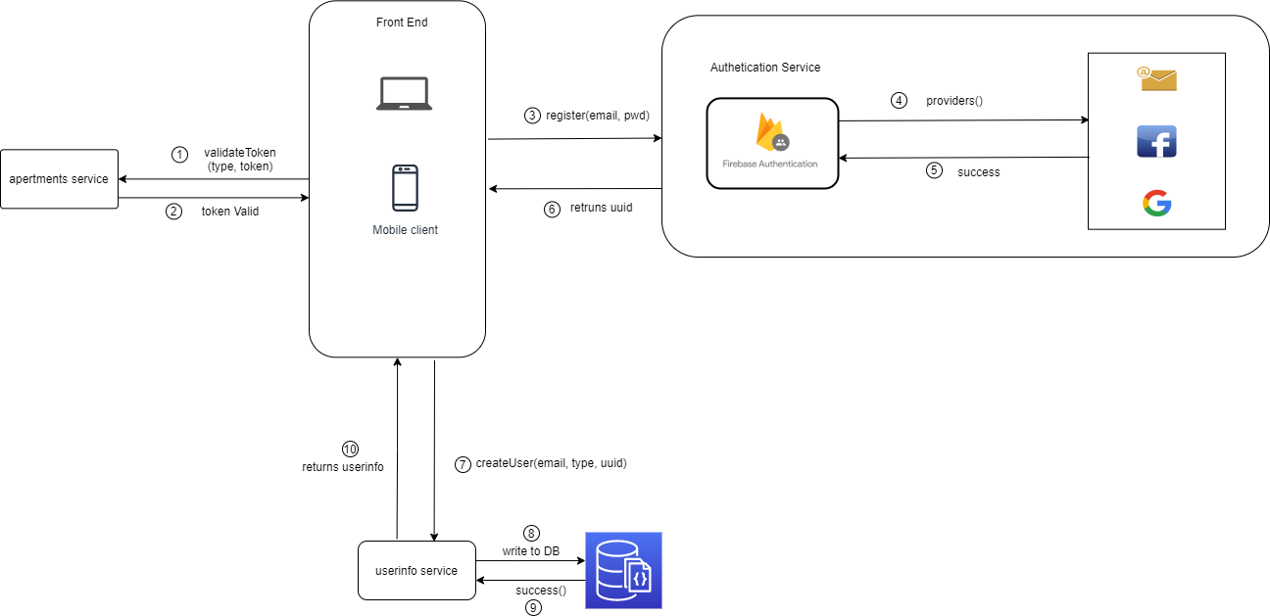

* 1. Validate given token by connecting with apartment service
  2. Application invokes register method with type of registration (gmail, facebook, email/password), he prefers. Based on the request received from client, firebase authentication service registers users and return user details (along with unique UUID).
  3. Once uuid received from firebase, createuser calls would be made to userinfo service to store user details like email address, uuid, etc..

Other details like name, phone number, blood group while resident/admin setup profile.

## 9.2 Login Service

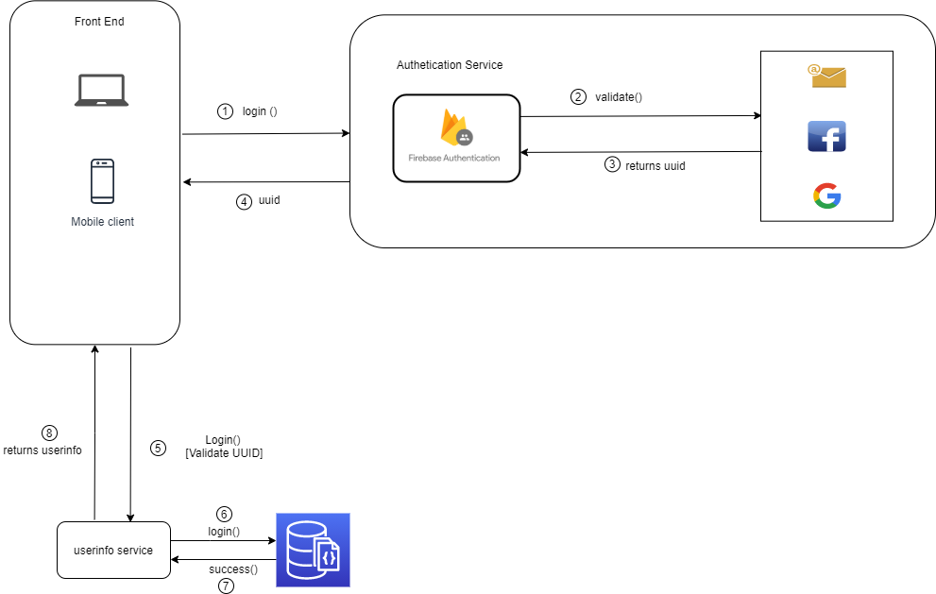

During login service call, firebase returns uuid, if user is registered already. This uuid would be compared with uuid present in userinfo collection with the help of userinfo service for vertification.

## 9.3 Notification Service

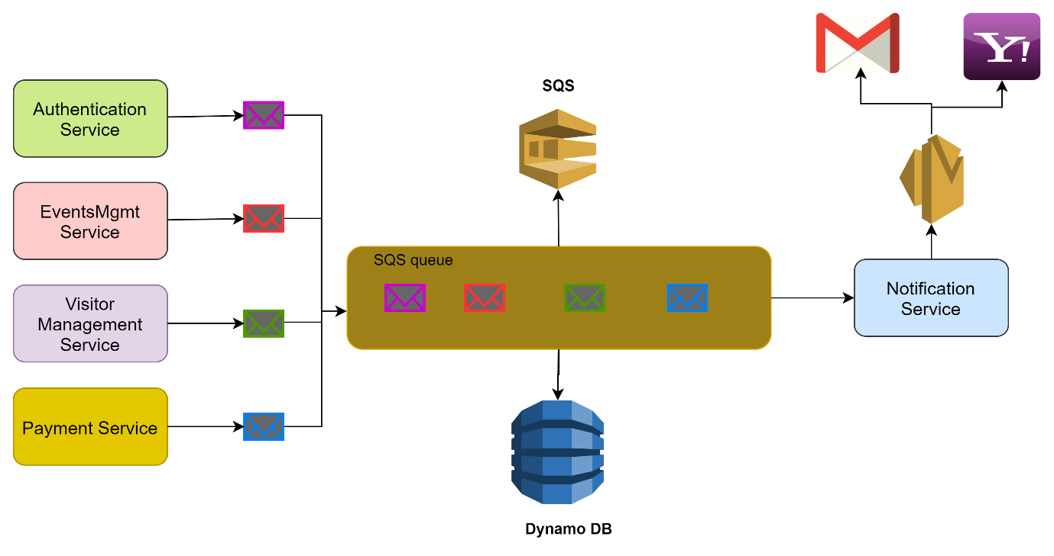

Email notification service is created using AWS-serverless method. SQS (Simple Queue Service), SES (Simple Email Service), Dynamo DB is used.

**SQS (Simple Queue Service):** Generated email message is sent to SQS queue and details are recorded in Dynamo DB. sendMail – POST API is called for this purpose. This endpoint is created by AWS gateway.

**SES (Simple Email Service) :** Notification service listens SQS using ‘receiveMail’ handler and generate email message. This generated email message sent to corresponding receipts. Any reminder mail which needs to be send, this service will take care of it.

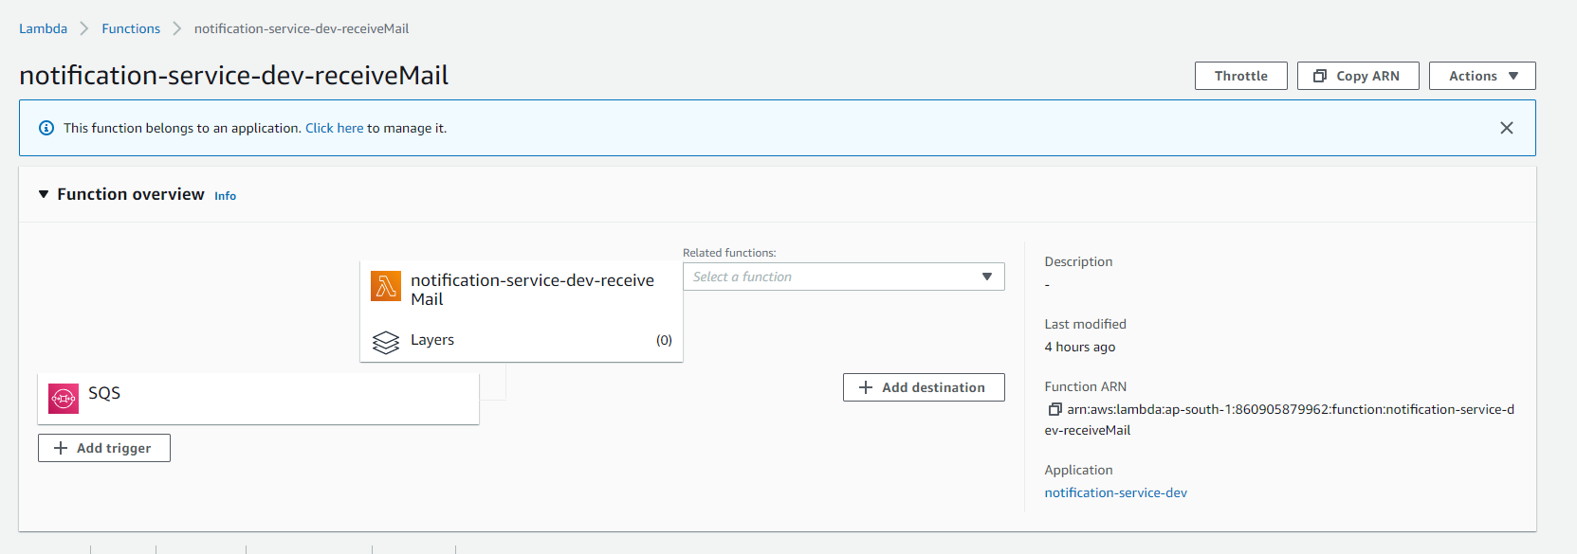

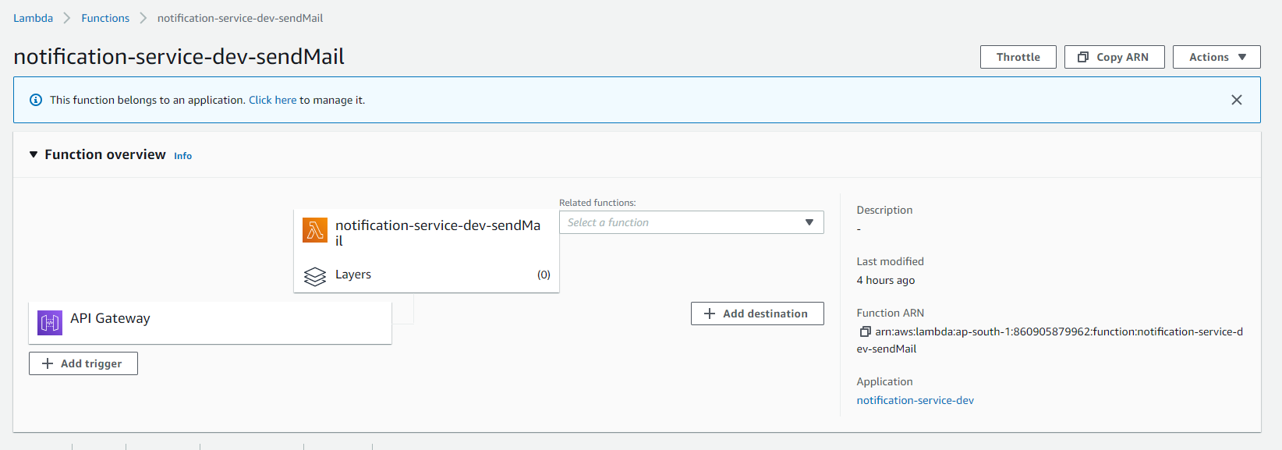

# 10. Software development process flow

## 10.1 Registration and Login Flow

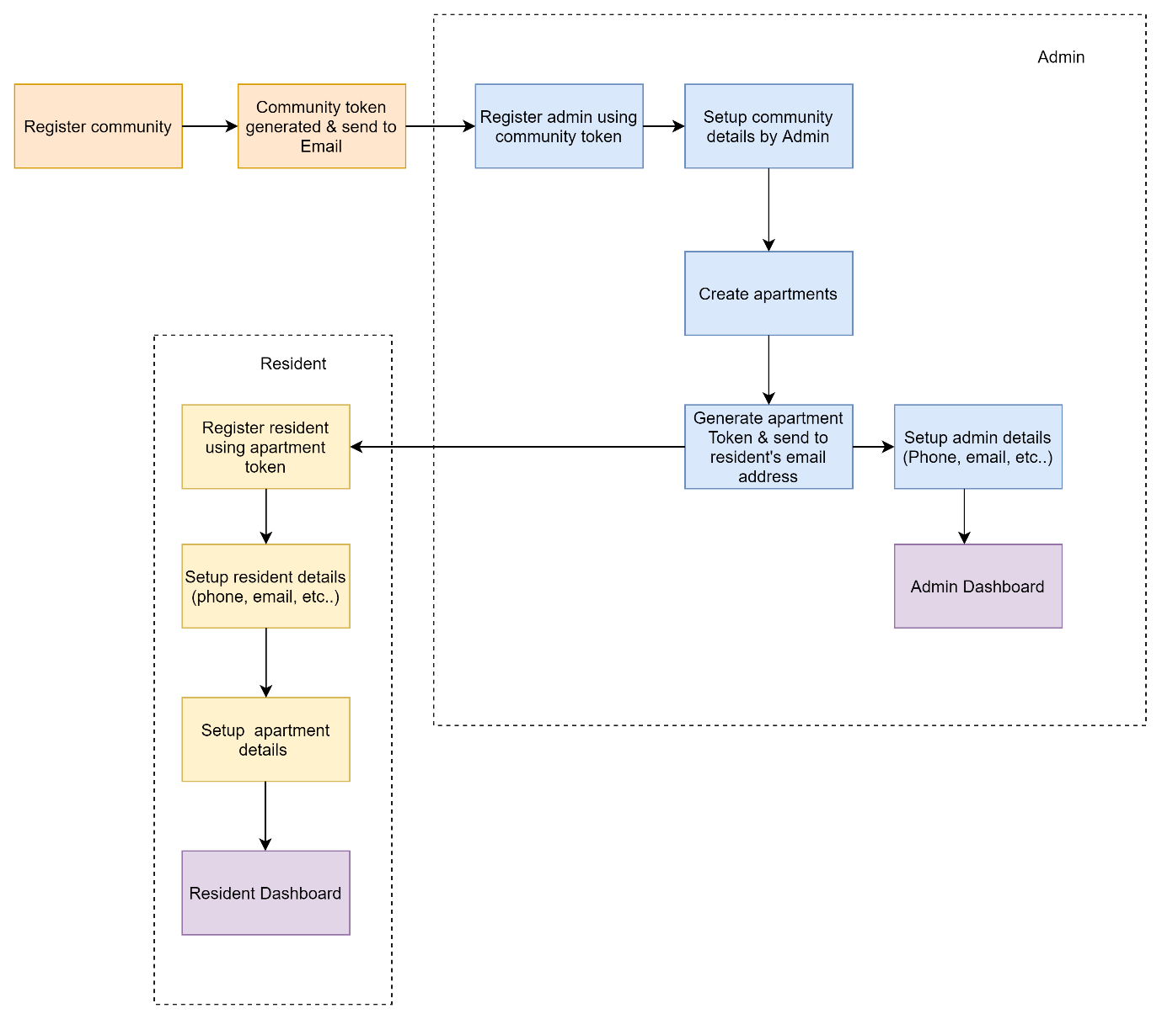

# 11. Detailed Plan

We have completed below services in this ‘Residents Connect’ project

1. Registration and Login into ‘Residents Connect’ app.

2. Profile (Individual & Community) setting

3. Opt-in / opt-out paid services

4. Initiate payment and pay Fees

5. Carpooling

6. Classifieds

7. Buy and Sell

8. Chat Room

9. Announcements and Poll

# 12. CI/CD Pipeline

There are two pipelines used in the project

1. Travis pipeline for deploying frontend application to AWS beanstalk and S3 buckets

2. AWS CodePipeline to deploy payment microservice on EKS.

## 12.1.1 CICD pipeline for microservices

Microservices are deployed to EKS & ECR using AWS code pipeline

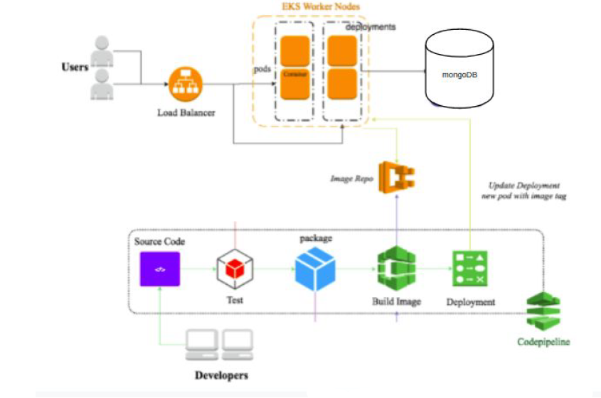

Steps involved,



* 1. User/developer pushed the code in git.
  2. “AWS Code Commit” in AWS code pipeline listening to code push happening in ‘main’ branch
  3. “AWS Code Build “tests microservice, It runs automation testcases
  4. When testcases passes, docker image is created and pushed to ECR.
  5. EKS updates the deployment Pods (groups of one or more Docker containers with shared storage/network) using a rolling update strategy by picking the images from Elastic Container Registry automatically.

### 12.1.1.1 AWS Code Pipeline

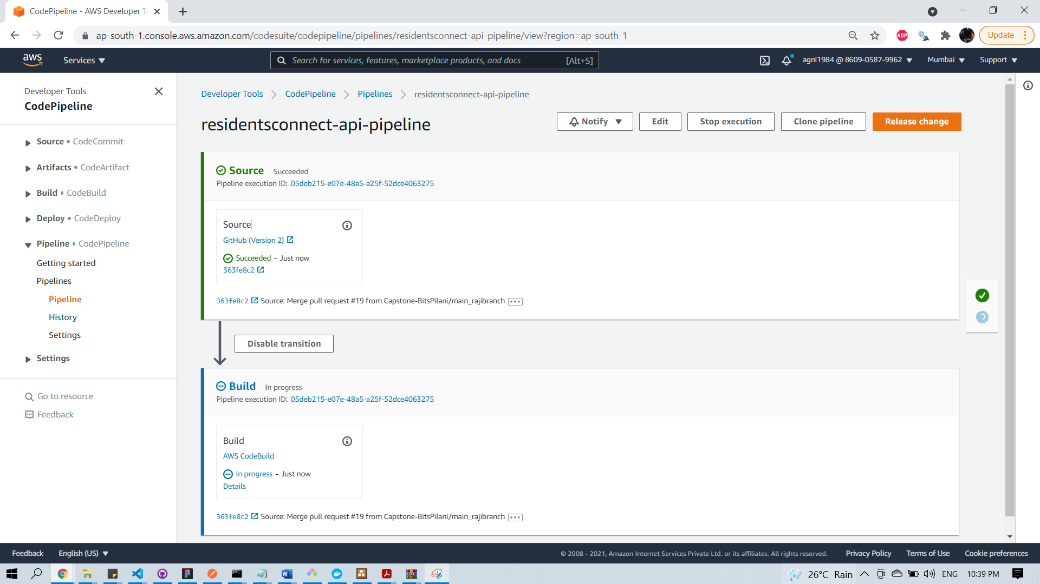

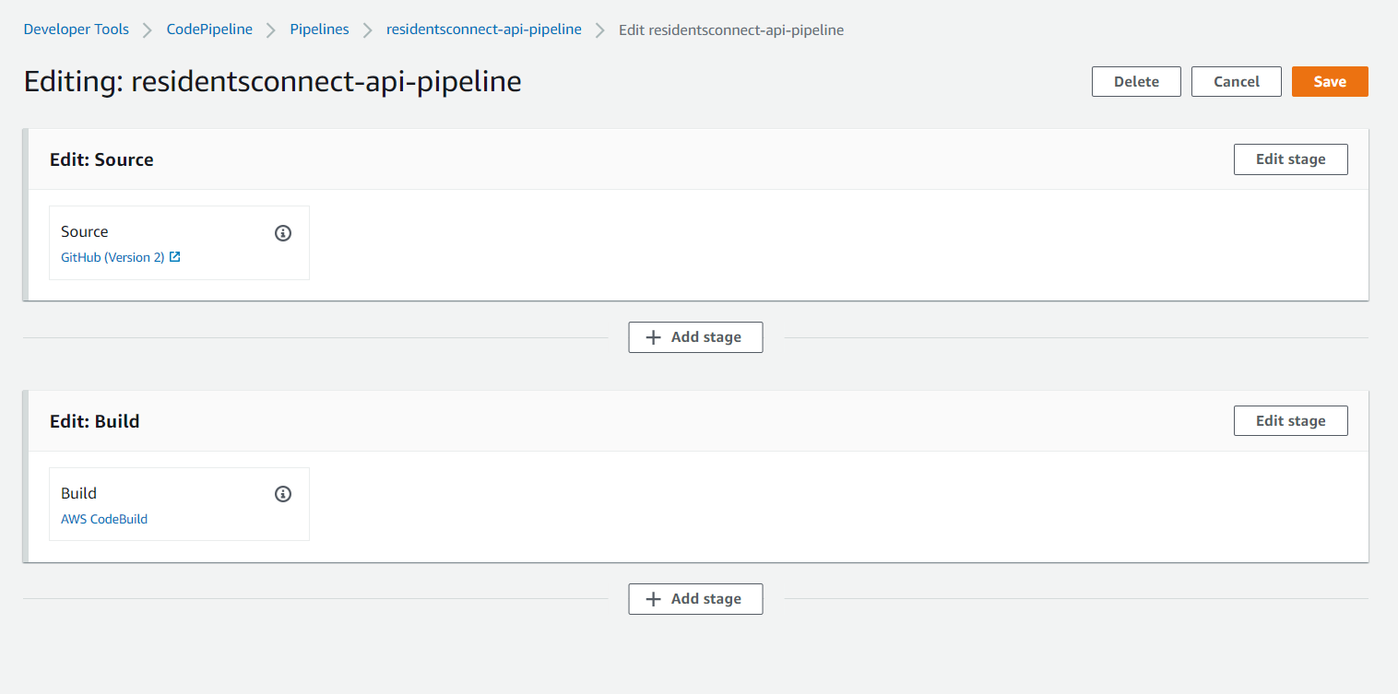

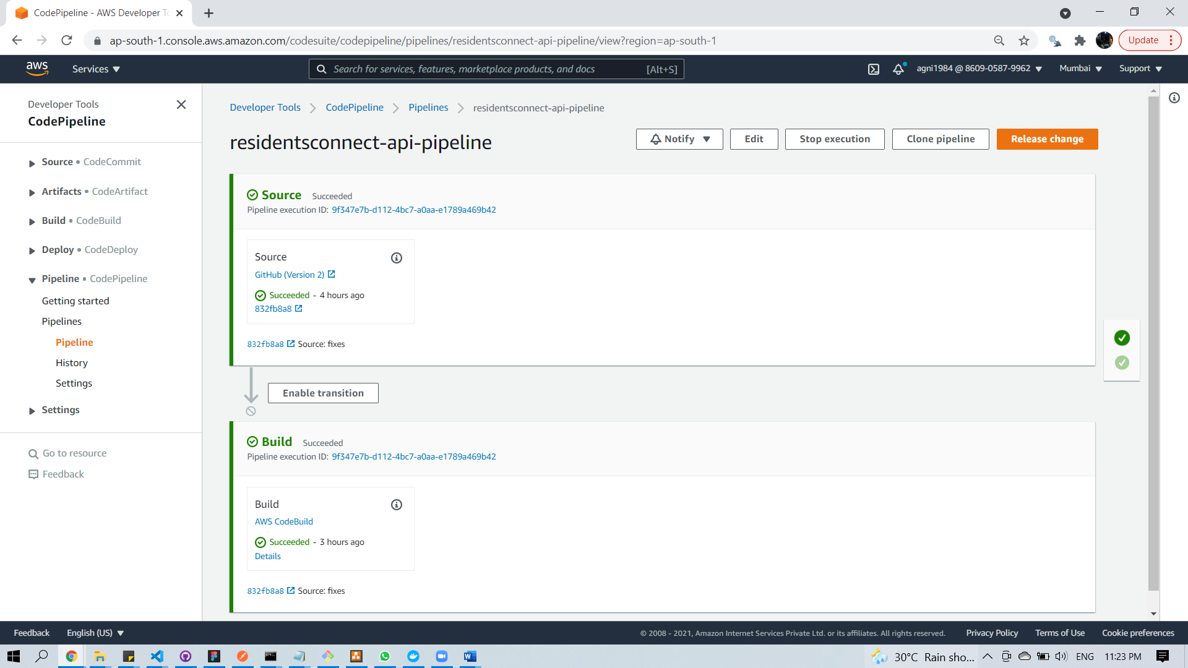

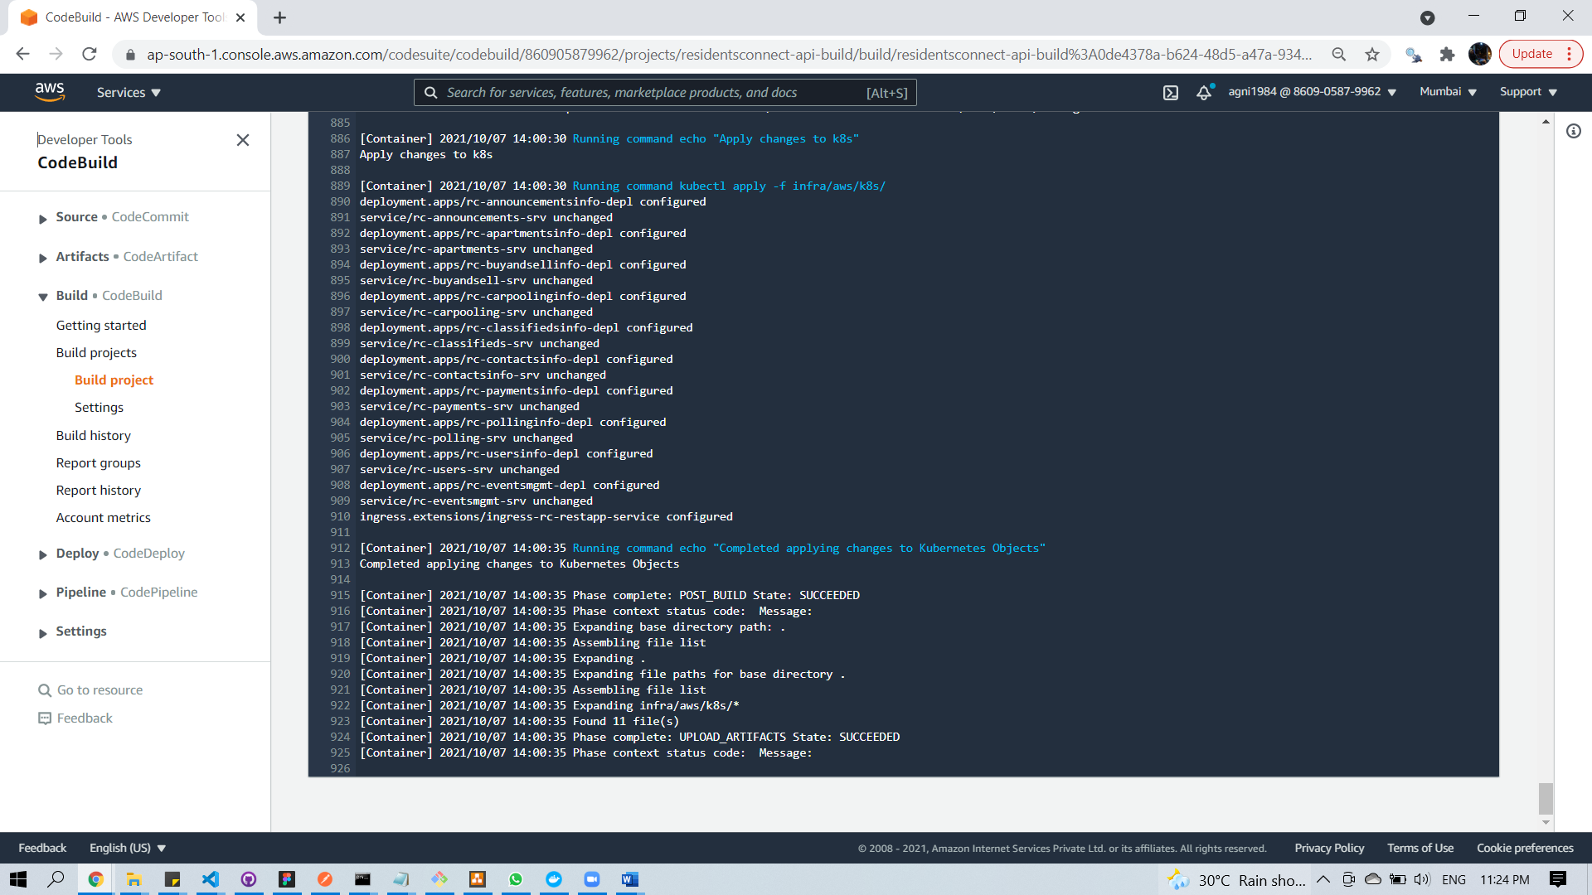

### 12.1.1.2 AWS Code Build

AWS code build uses buildspec.yml file to orchestrating build. It instructs ‘code build task’ to run ‘unit testcases’. When testcases passes, it builds docker images for each microservice and push the images into ECR. Then Theses images are deployed into running cluster. Cluster name and ECR repository names are provided in environment variables in code build.

Below is list of environment variables used in AWS code build. (Starts from 3rd, environment variable refers arn of ECR repositories)

1. EKS_KUBECTL_ROLE_ARN
2. EKS_CLUSTER_NAME
3. REPOSITORY_ANNOUNCEMENTS_URI
4. REPOSITORY_APARTMENTS_URI
5. REPOSITORY_ADVERTS_URI
6. REPOSITORY_CARPOOL_URI
7. REPOSITORY_CLASSIFIEDS_URI
8. REPOSITORY_CONTACTS_URI
9. REPOSITORY_PAYMENTS_URI
10. REPOSITORY_POLLING_URI
11. REPOSITORY_USERS_URI

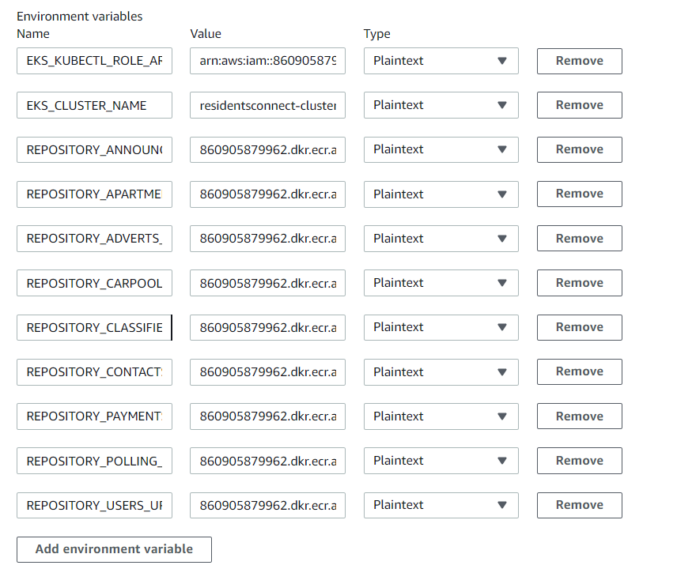

### 12.1.2 CICD pipeline for Frontend

Below Travis pipeline used for deployment of ‘React JS front end’ code in AWS EC2 instance.

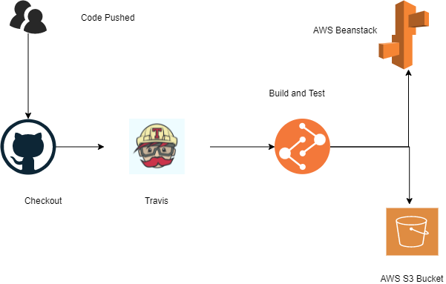

Steps involved,



* 1. User/developer pushed the code in git.
  2. Travis performs build& test,
     + 2.1 It runs automation testcases
     + 2.2 When testcases passes, application would be built
  3. Build would be pushed to S3 and build is taken by beanstalk from S3
  4. Elastic Beanstalk will deploy the application and manage the application so that there is a very less down time. Load balancer attached with Beanstalk provides autoscaling and make sure the application is running properly and if there is high traffic load then it will spin up a new instance to balance the traffic

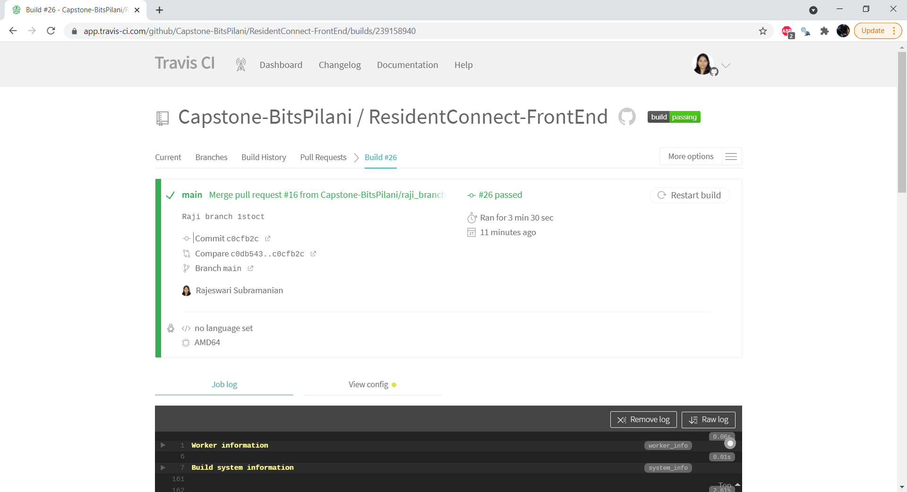

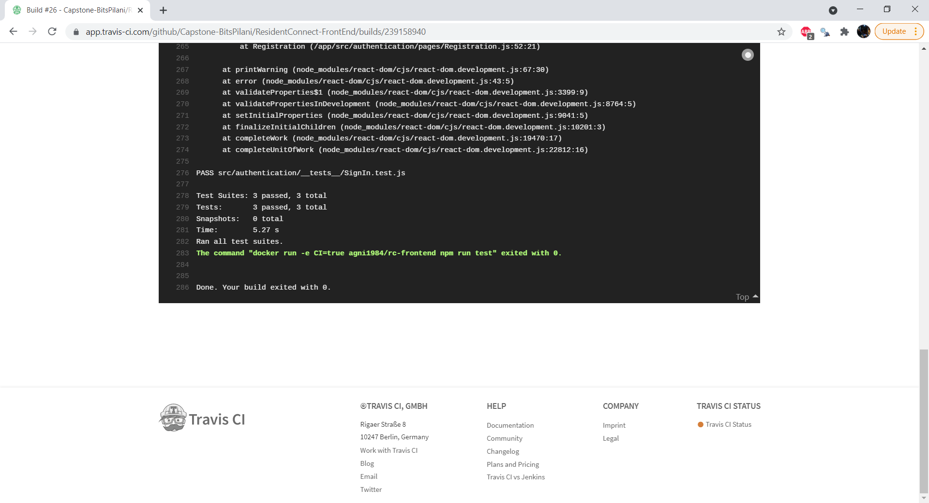

# 13. Quality Assurance

Unit test are created and testcases are run during CICD pipeline

Sample testcases are shown below

Front end,

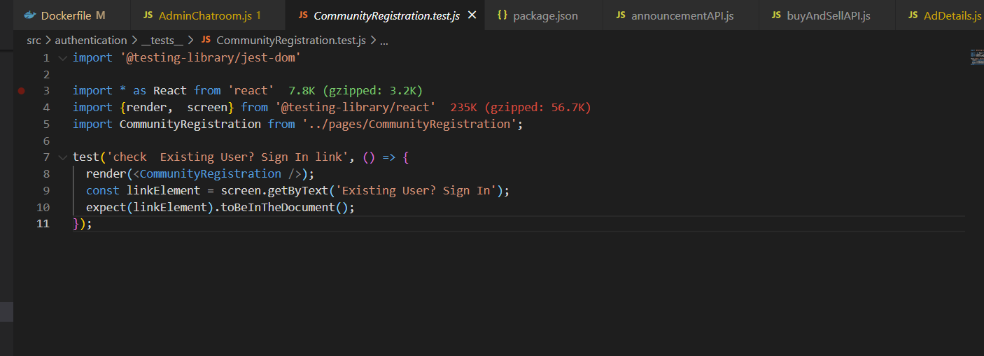

Backend,

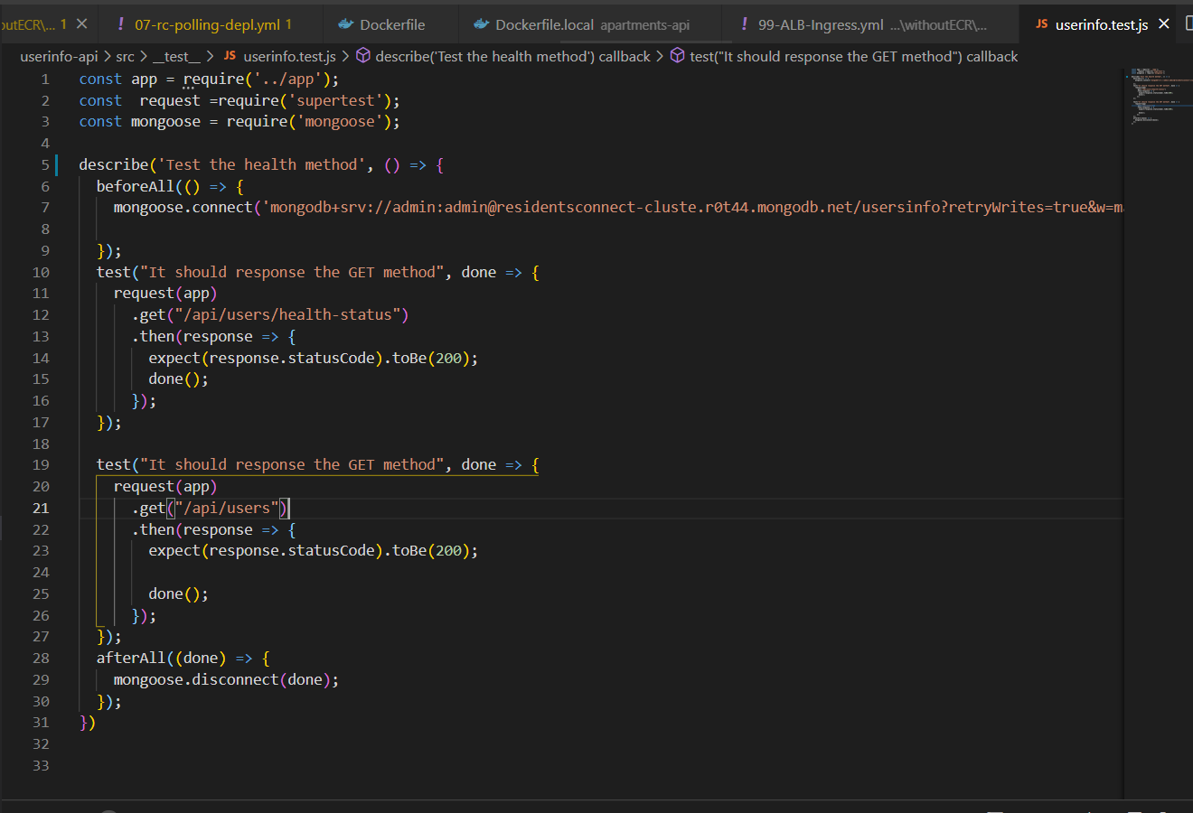

# 14. Deployment Architecture

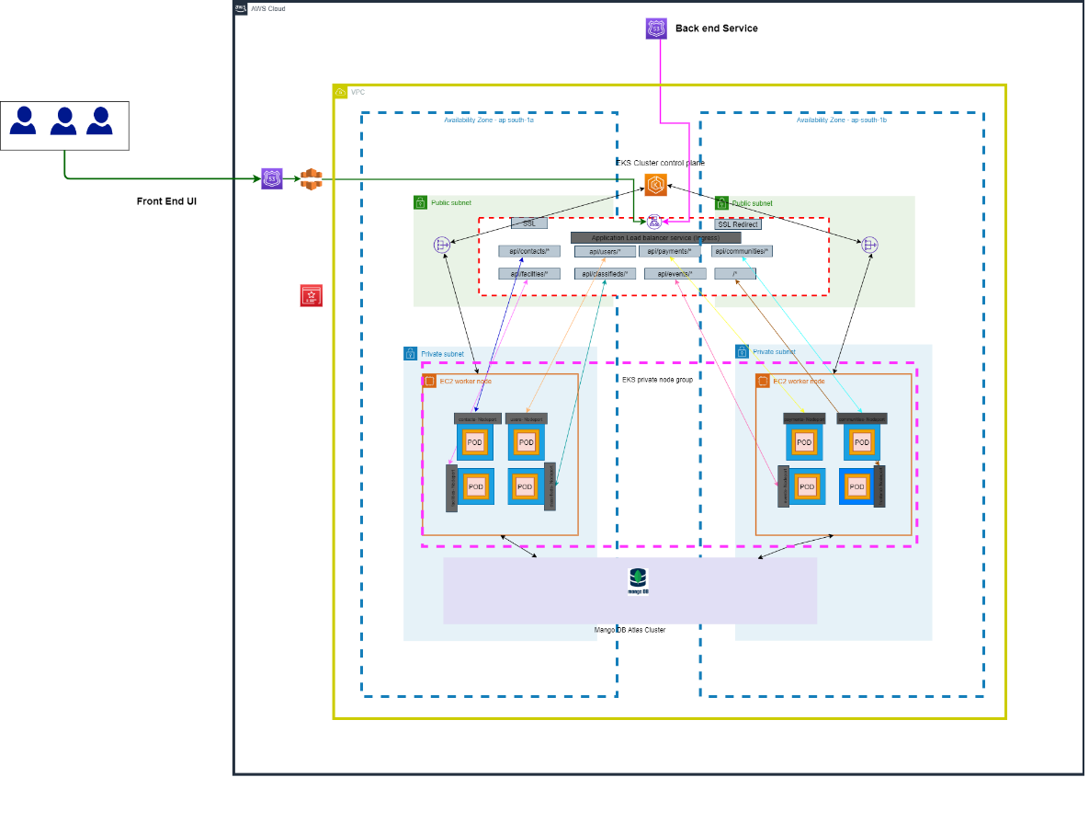

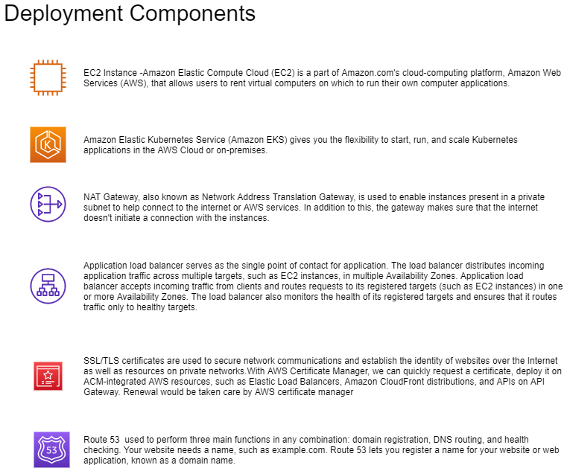

Below AWS infrastructure used for deployment,

* AWS Resources
* VPC
* Internet Gateway (IGW)
* Security Groups, Route Tables and Route Table Associations
* IAM roles, Instance profiles and Policies
* An EKS Cluster
* Autoscaling group and Launch Configuration
* EKS Worker Nodes
* ALB Ingress
* The ConfigMap required to register Nodes with EKS
* KUBECONFIG file to authenticate kubectl using the heptio authenticator aws
* binary
* Elastic Beanstalk
* MongoDB in Atlas
* Jenkins in EC2 instance
* IAM user for accessing the resources
* CloudFront
* ECR Repositories:

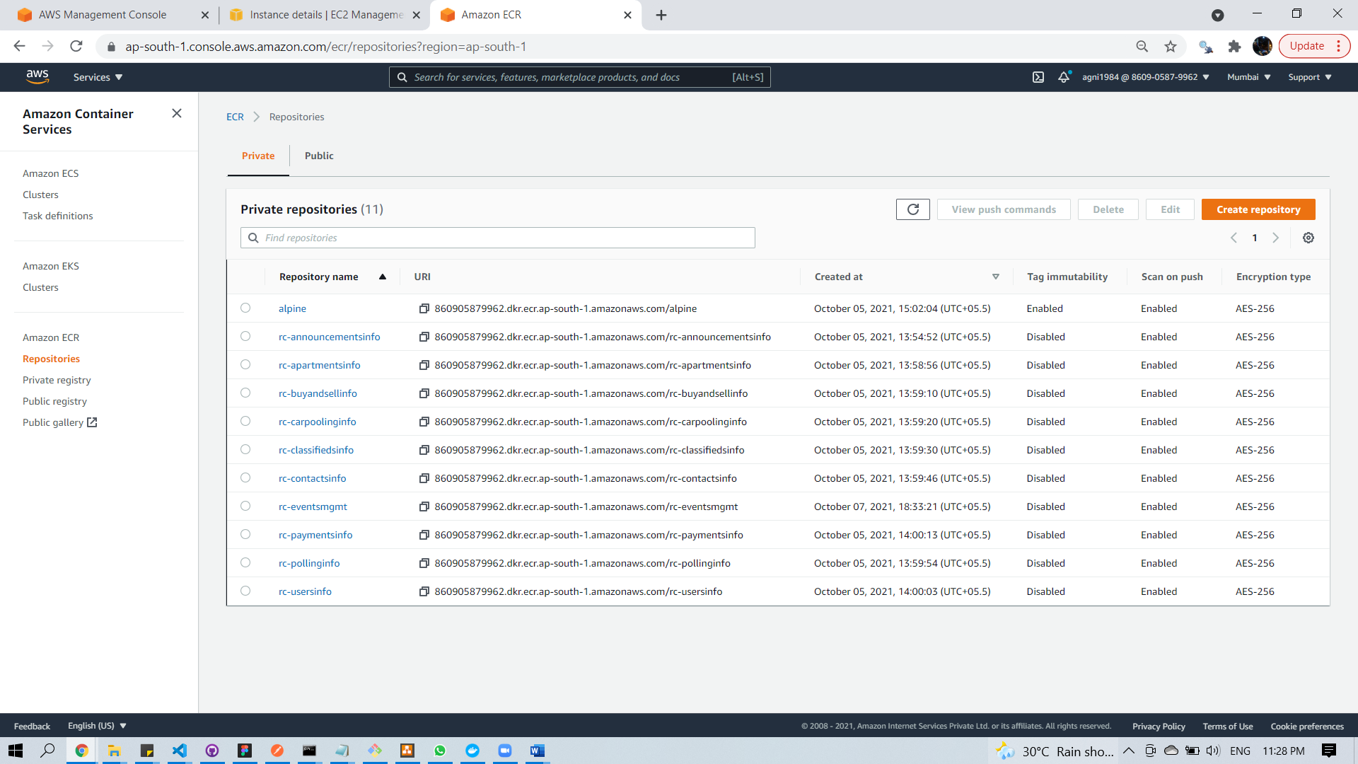

EKS cluster:

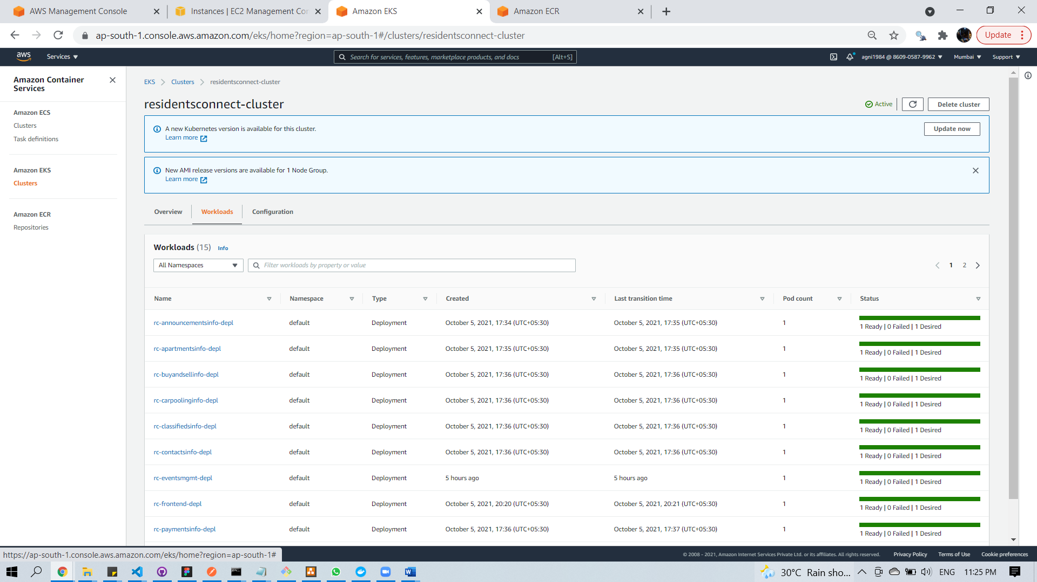

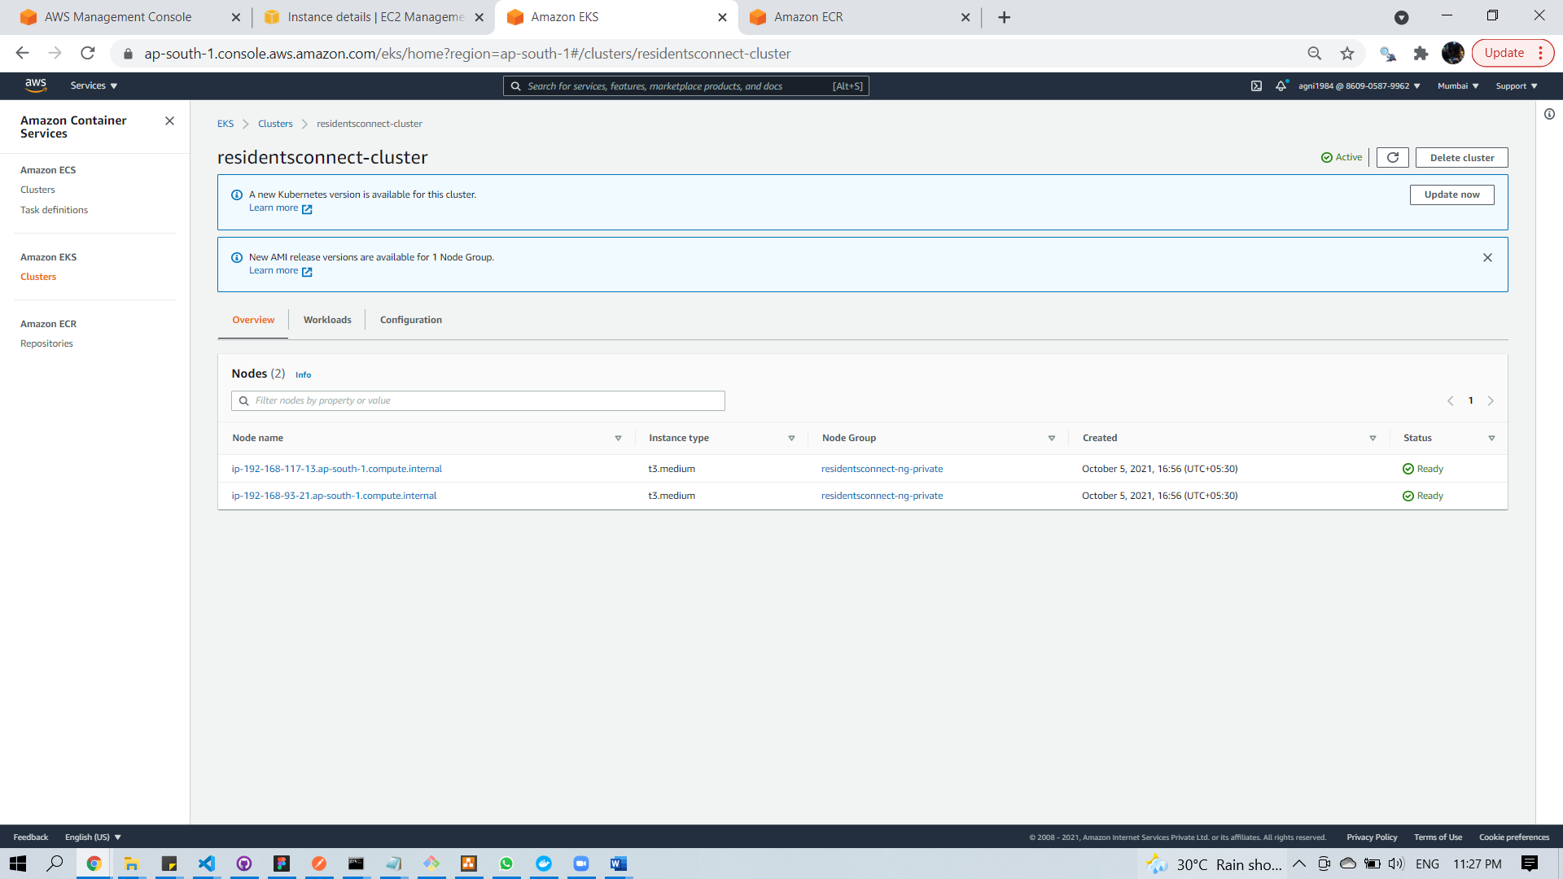

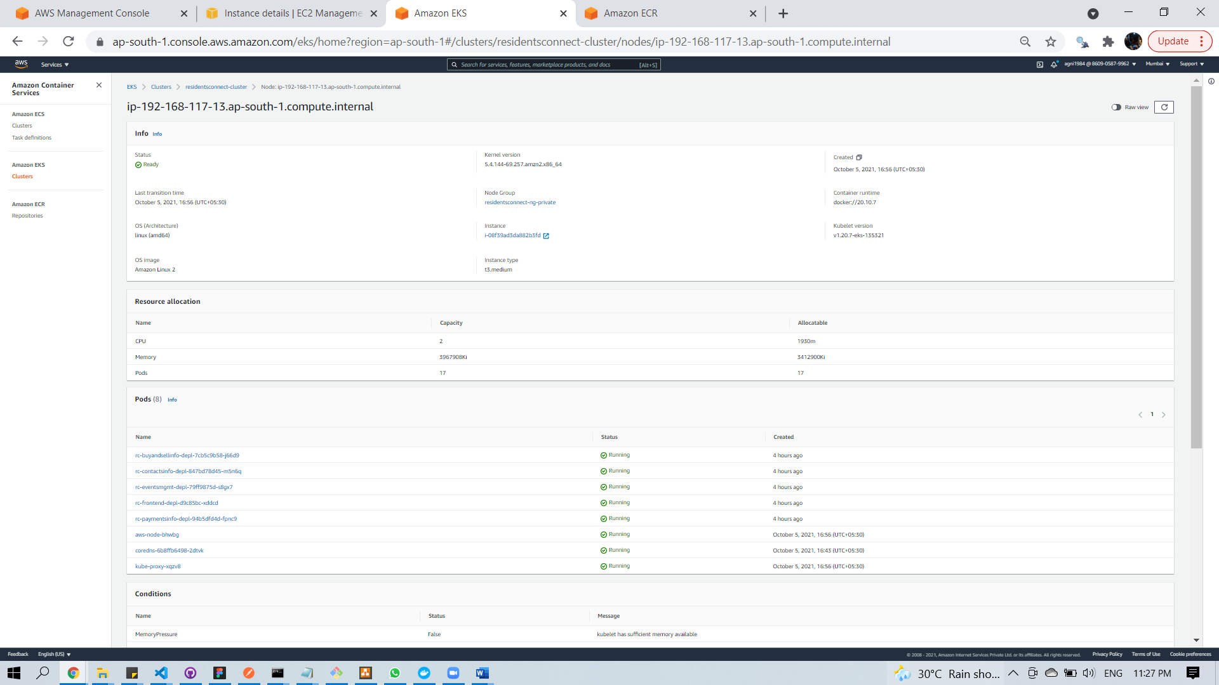

EC2 Machines:

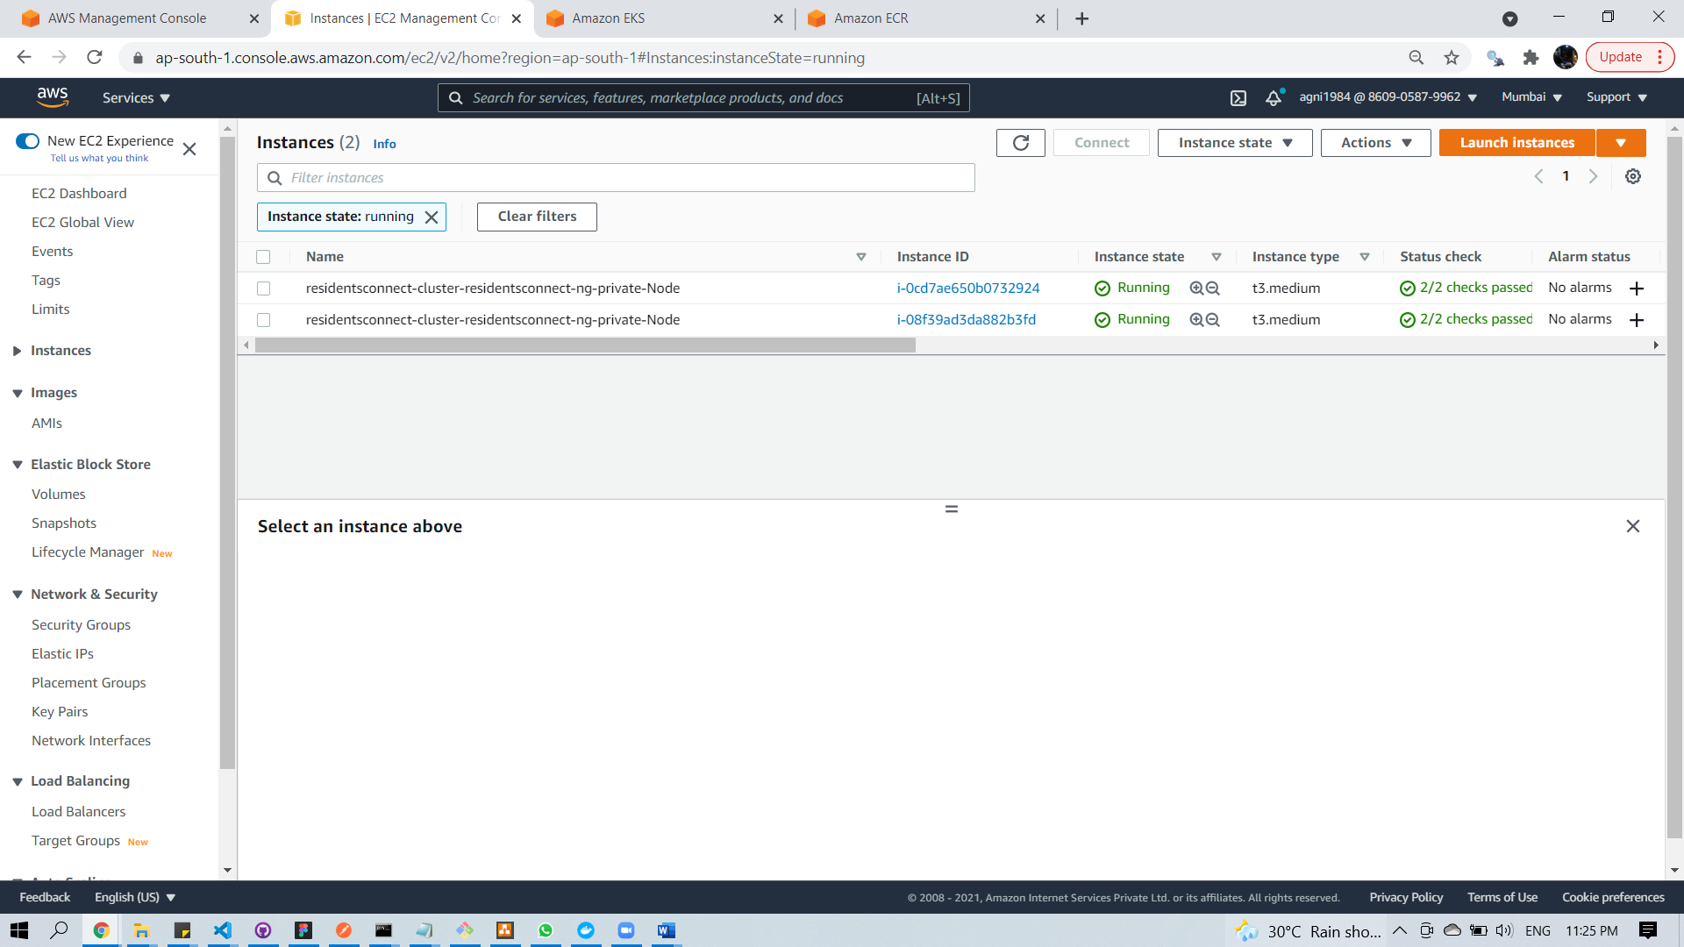

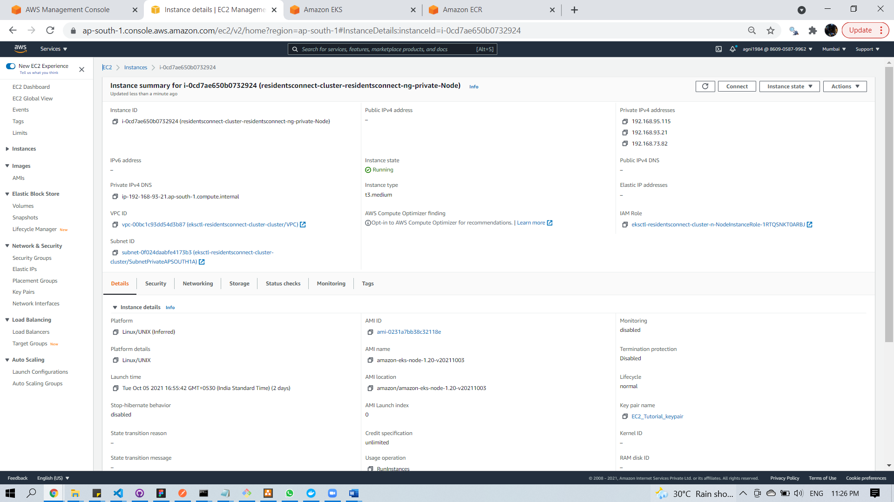

Application Load Balancer:

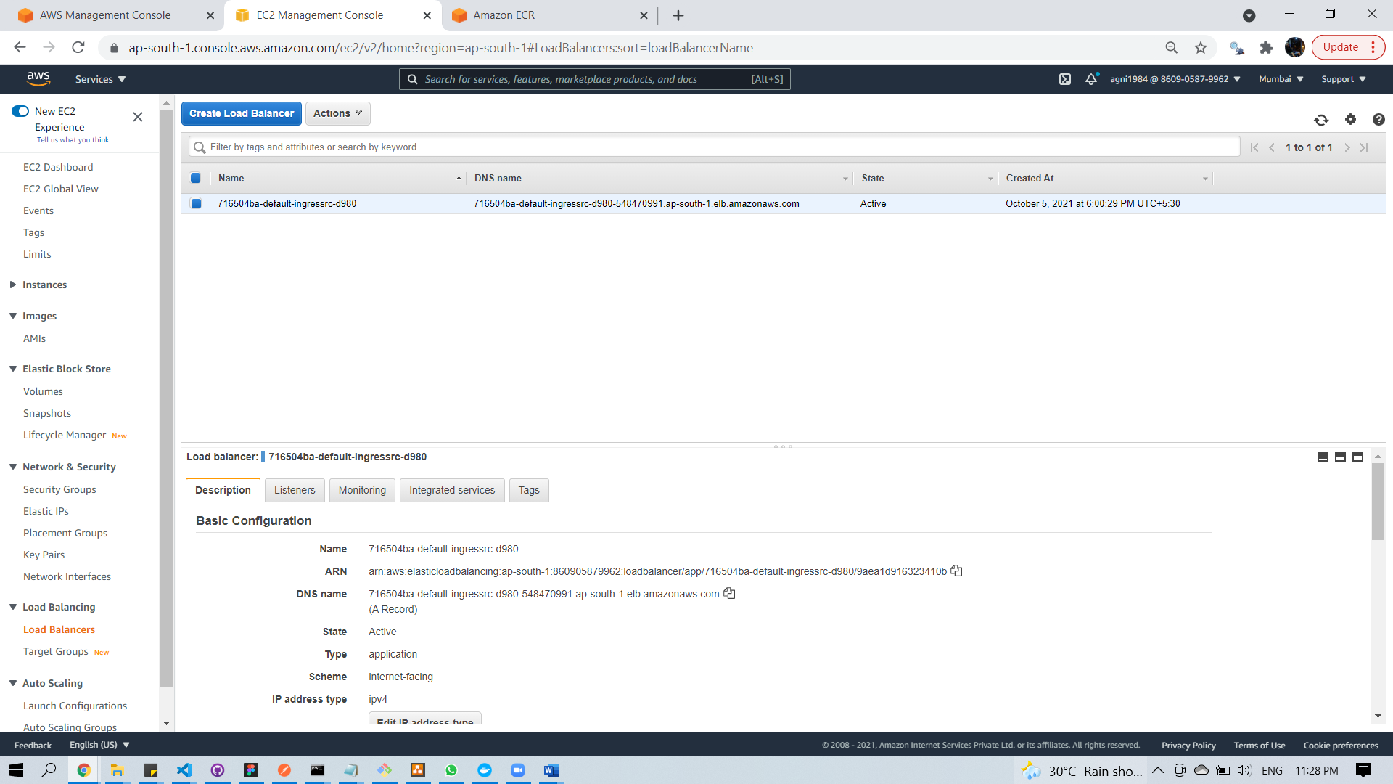

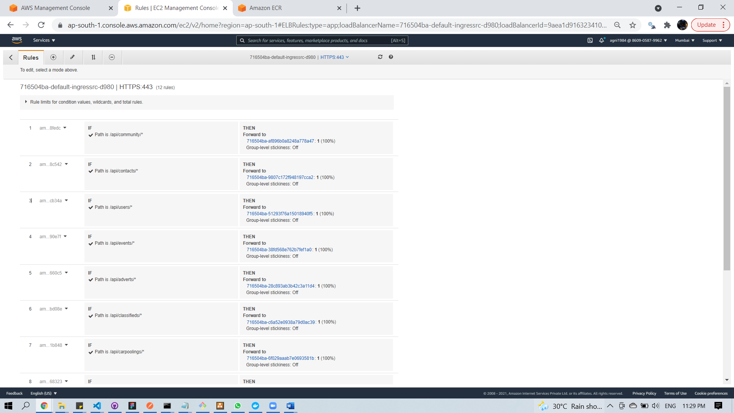

# 15.Code

## 15.1. Code Flow

### 15.1.1 Microservice framework

Separate project used for every microservice. Each has its own ‘package.json’ , build & deployments files (docker , deployment file).

MVC folder structure.

* Models folder -> holds all the mongo DB’s collection’s schema
* Controllers folder -> functions which interact with mongodb for API implementation
* Routes folder -> binding the function with API url.

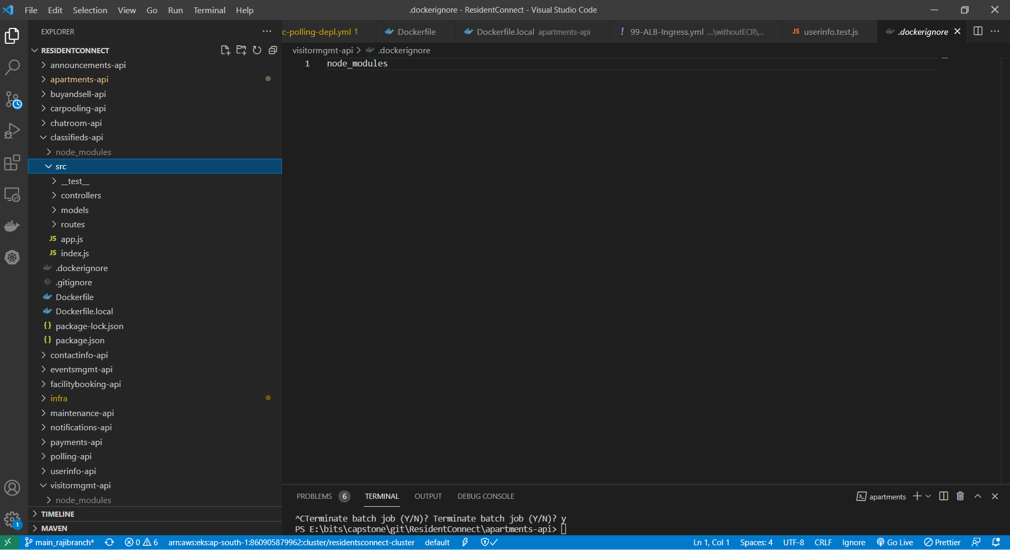

### 15. 1.2 Front end code

Separate folder used for each feature

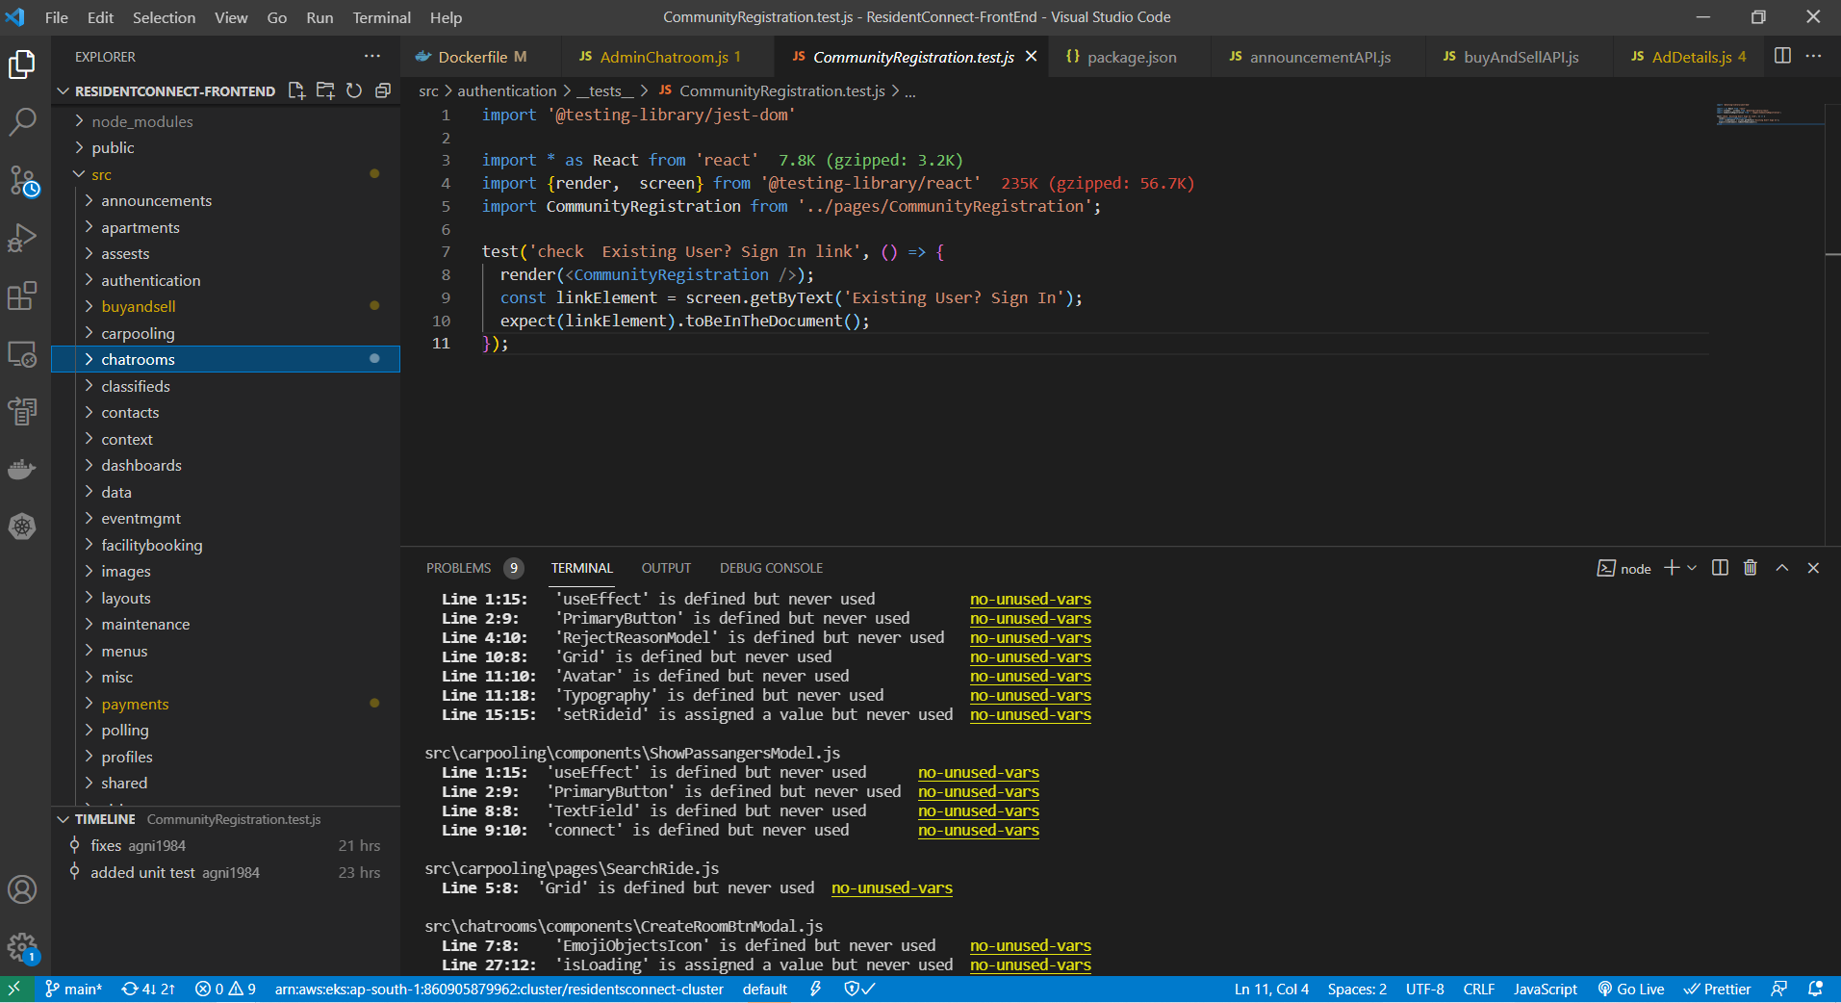

### 15.1.1. API Documents

API details are documented in Swagger. Please refer below link,

<https://app.swaggerhub.com/apis/ResidentConnect/ResidentsConnect/1.0.0>

Live version would be found as part of API

“<hostname>/api/<servicename>/docs” – shows documentation of API

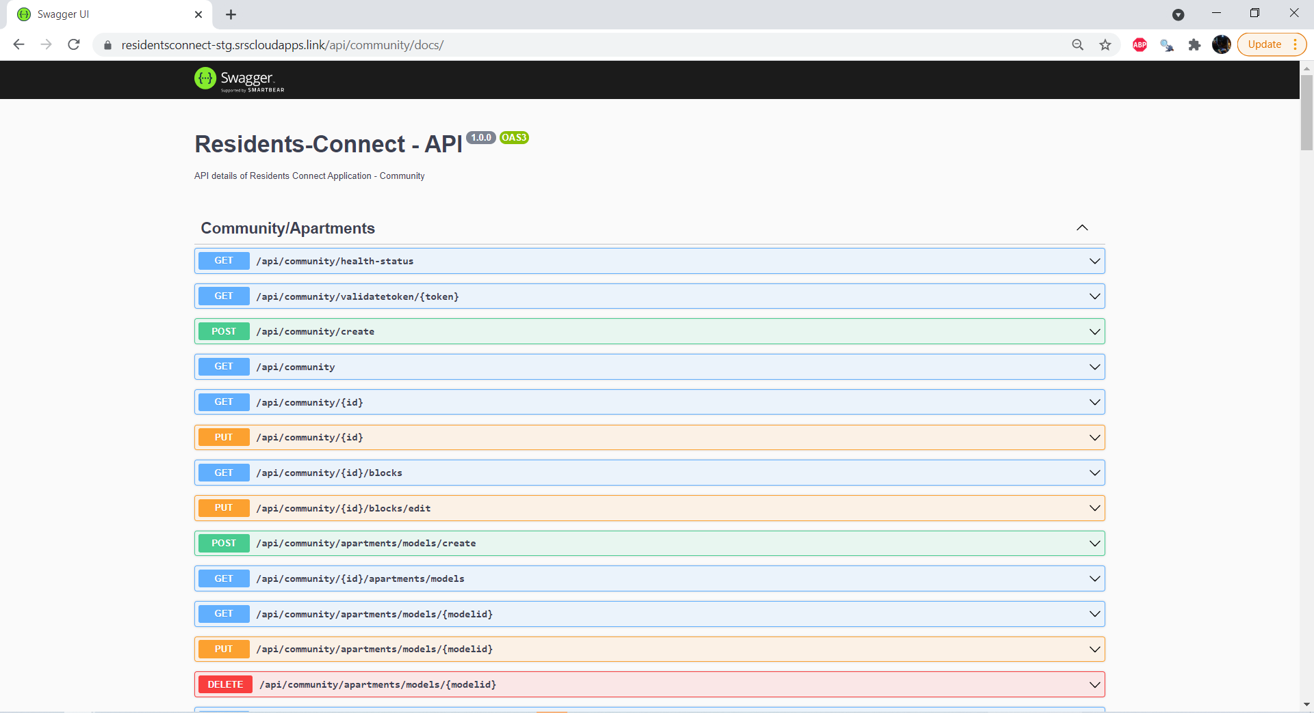

## 15.2 Screenshots

### 15.2.1 Sign In Screen

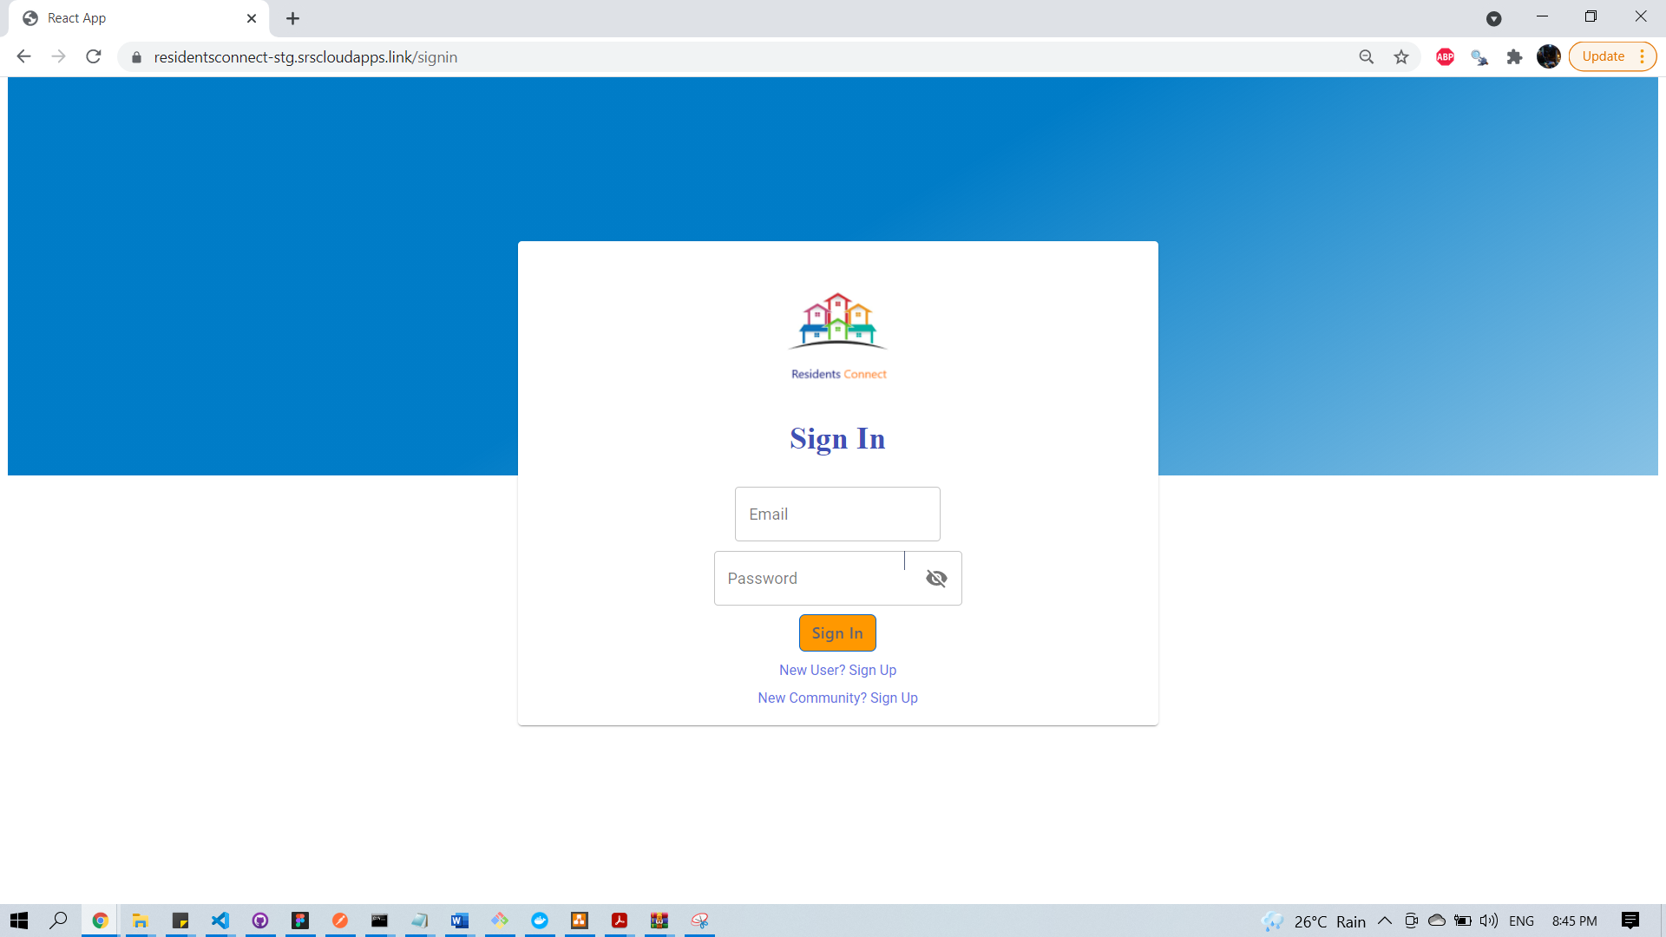

Select Profile (Resident)

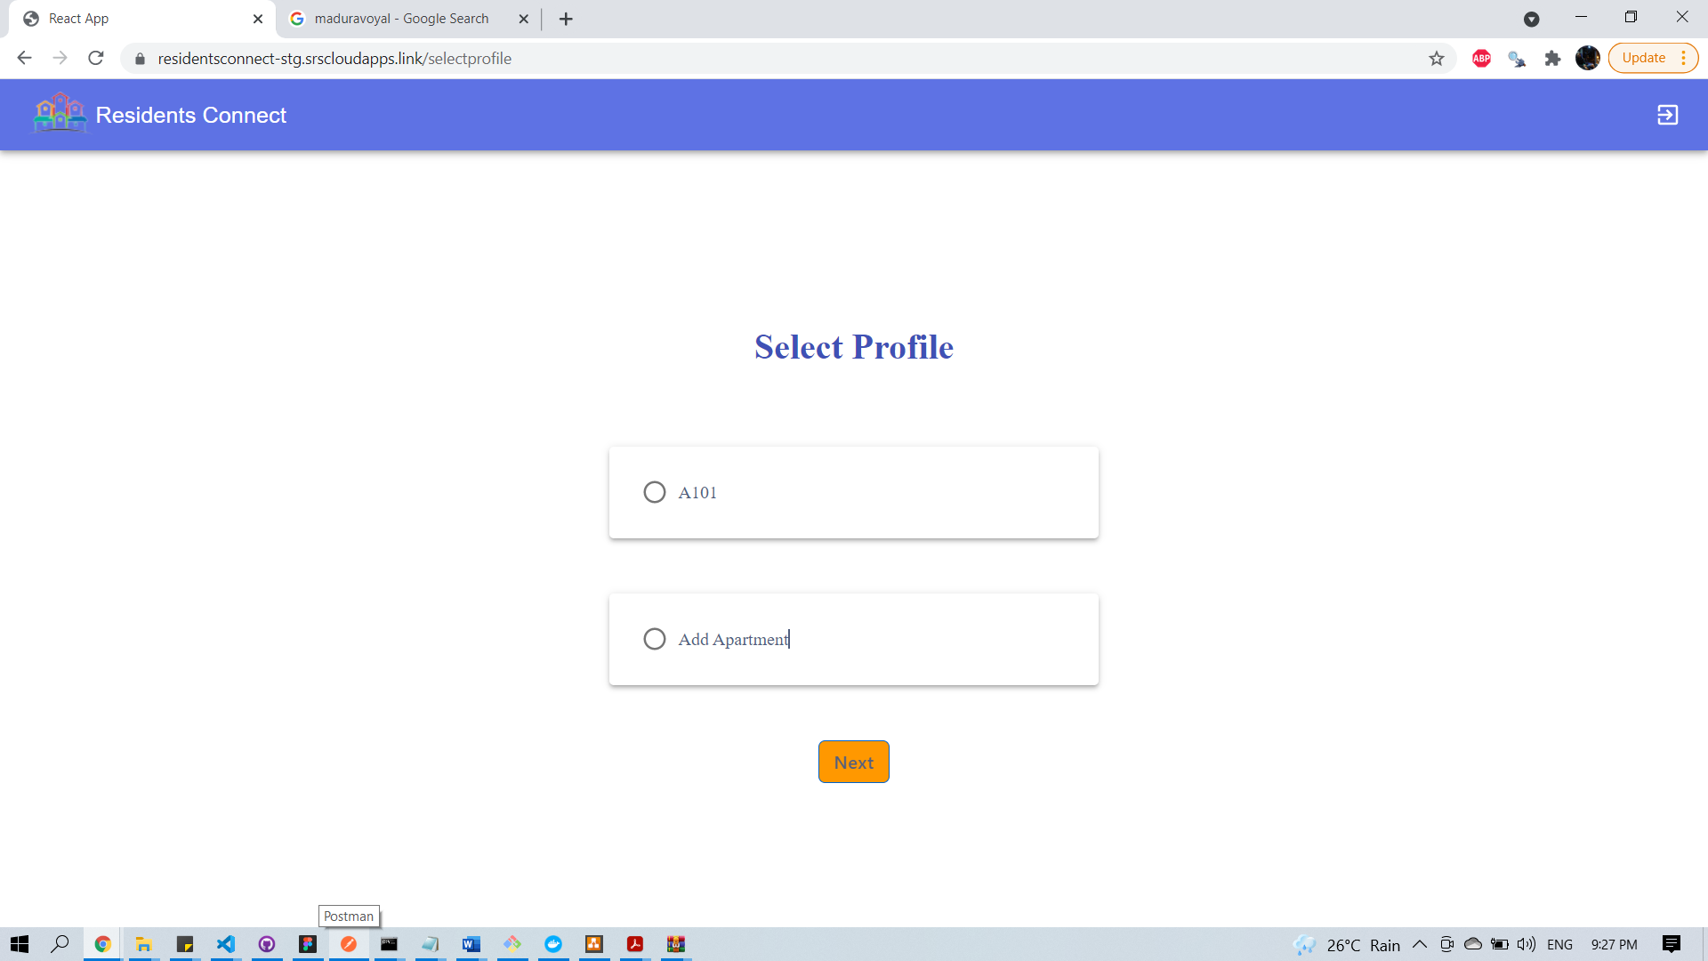

Add New Apartment (Resident)

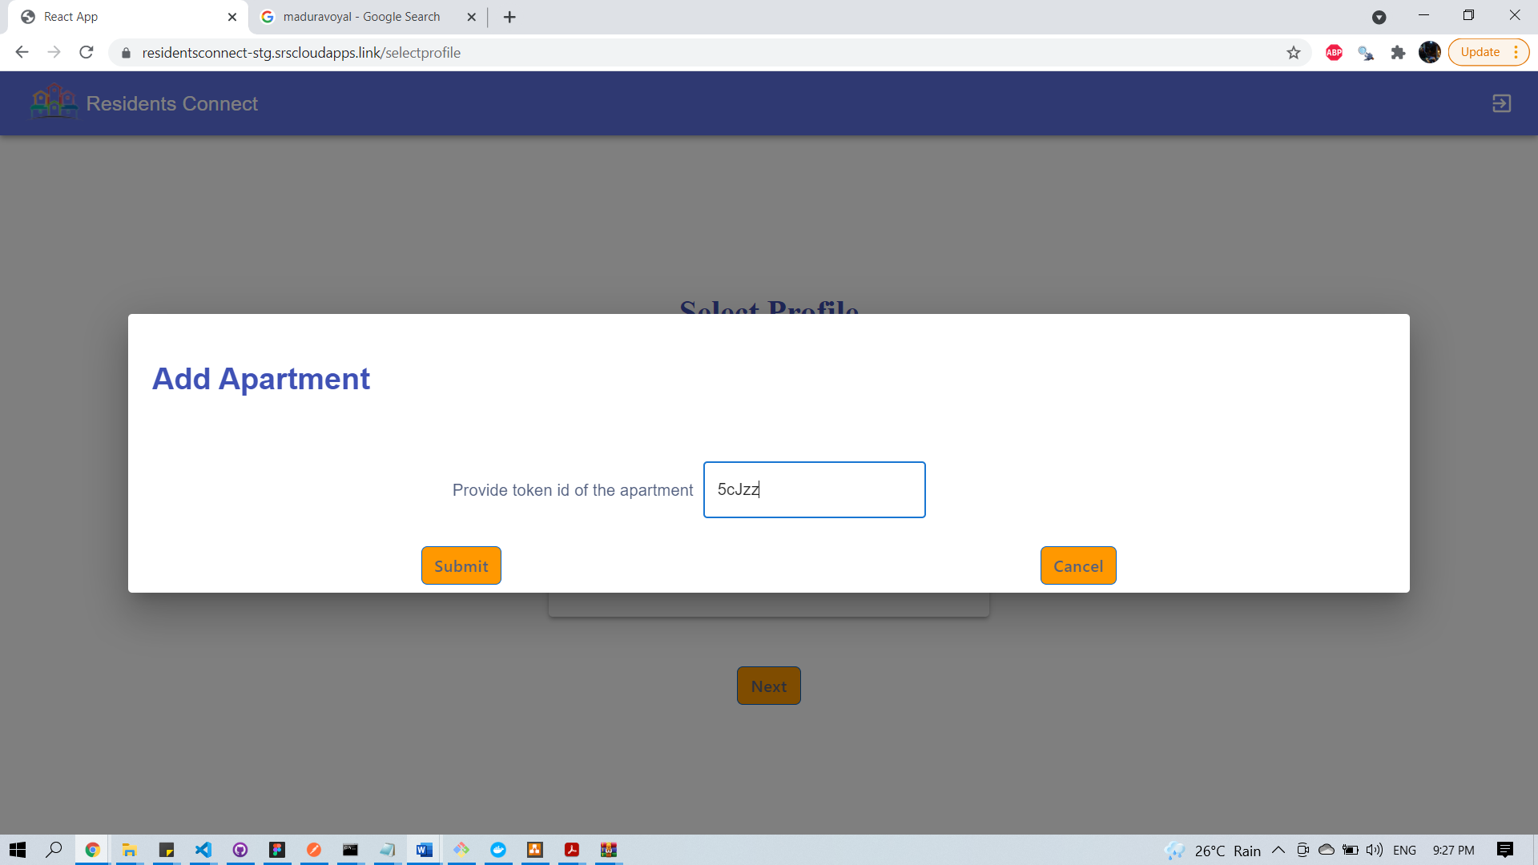

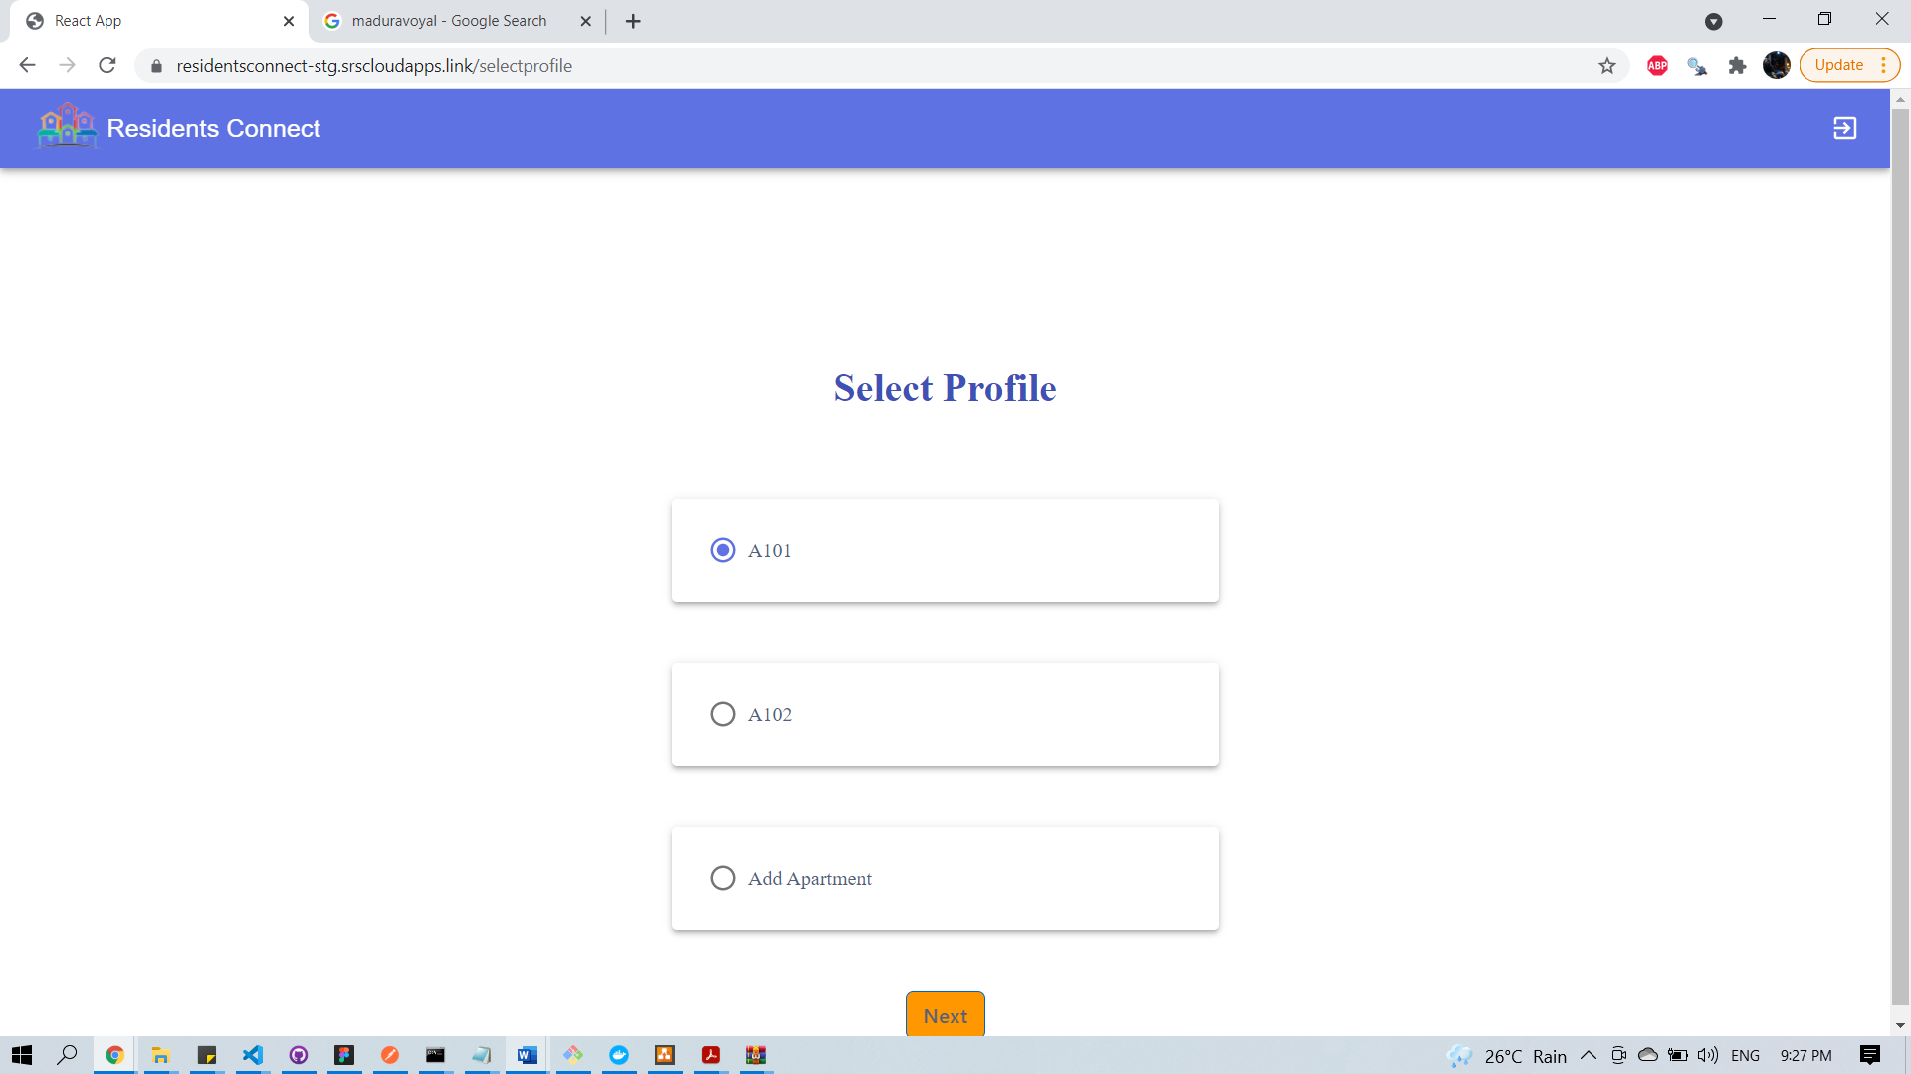

### 15.2.2 Signup Screens (Community/Individual)

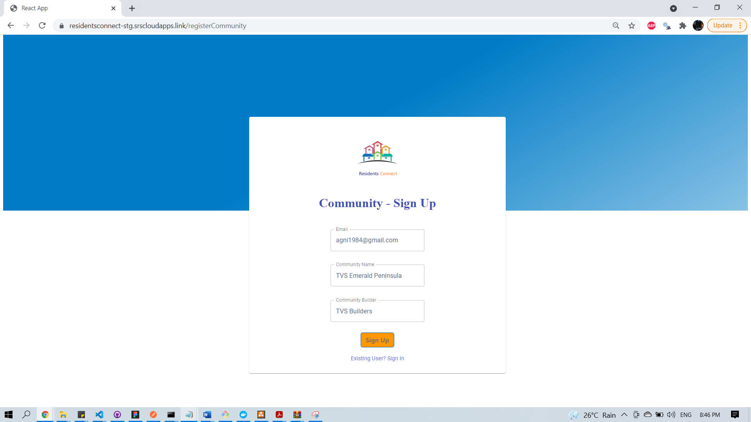

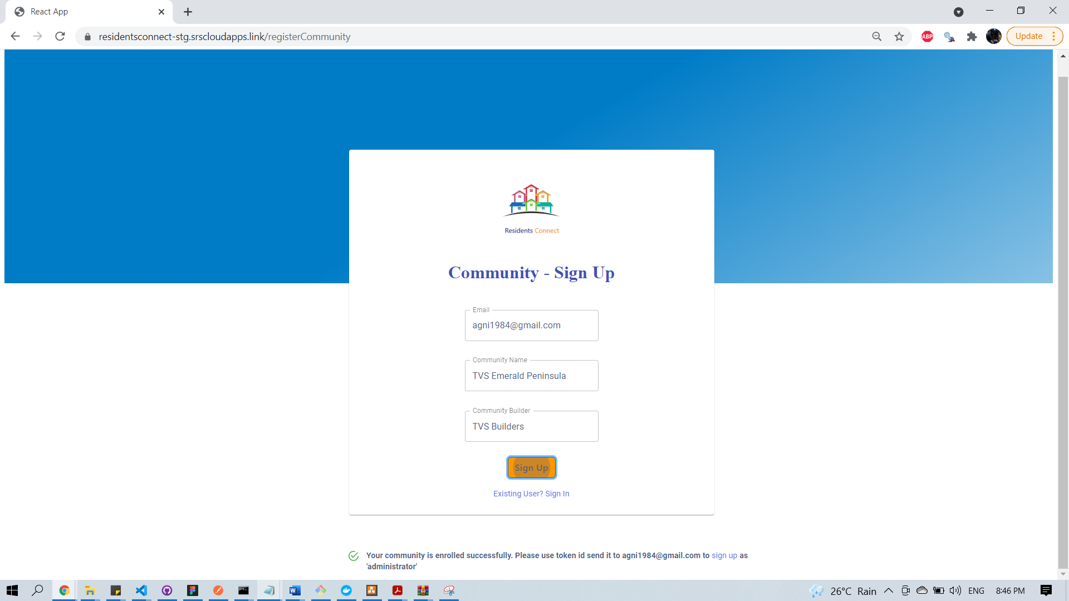

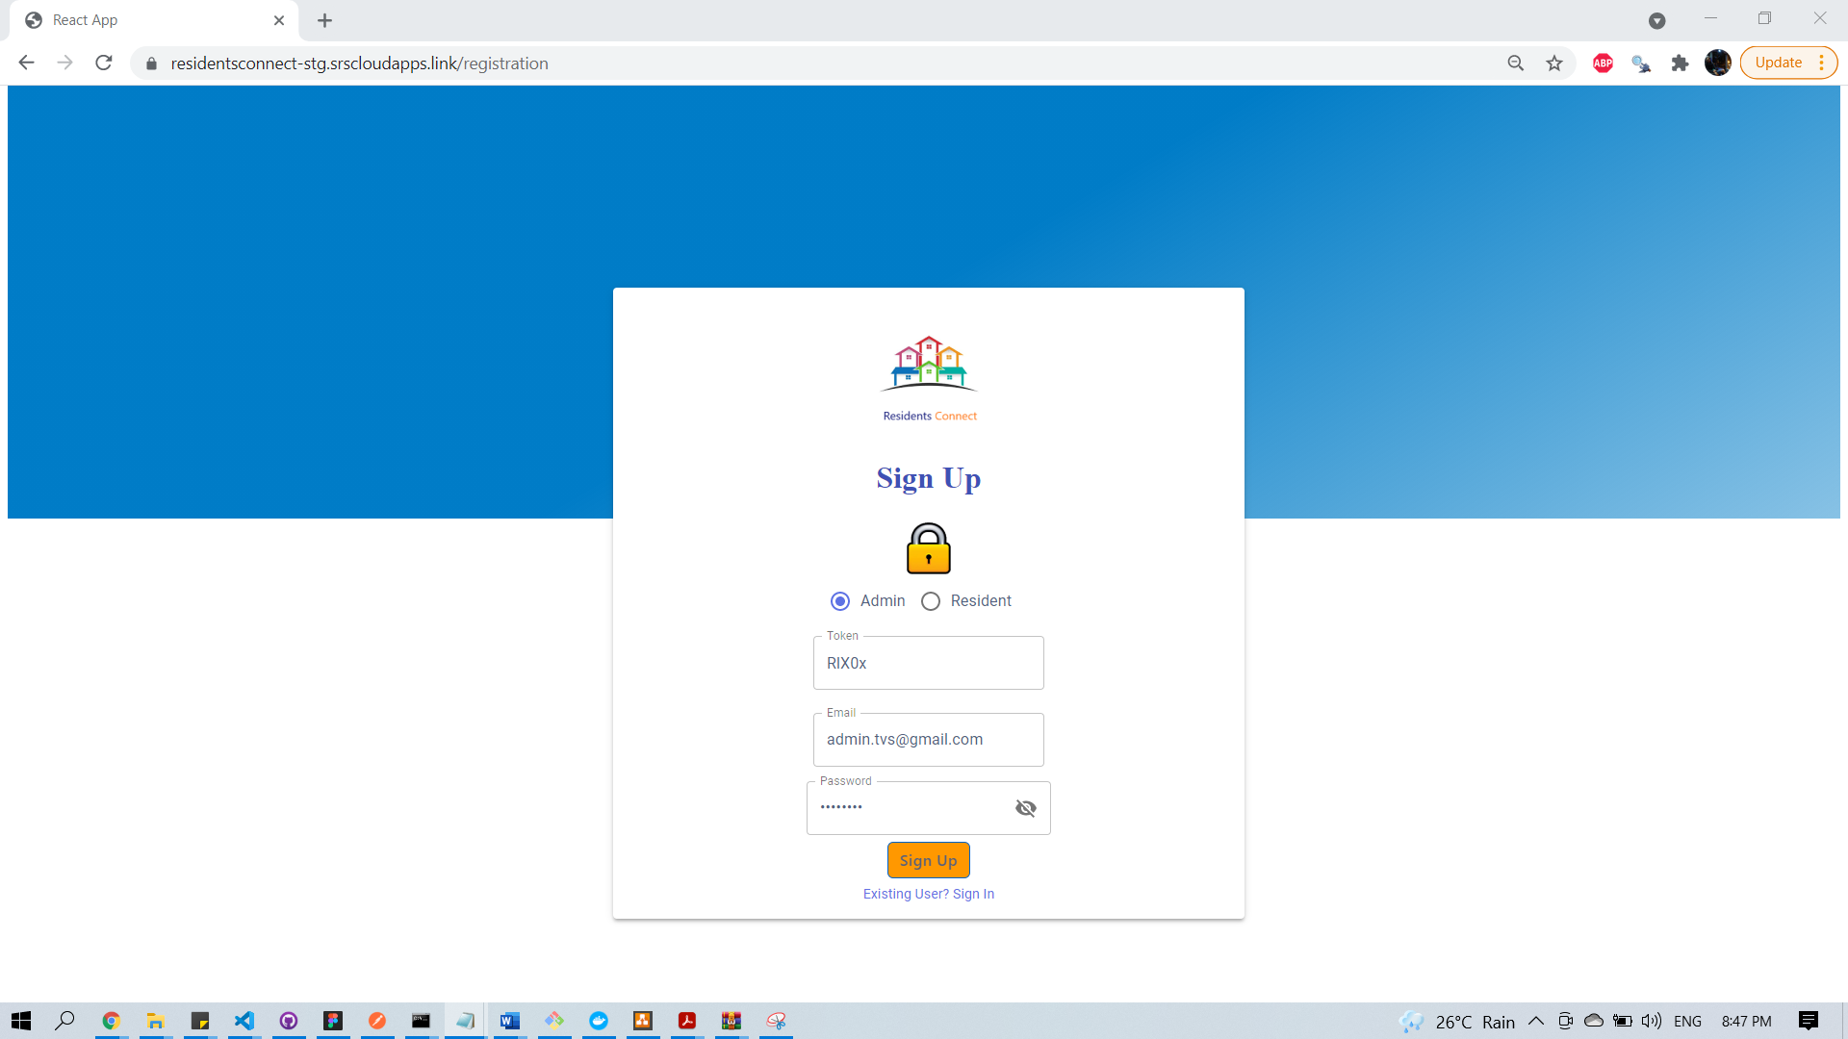

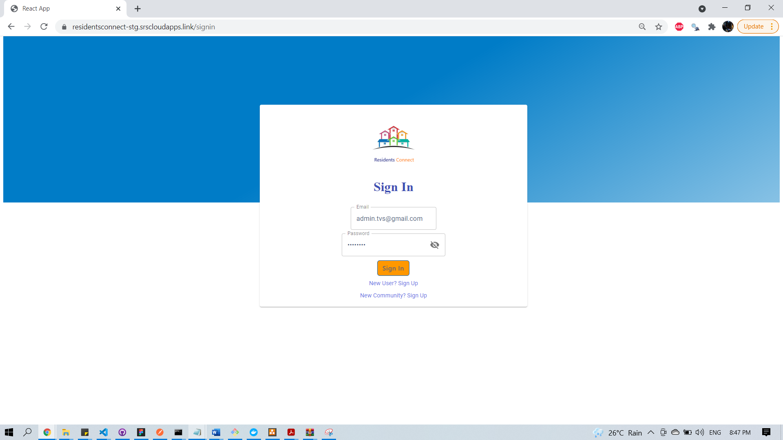

### 15.2.3 Select Community

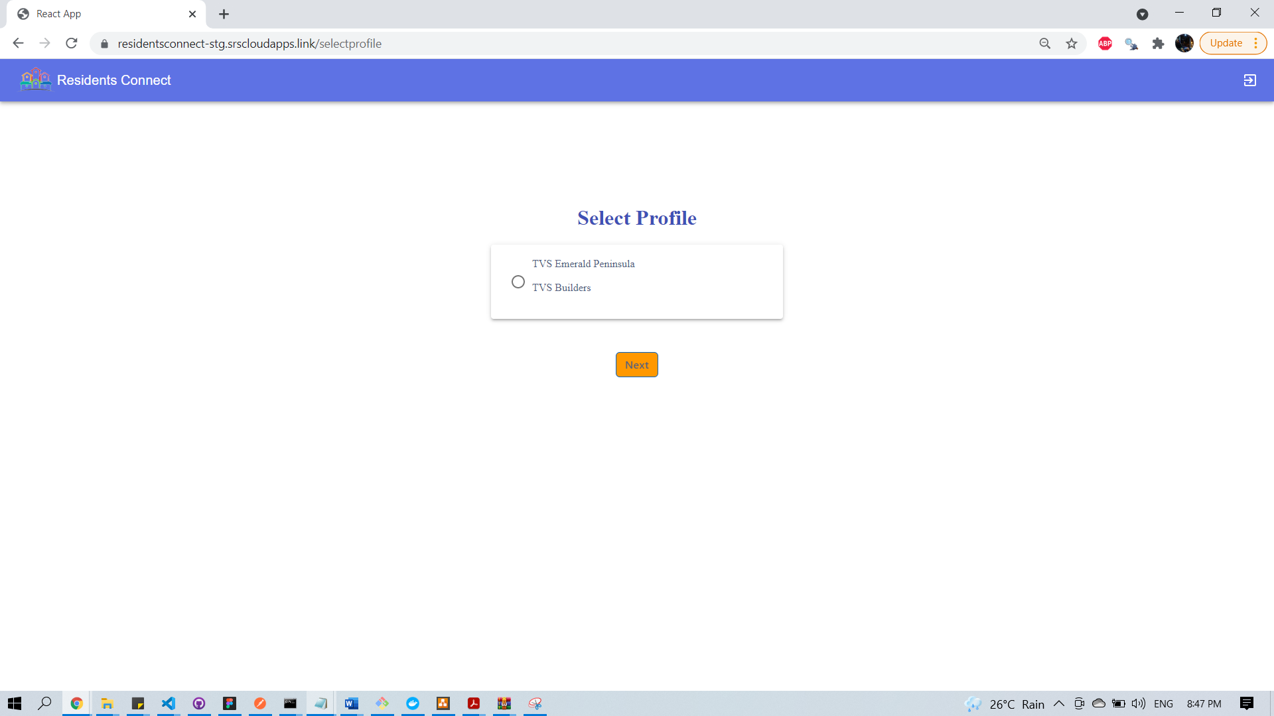

### 15.2.4 Community Profile Setup:

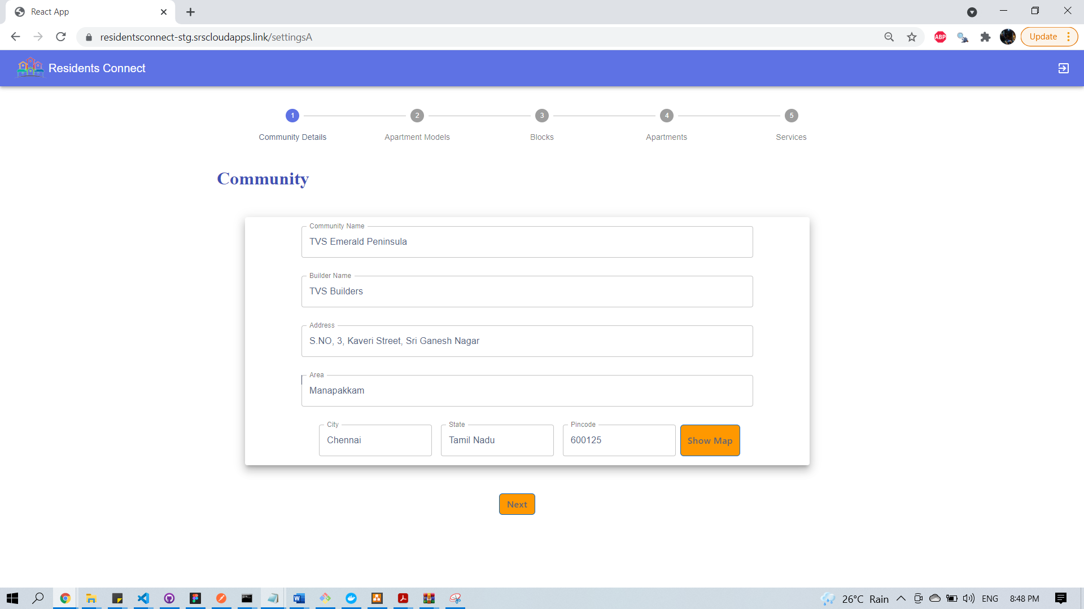

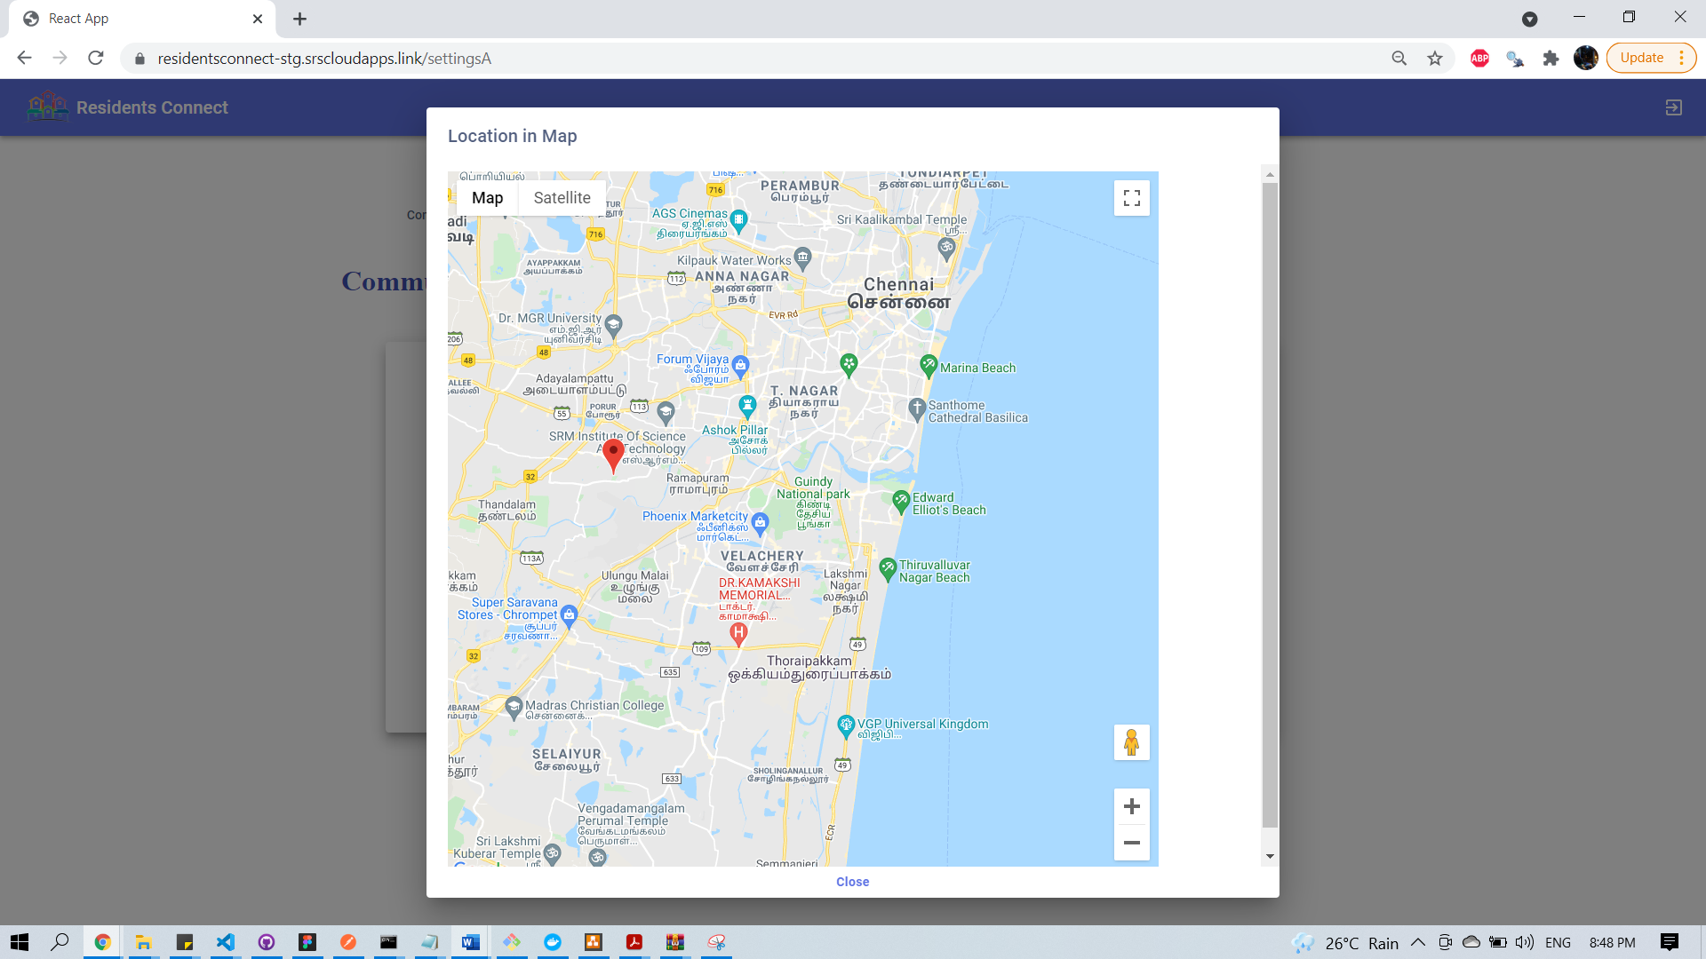

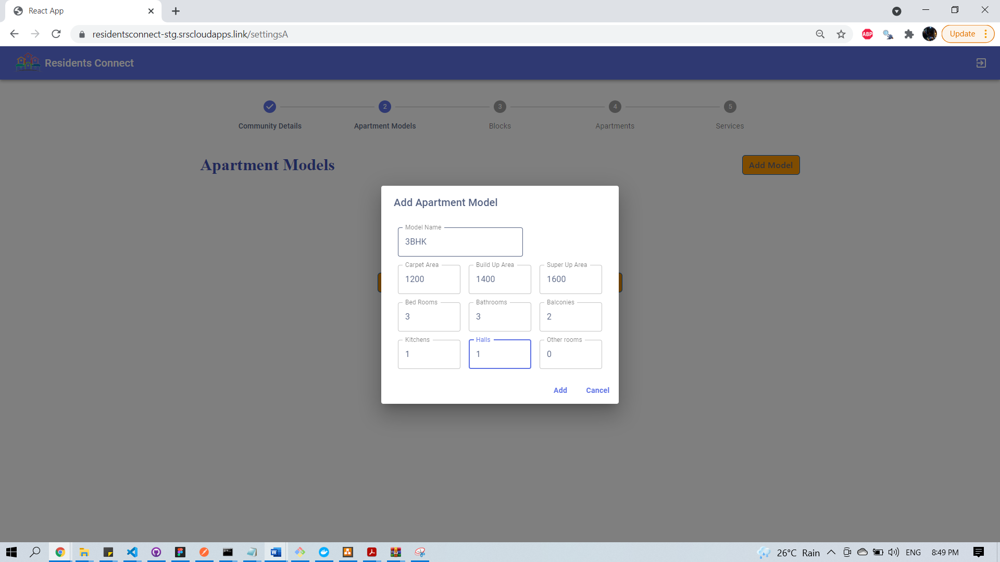

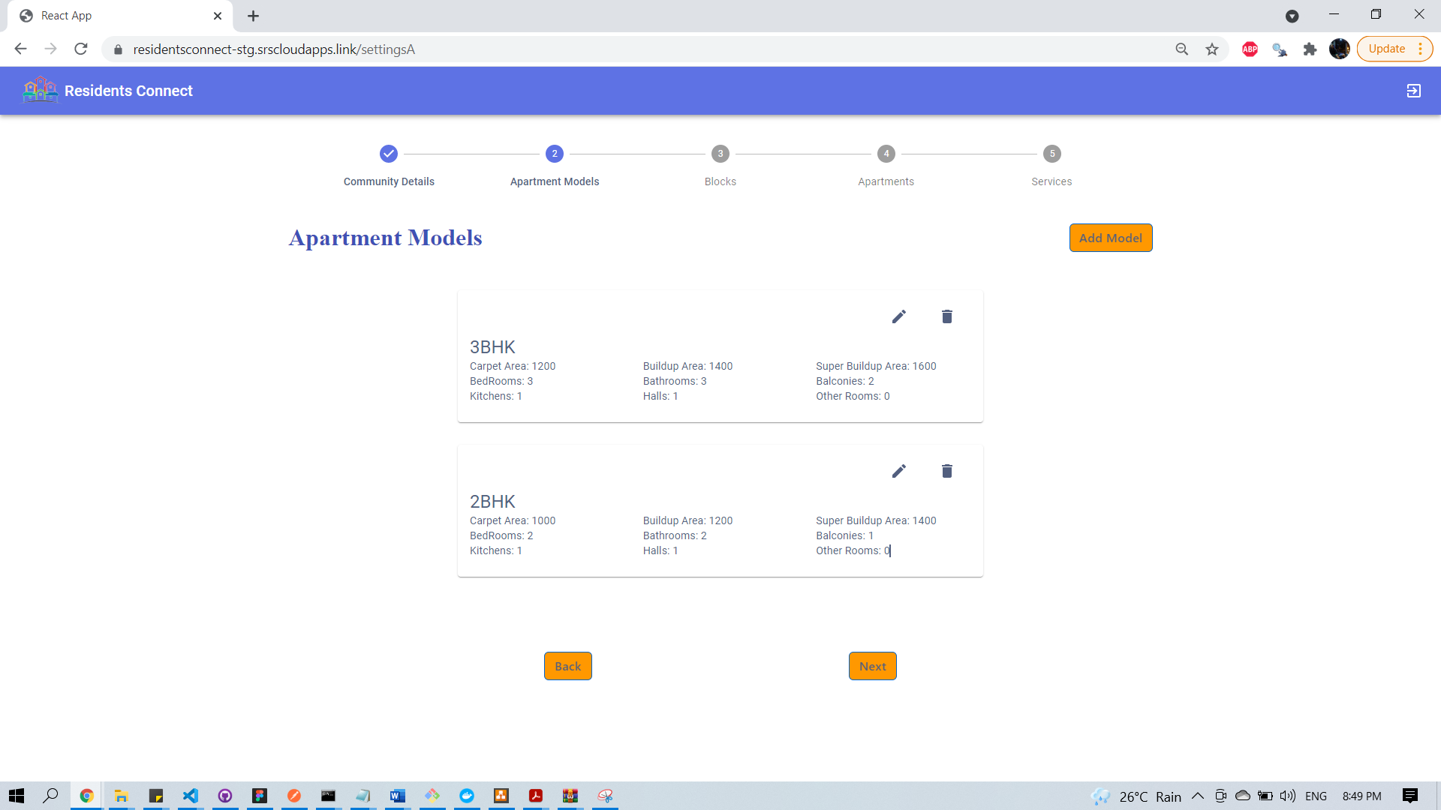

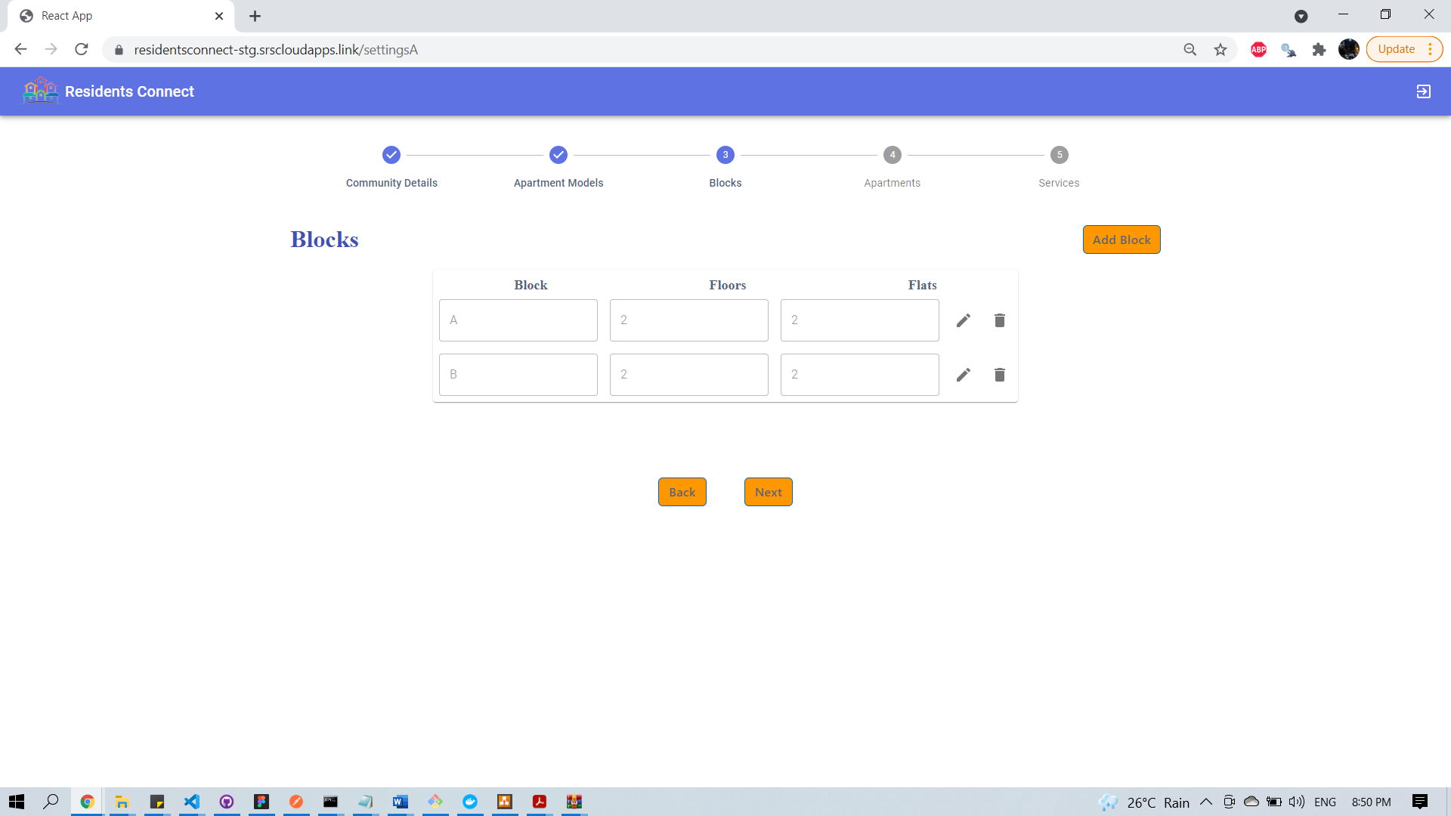

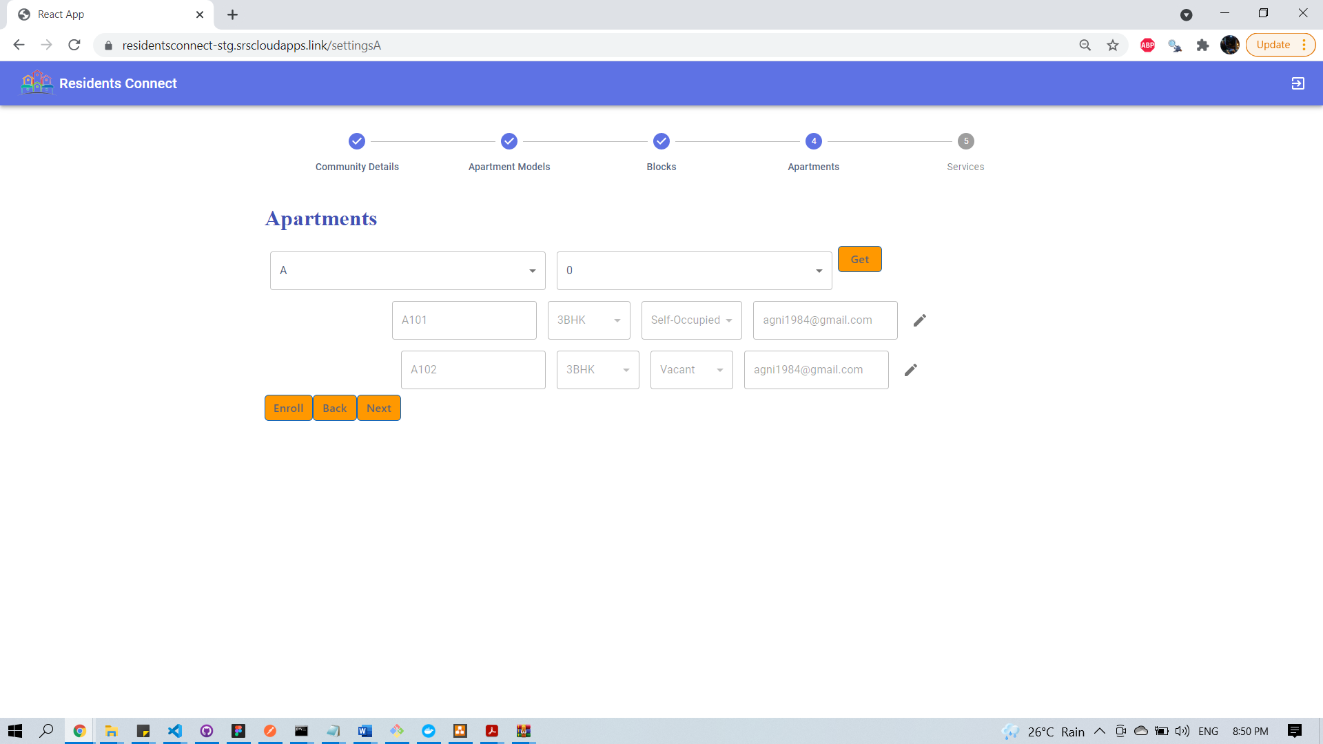

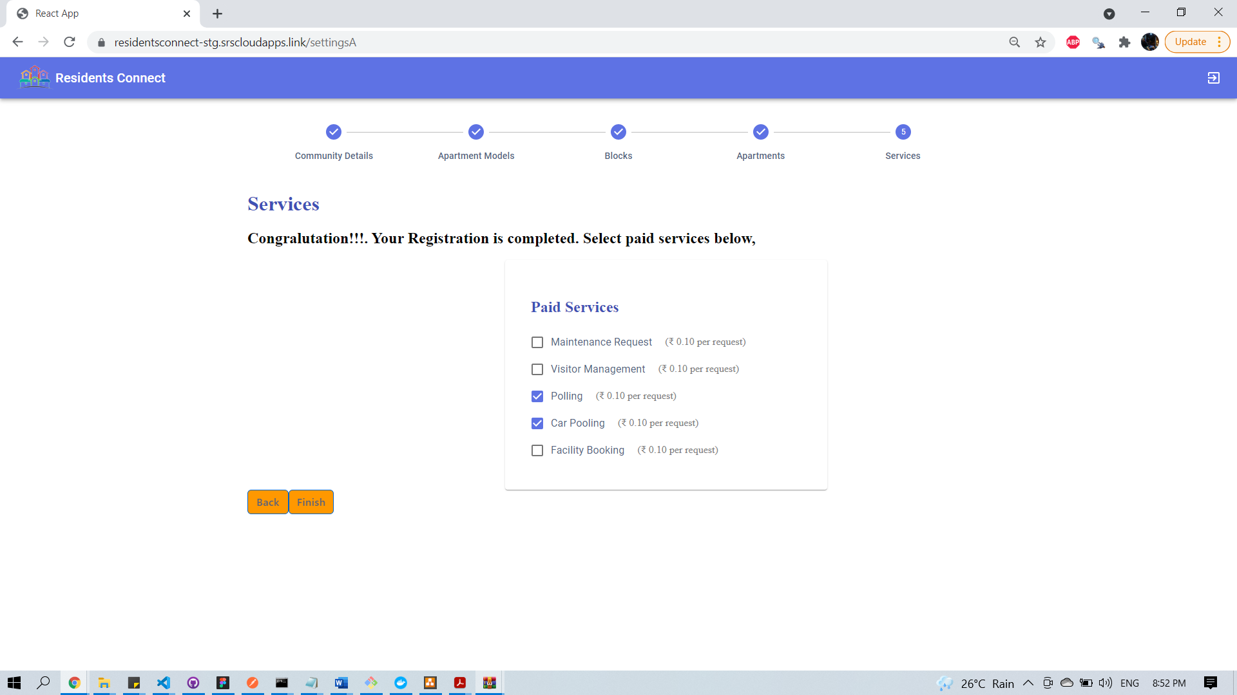

### 15.2.5 Individual Profile Setup

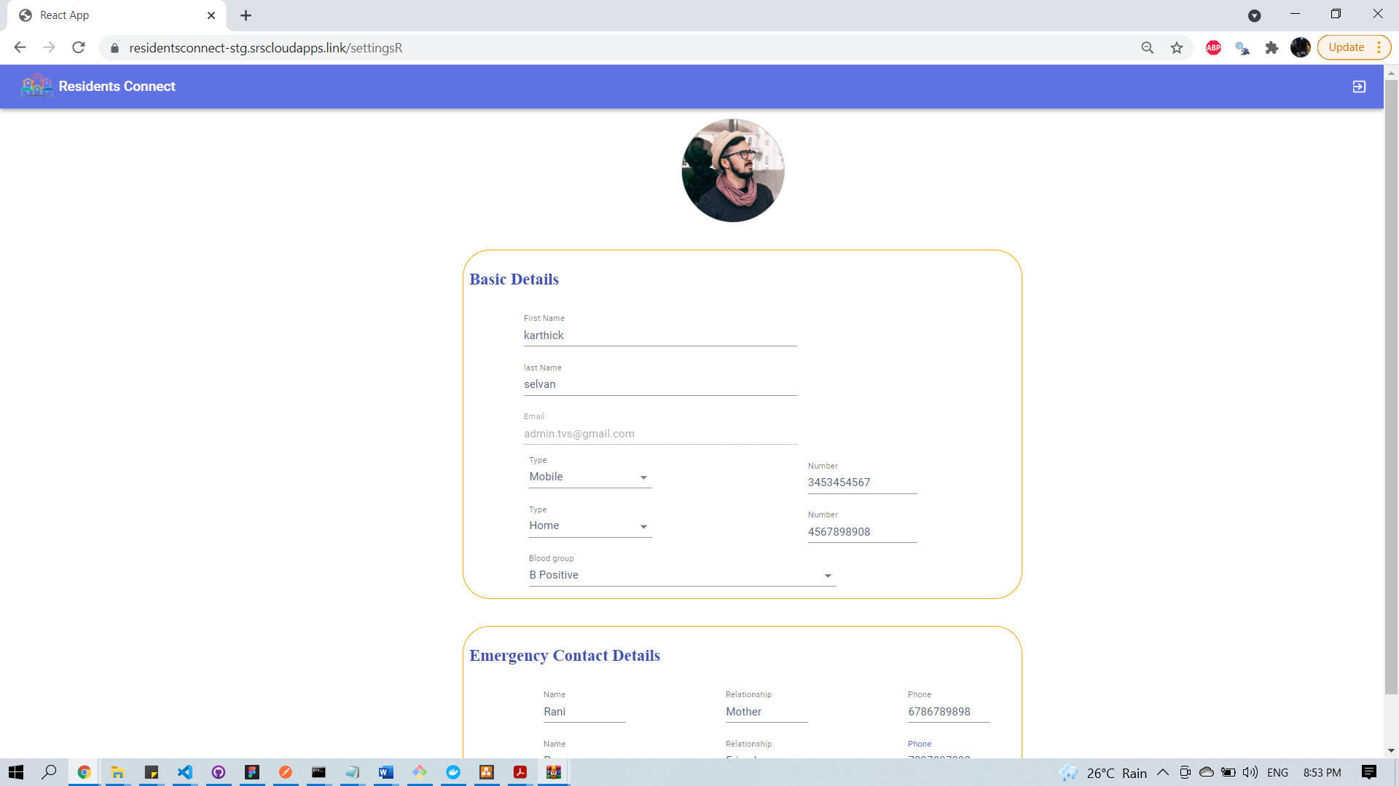

### 15.2.6 Resident Dashboard

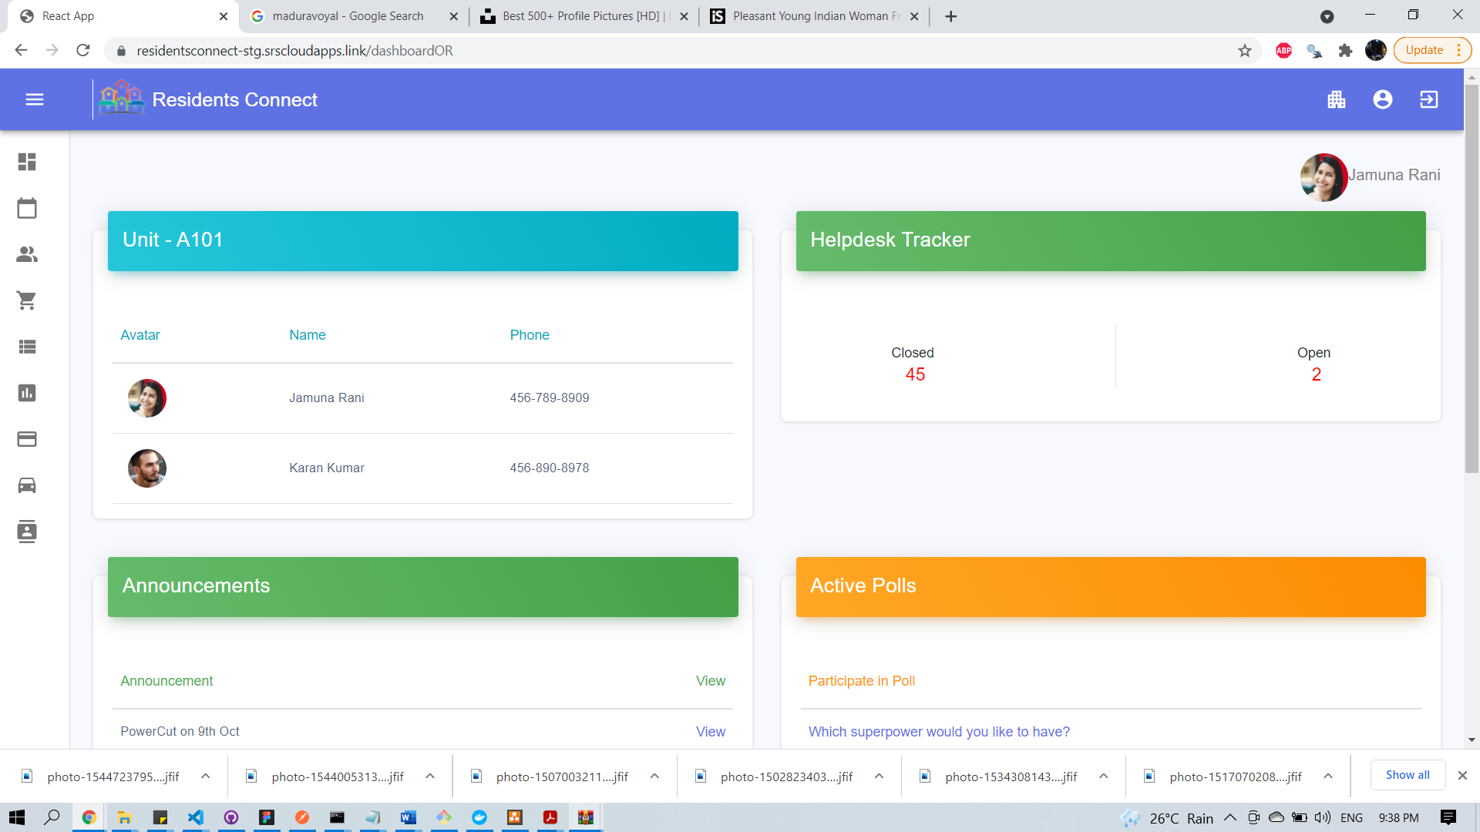

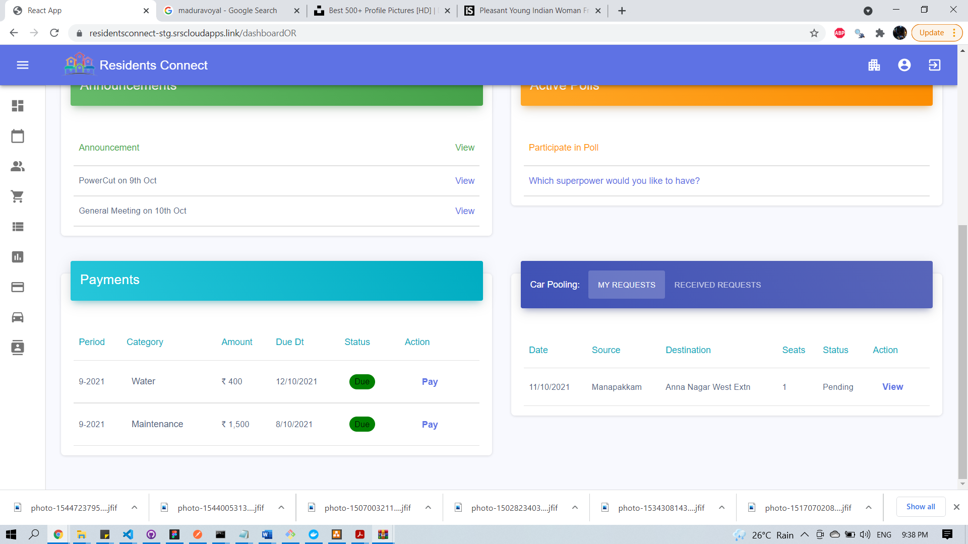

### 15.2.7 Admin Dashboard

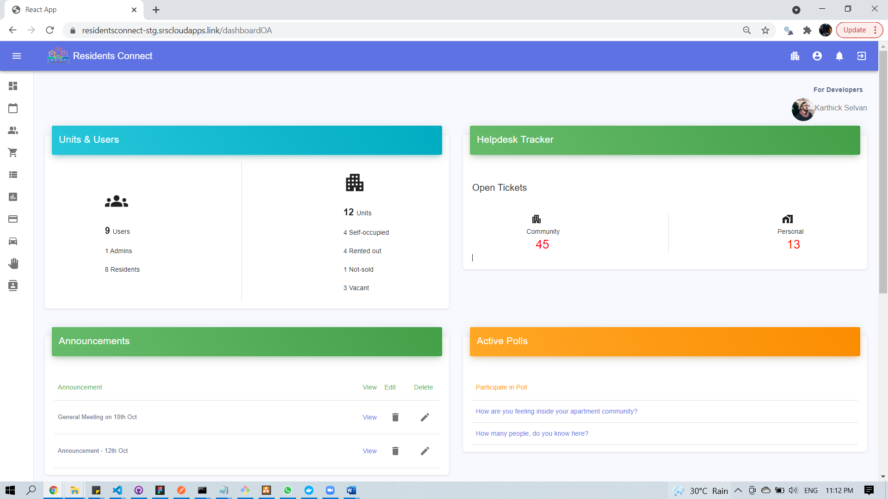

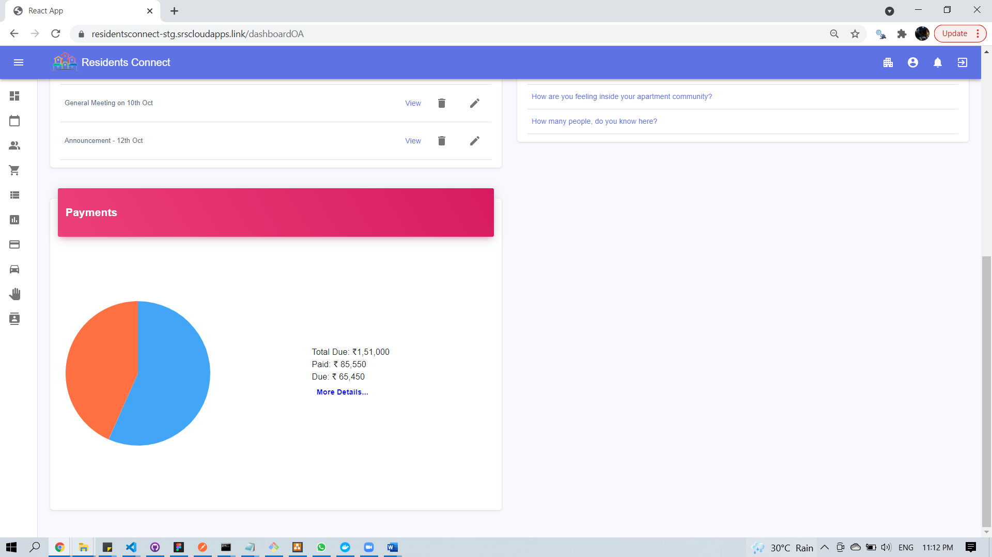

### 15.2.8 Announcements

Create Announcement (admin):

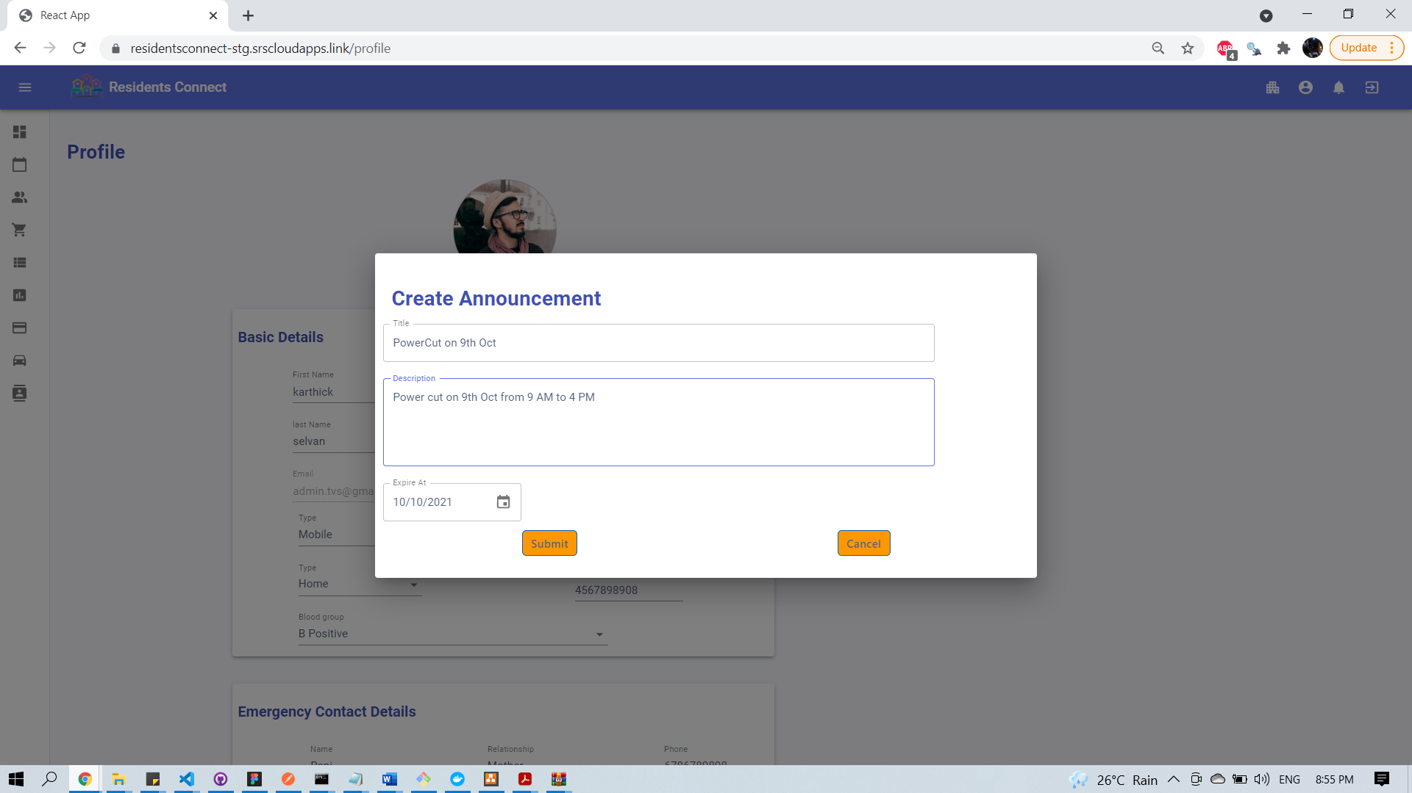

Residents- View Announcements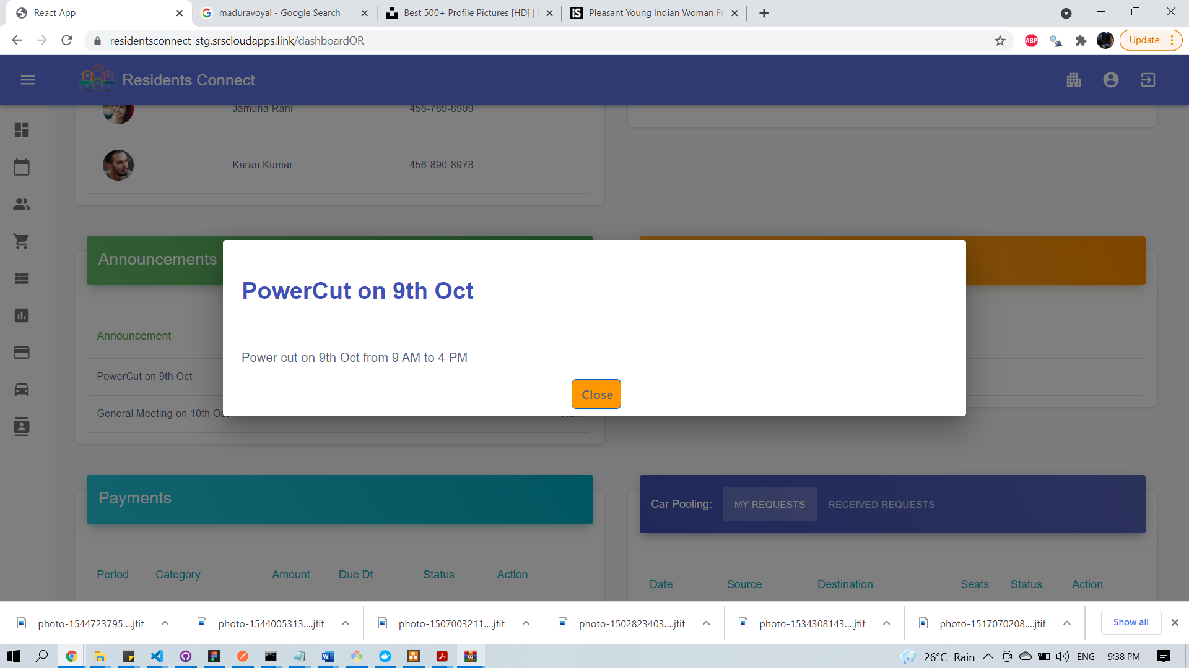

### 15.2.9 Payments

Create Payment (Admin):

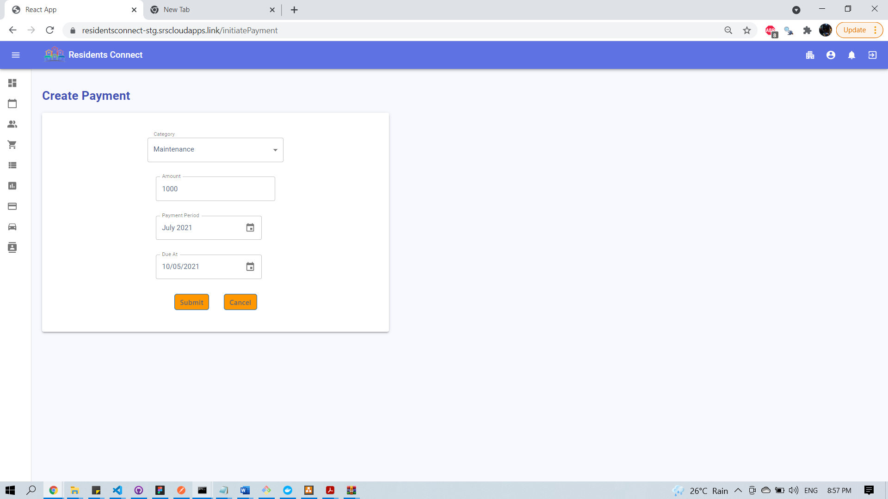

Payments- Admin

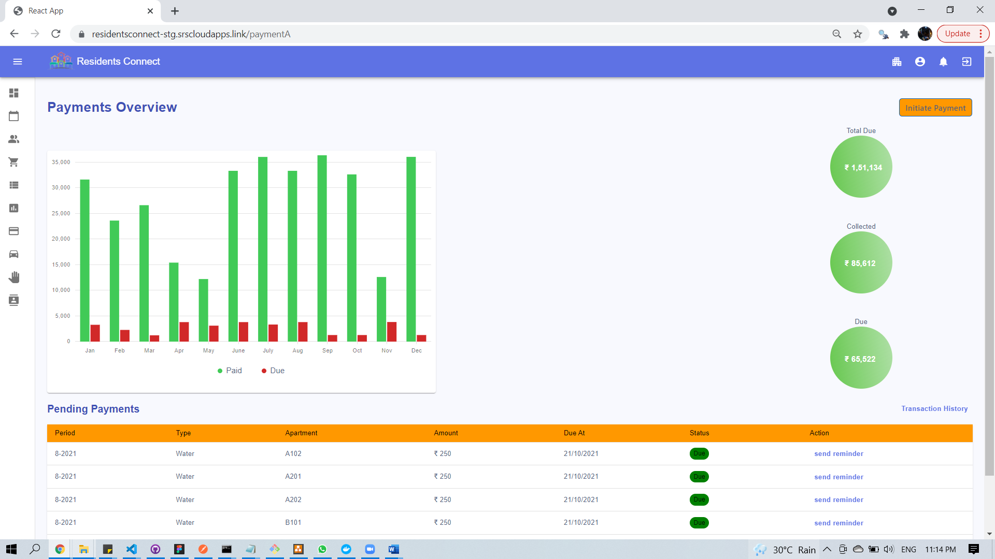Payments- Residents

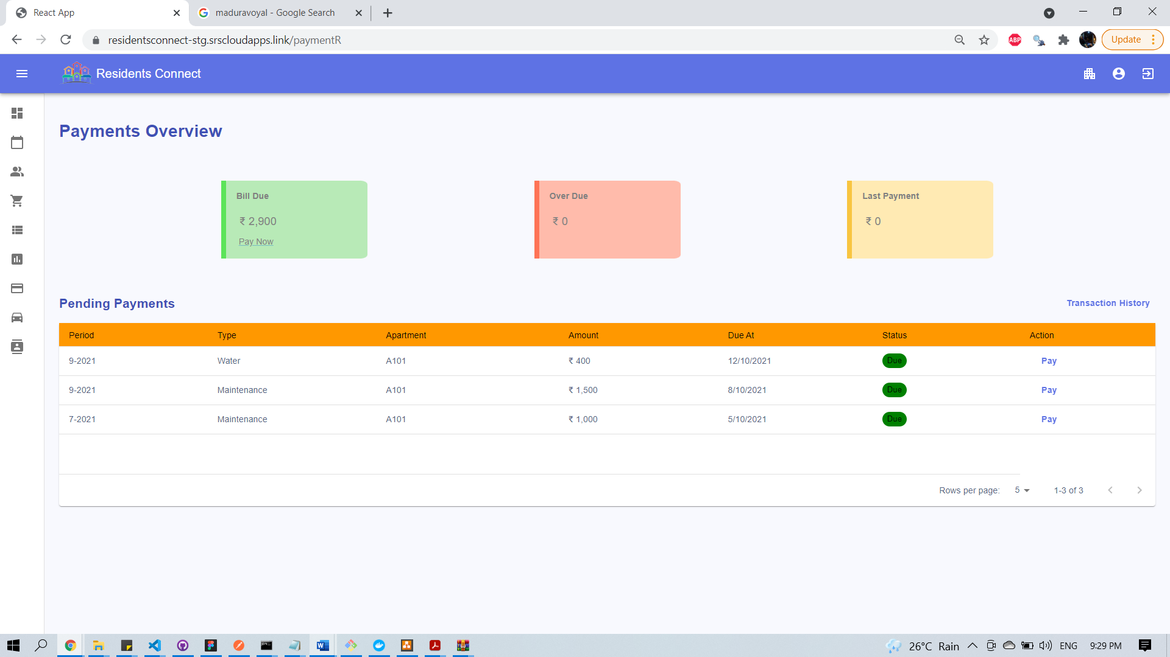

Pay Bill - Residents

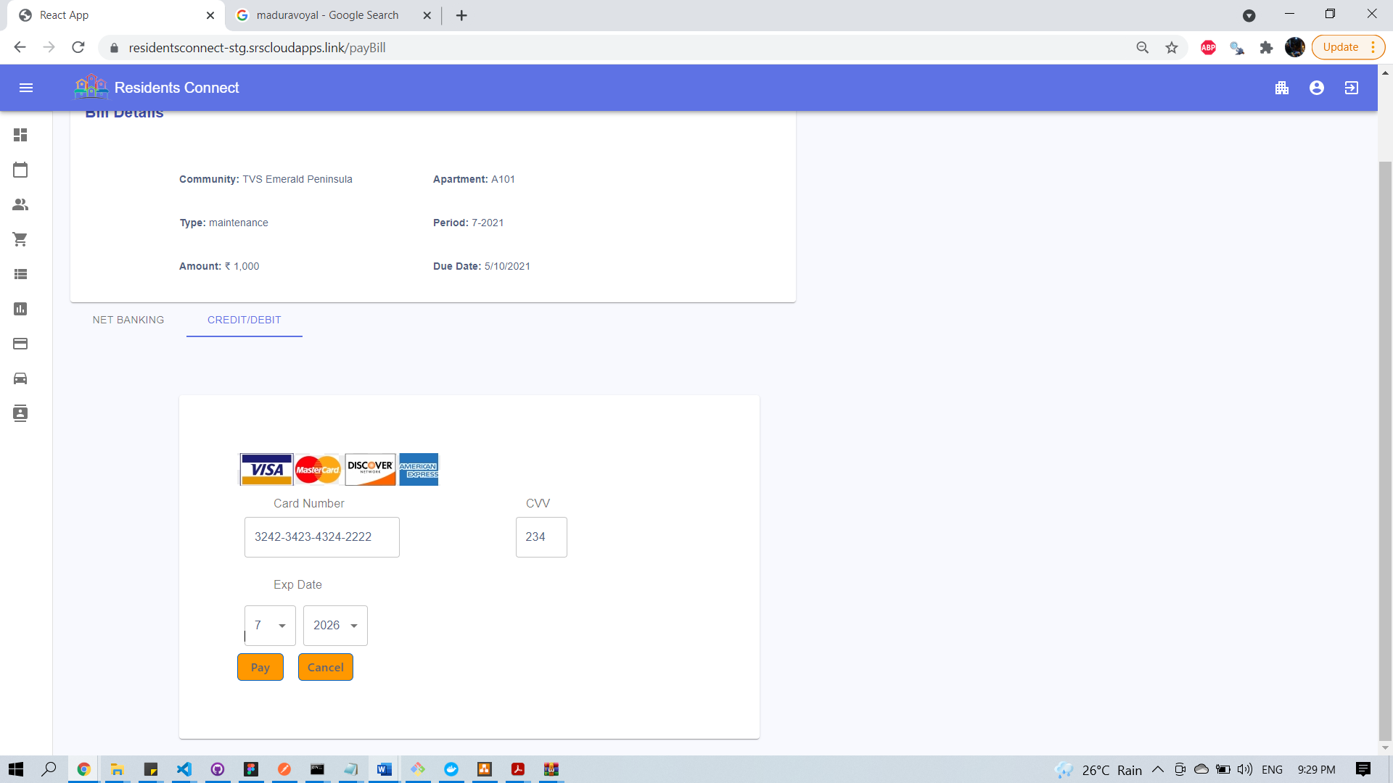

Transaction History – Residents/Admin

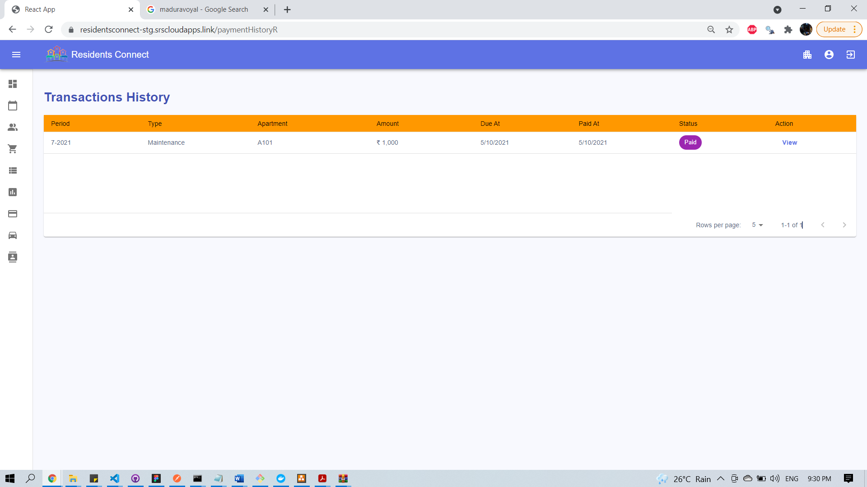

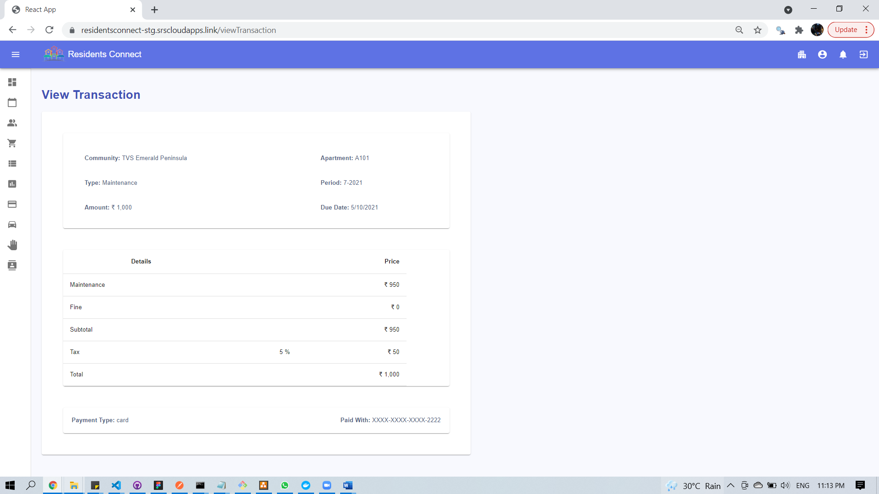

### 15.2.10 Polling

Poll Overview

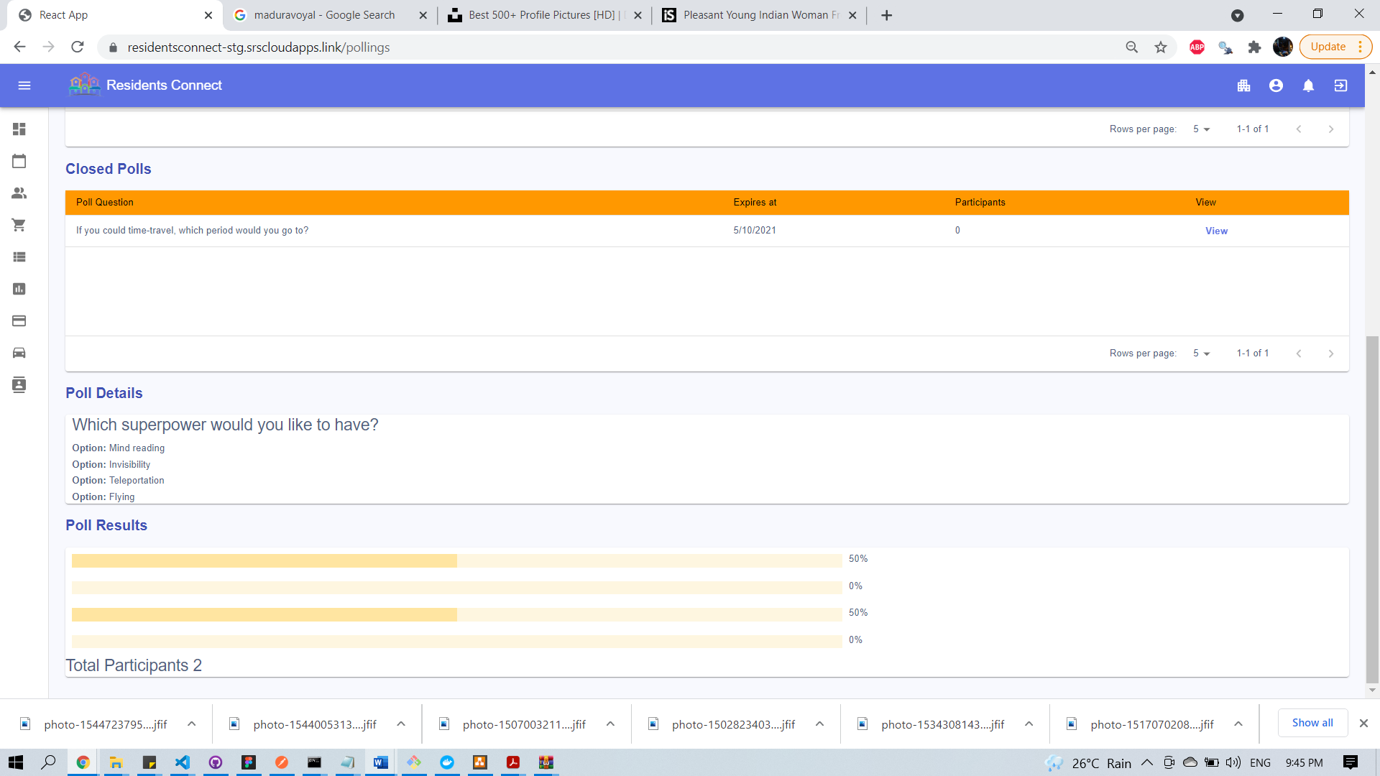

Create Poll

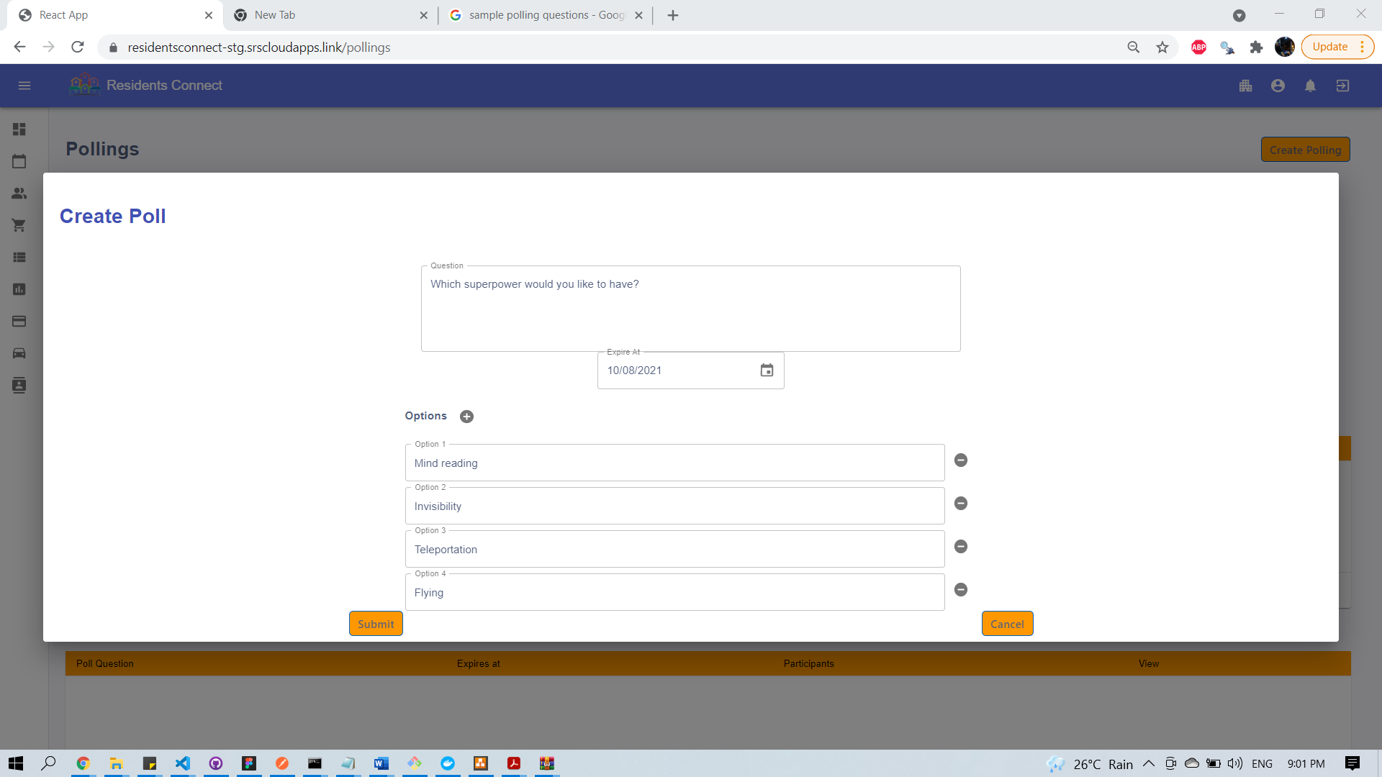

Pool Submission

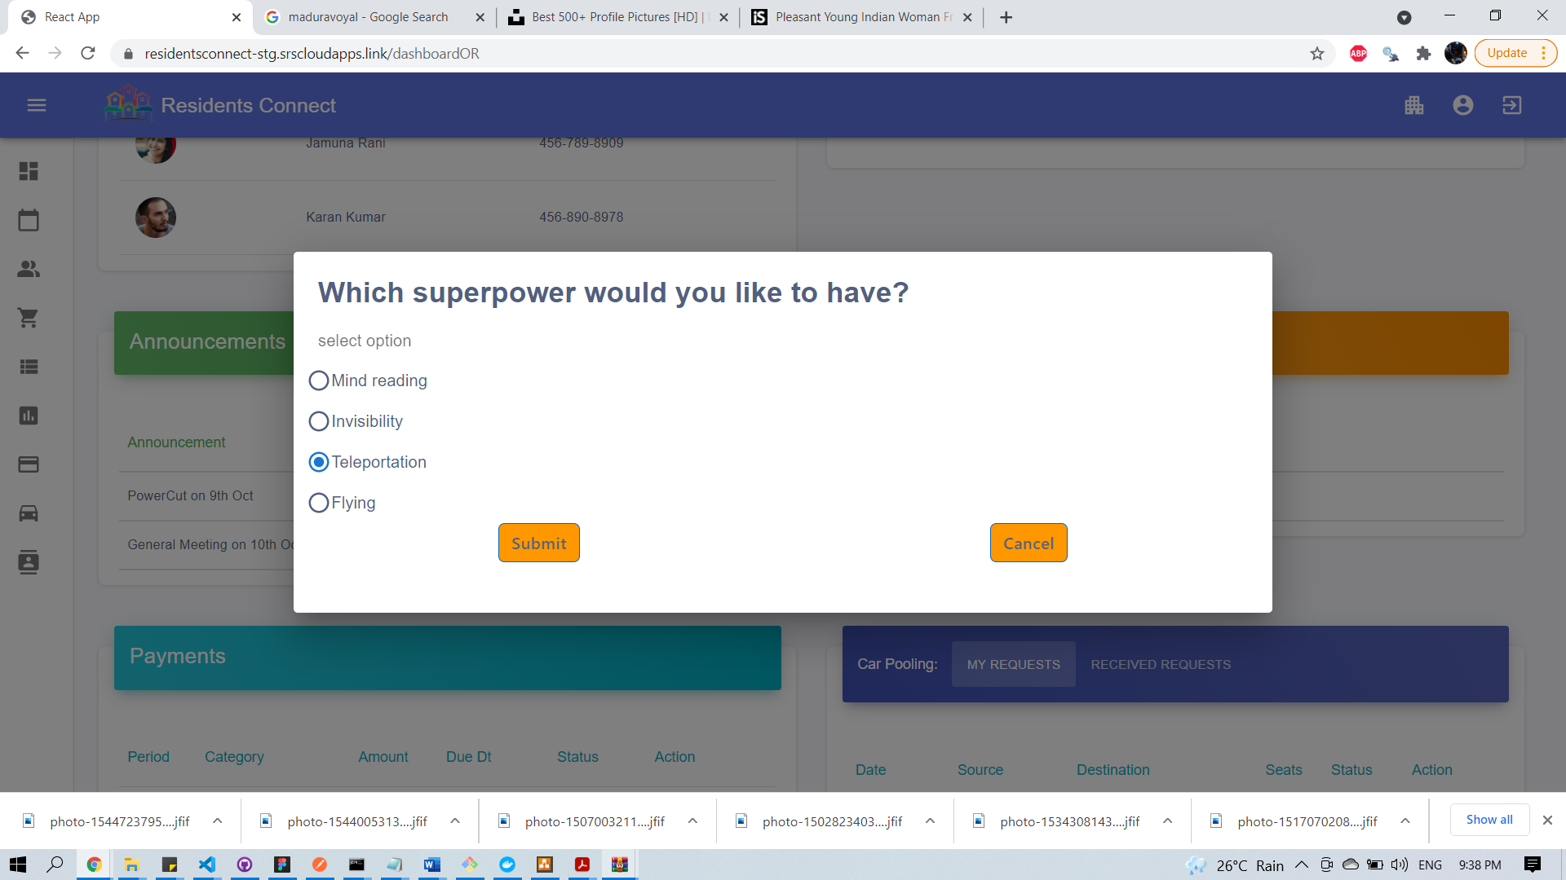

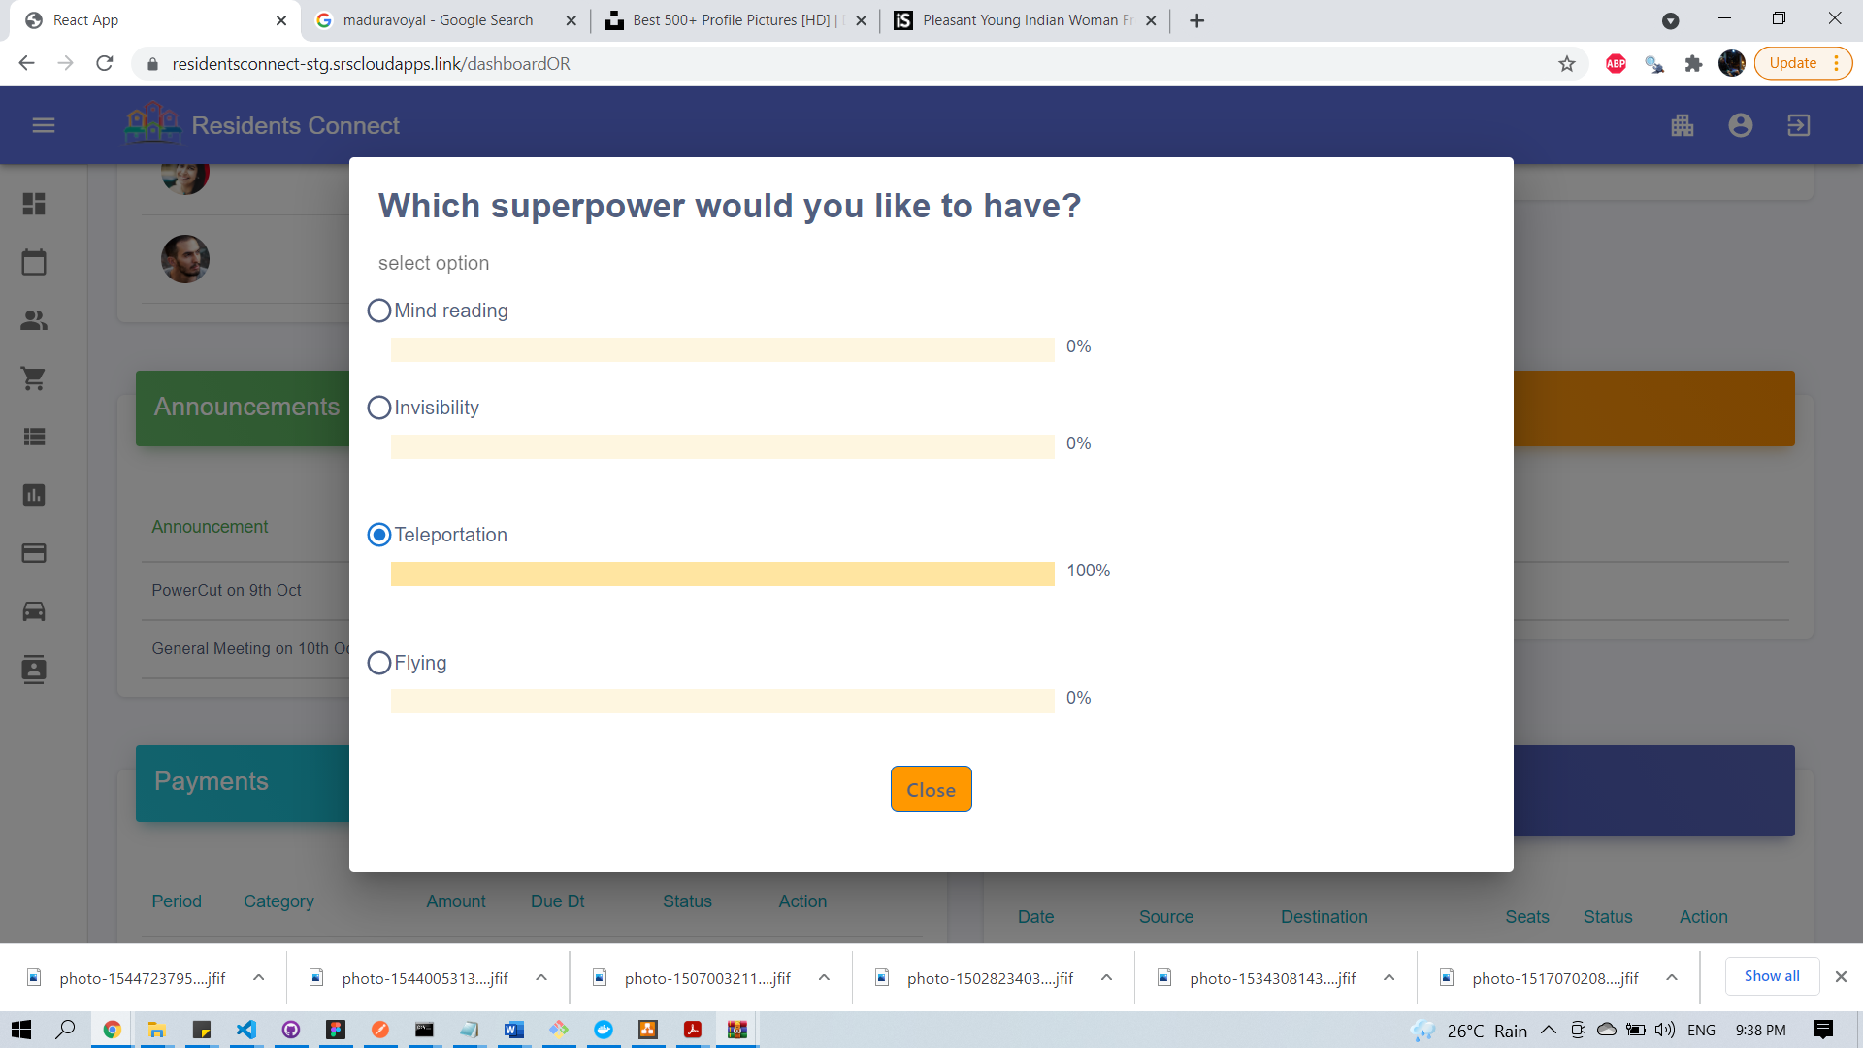

### 15.2.11 Classifieds

Add Classified:

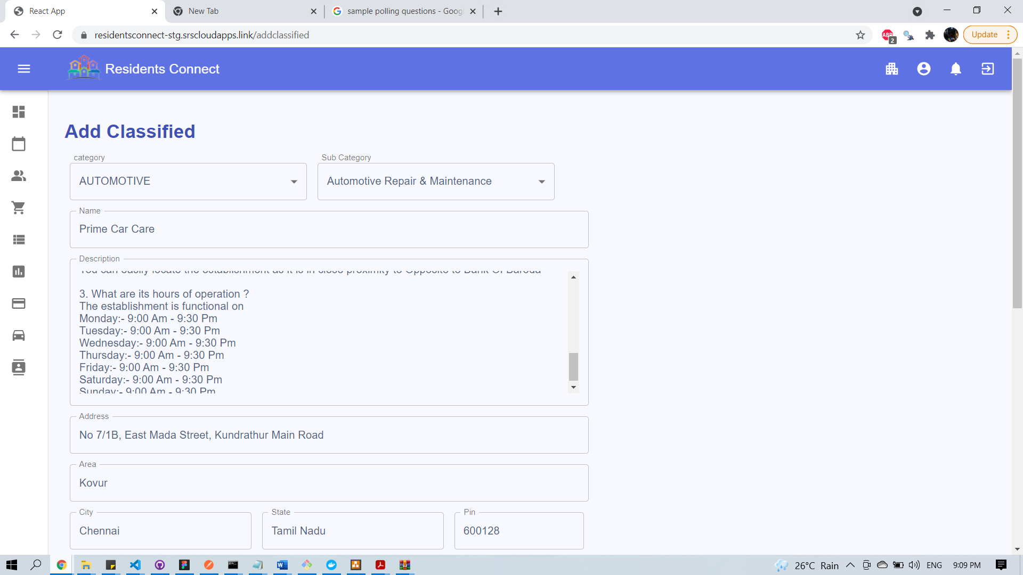

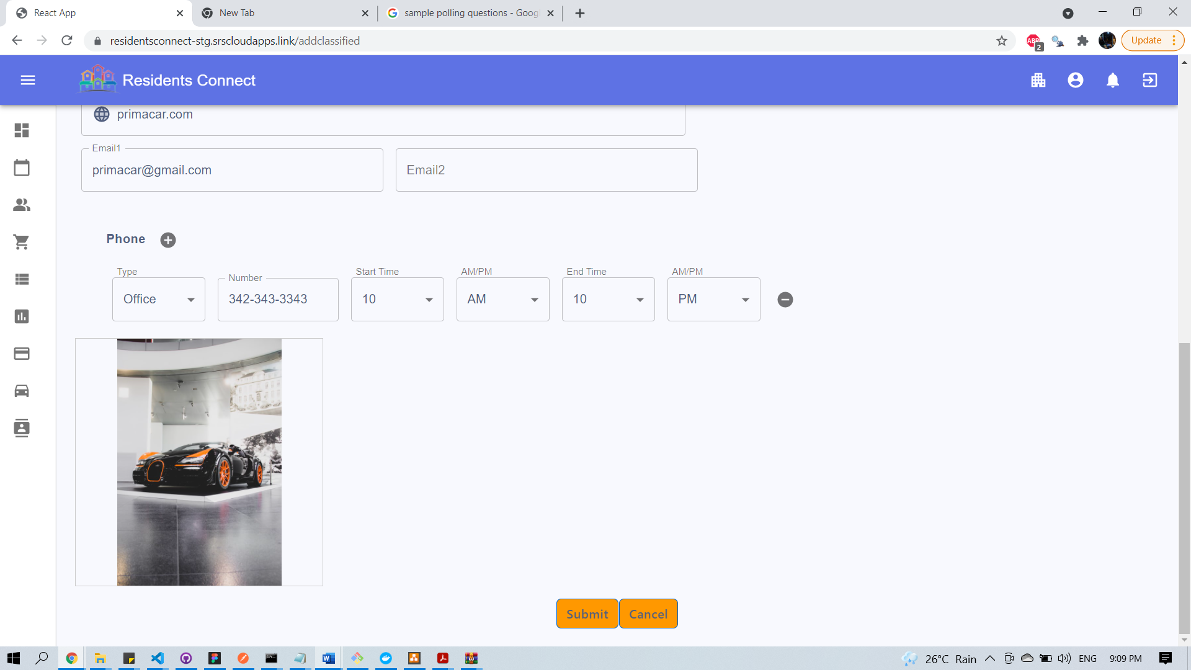

View/Filter Classified

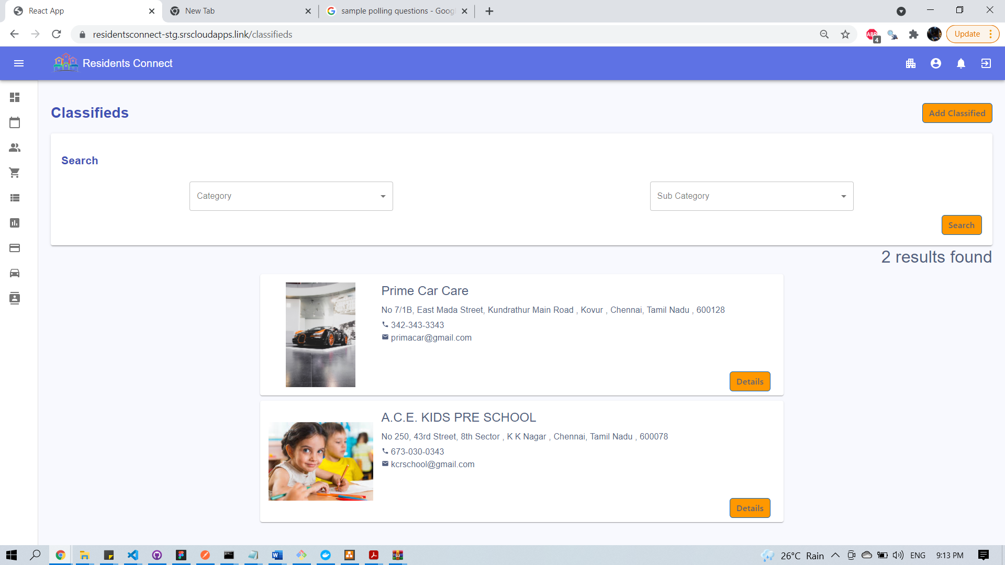

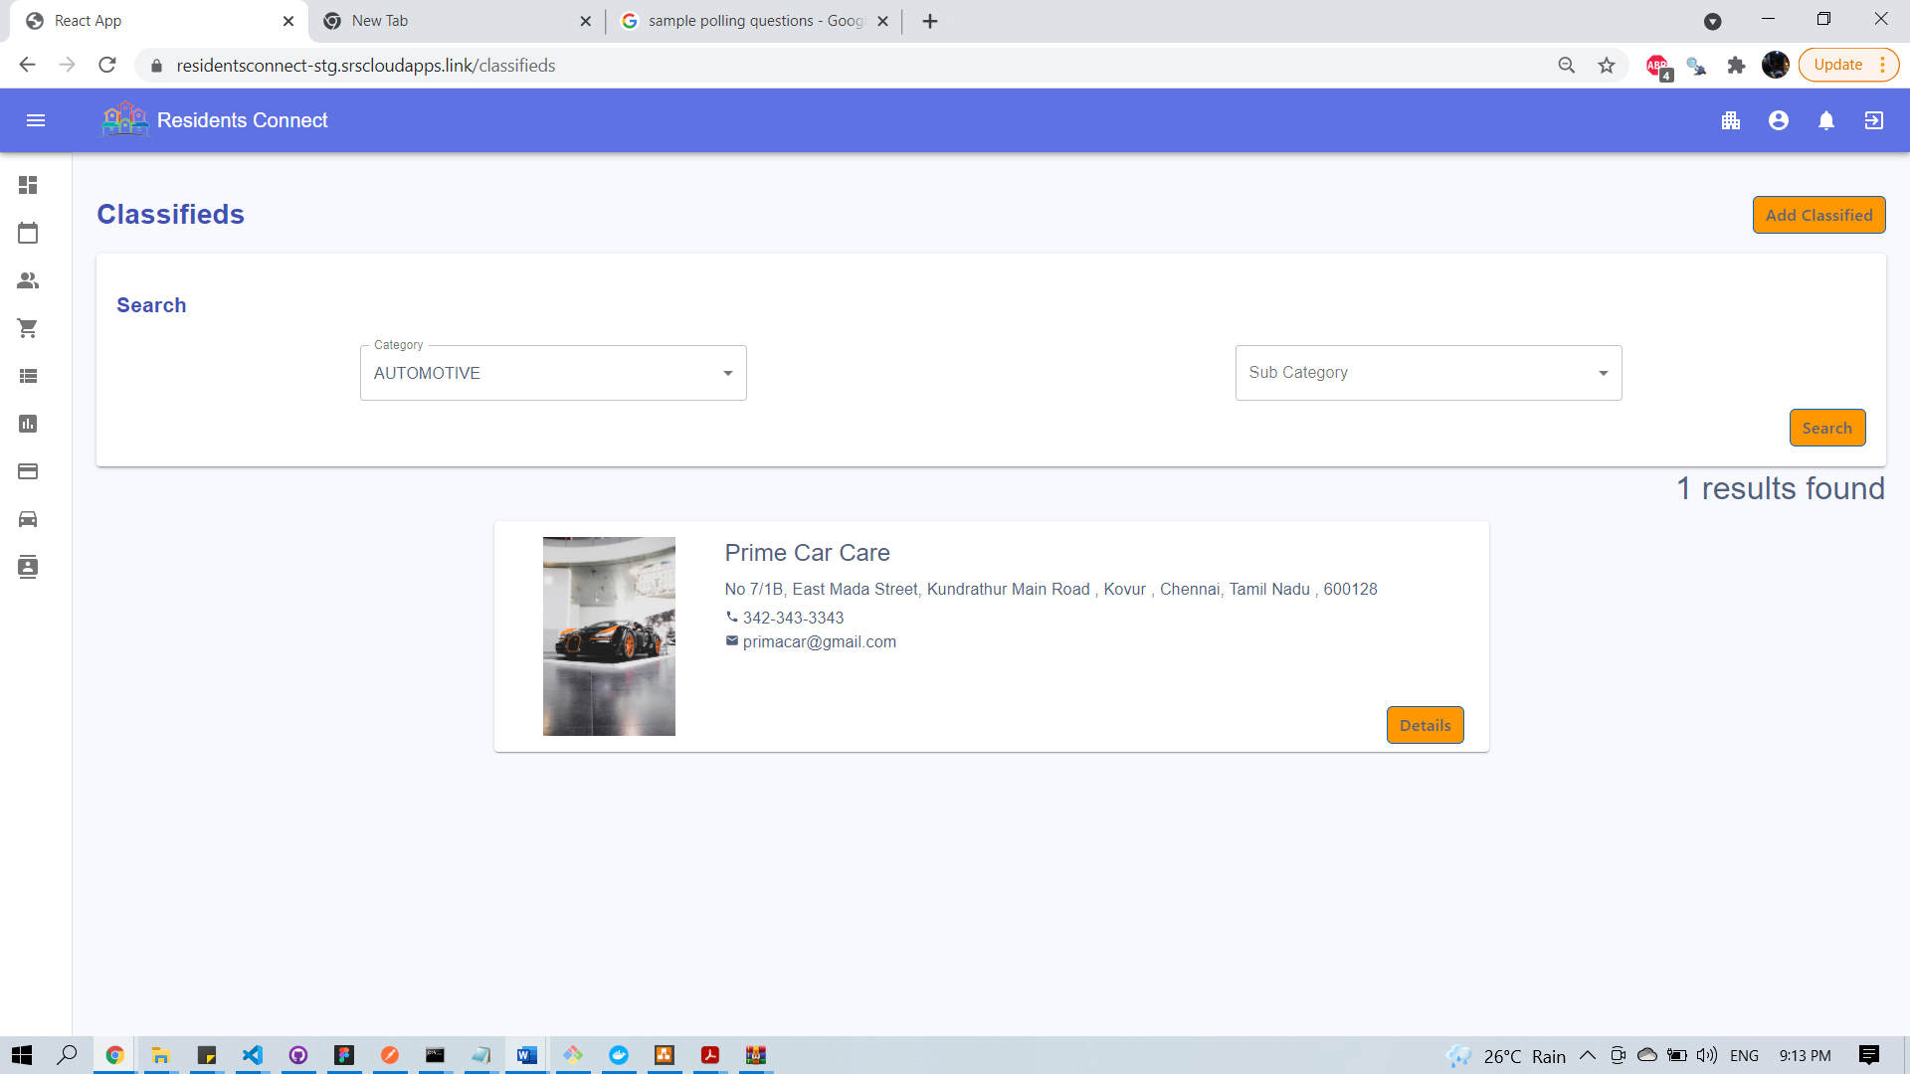

Show Classified Details

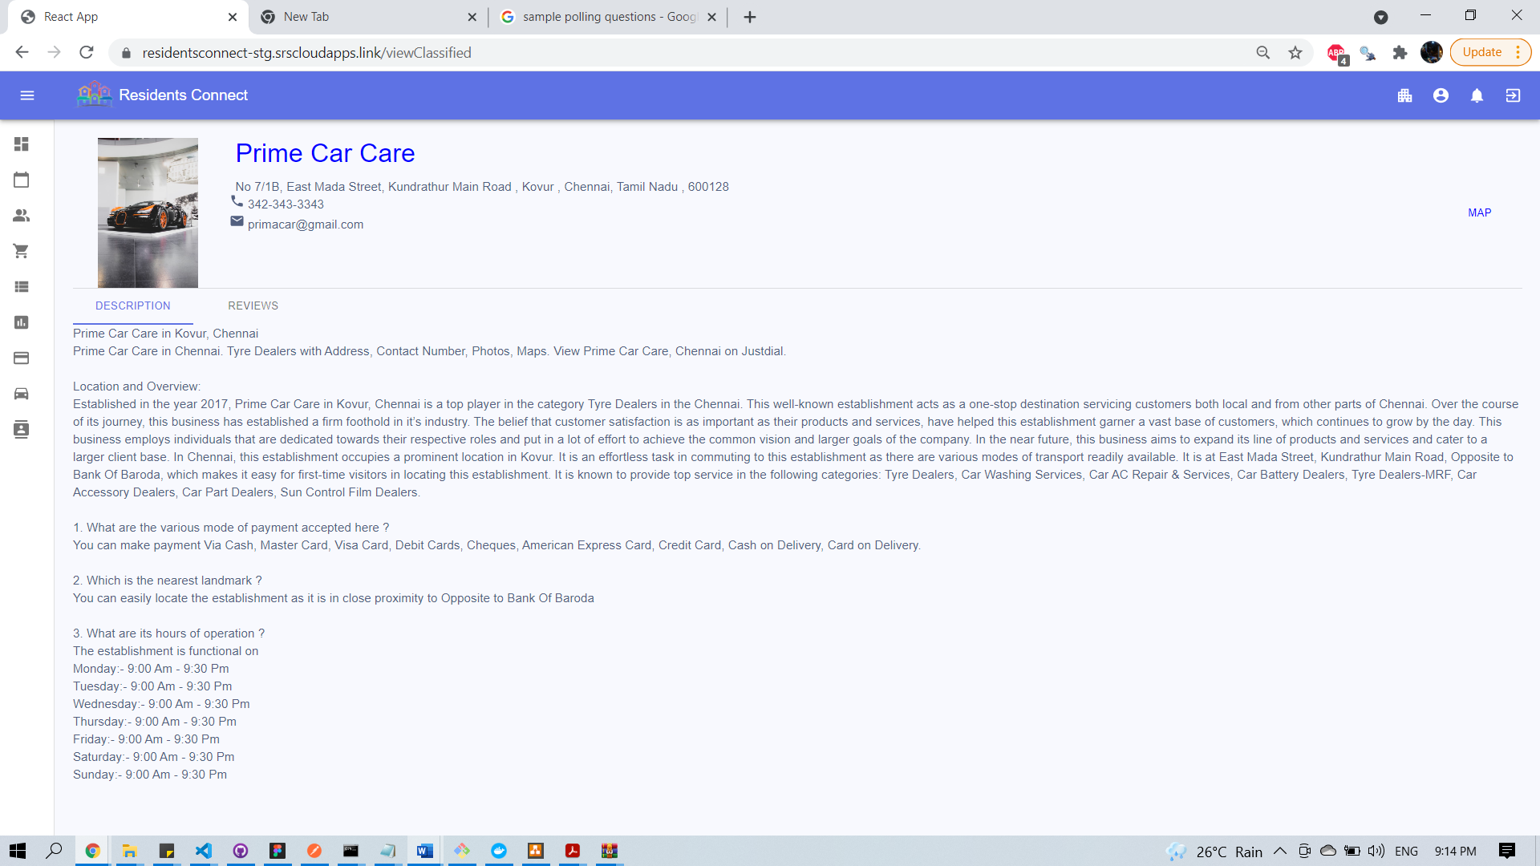

Rate & Provide Feedback

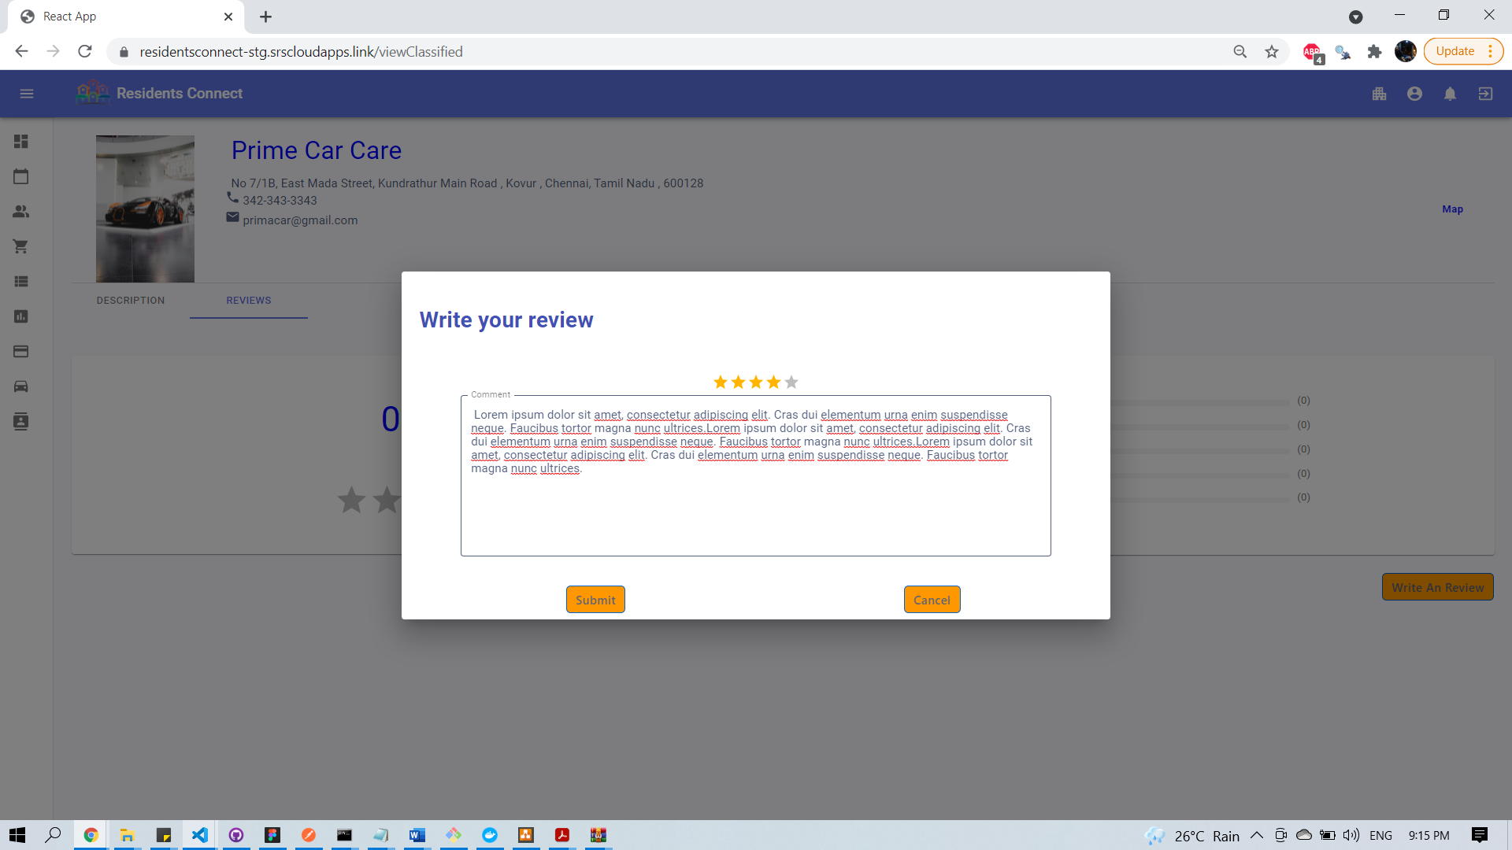

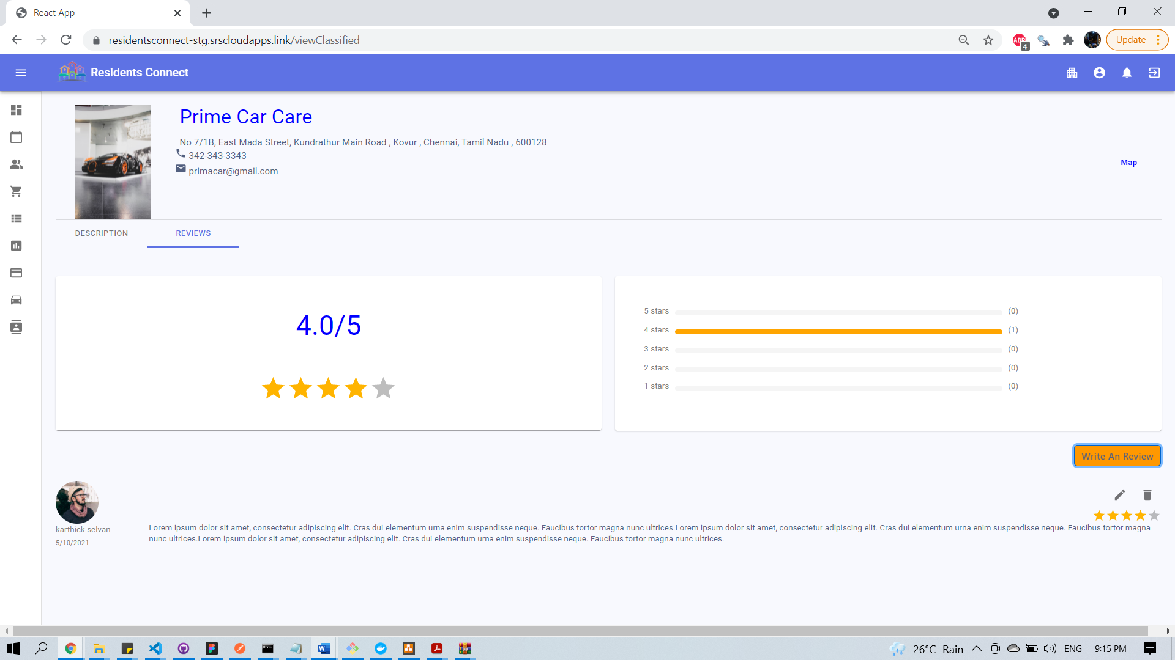

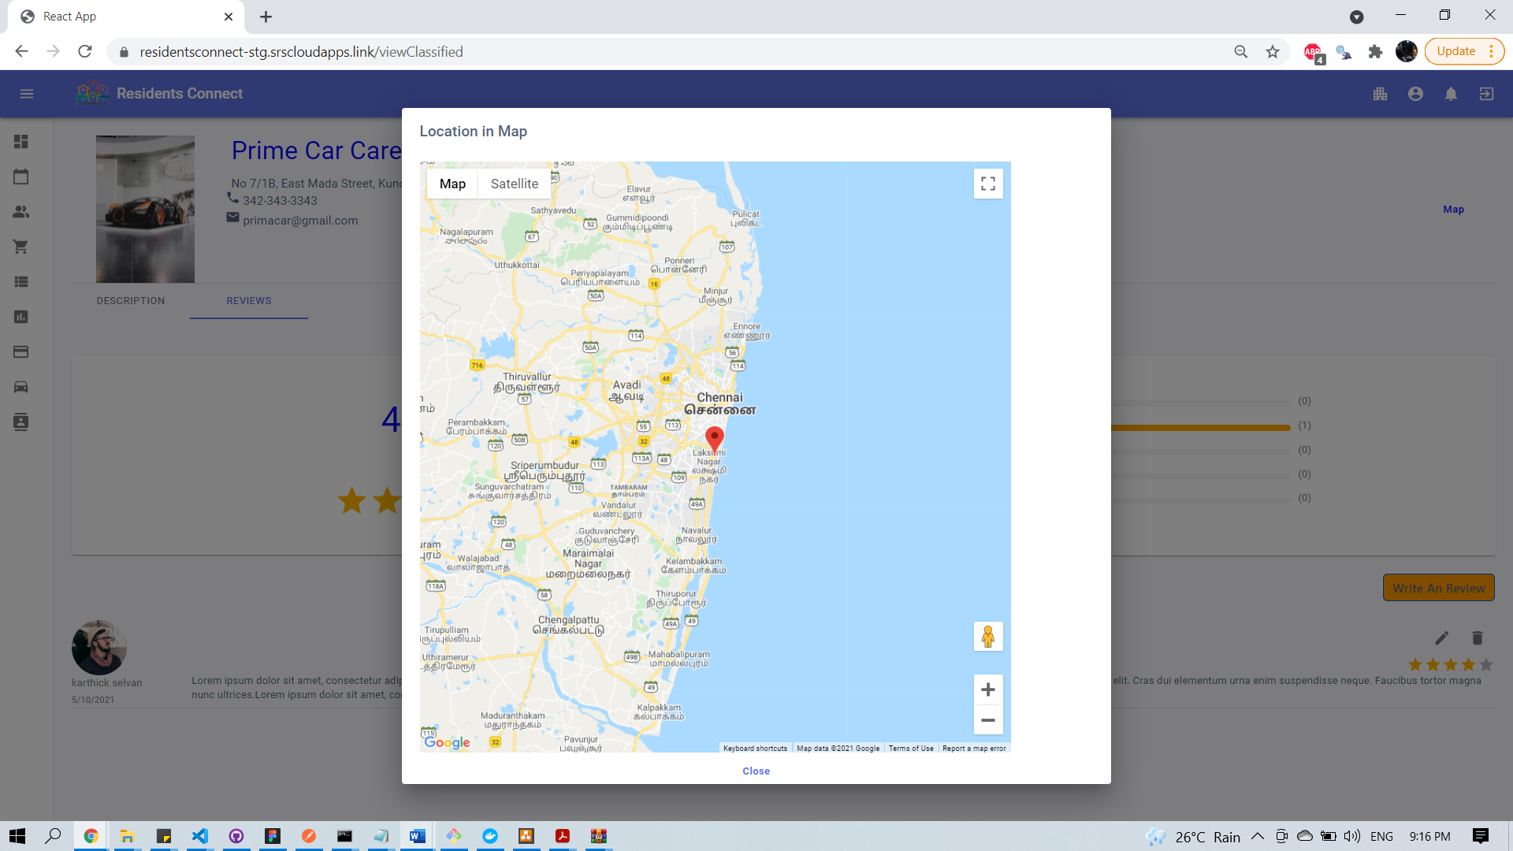

### 15.2.12 Car Pooling

Create Car Pool ride:

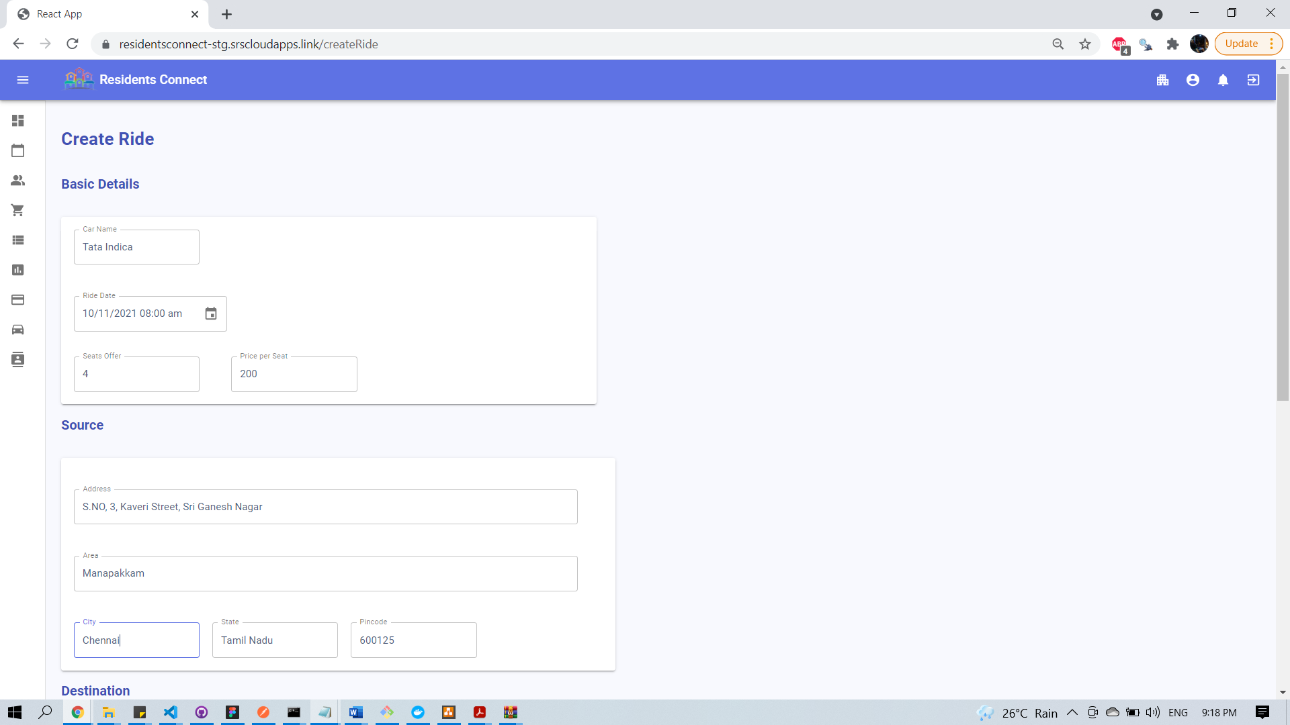

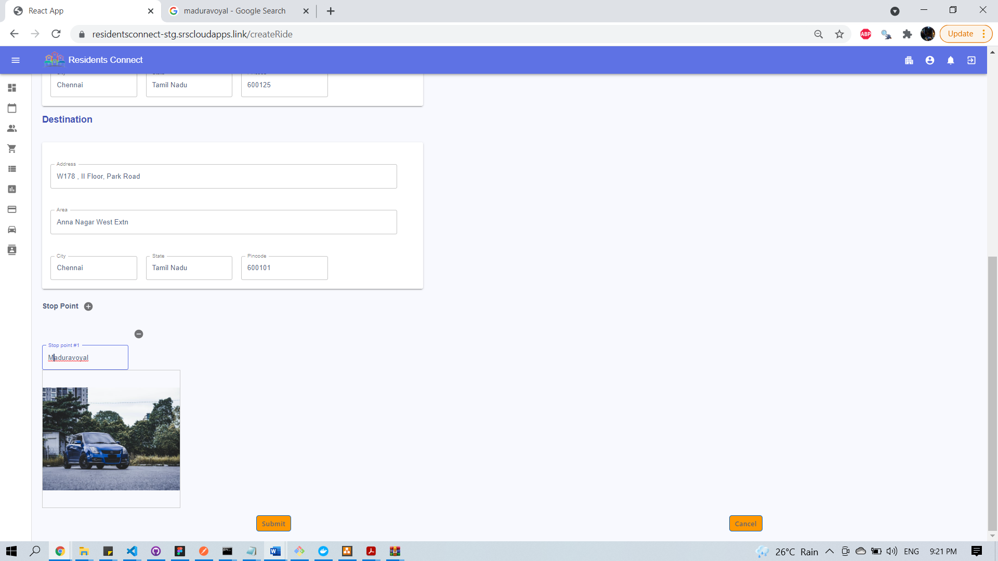

View your Rides

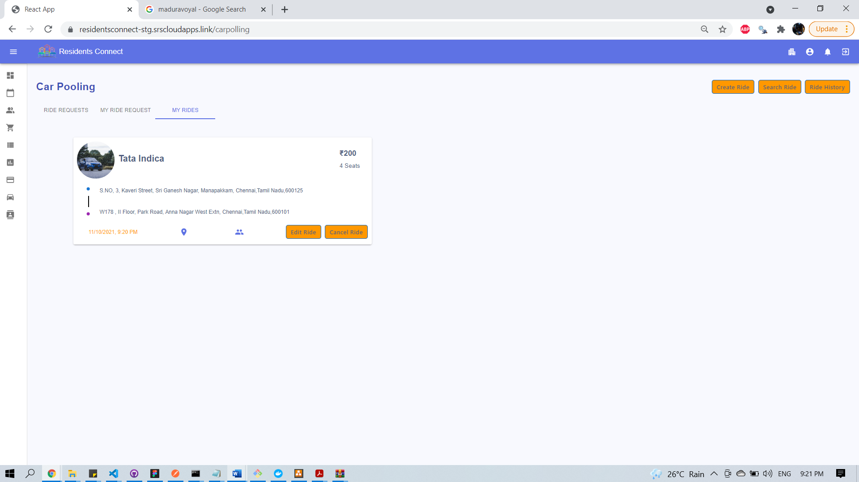

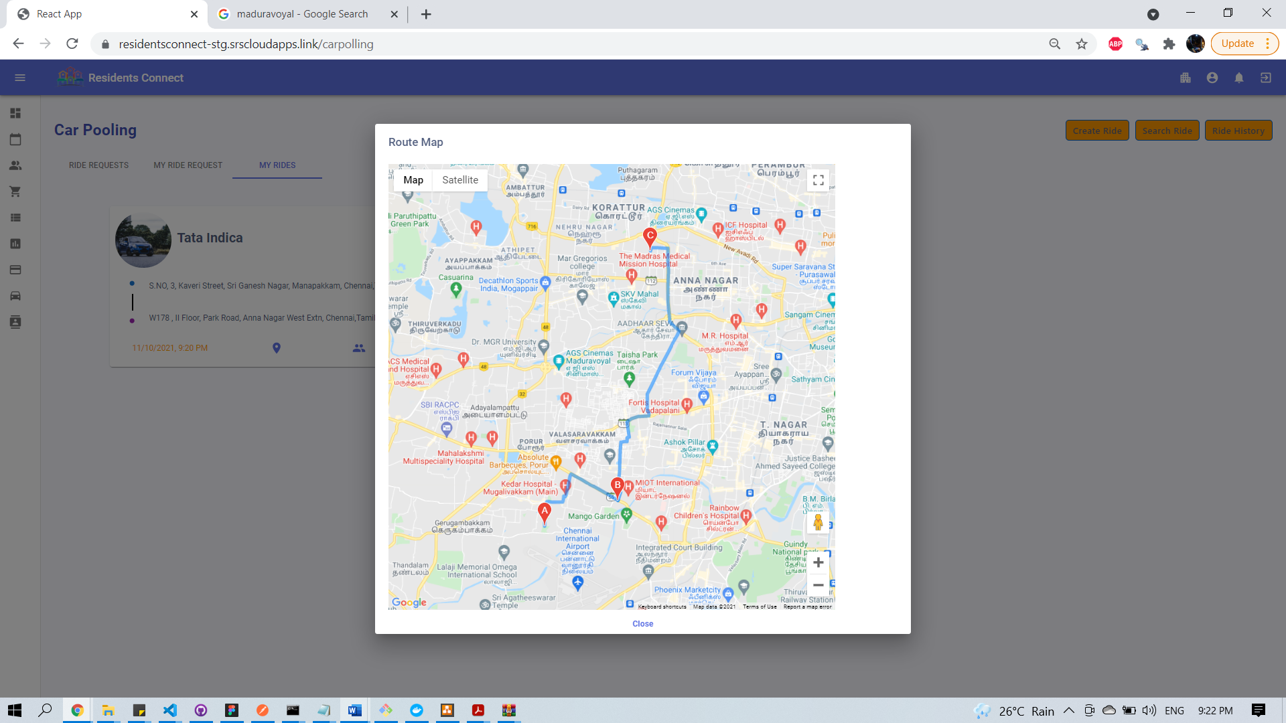

Search -CarPool Ride

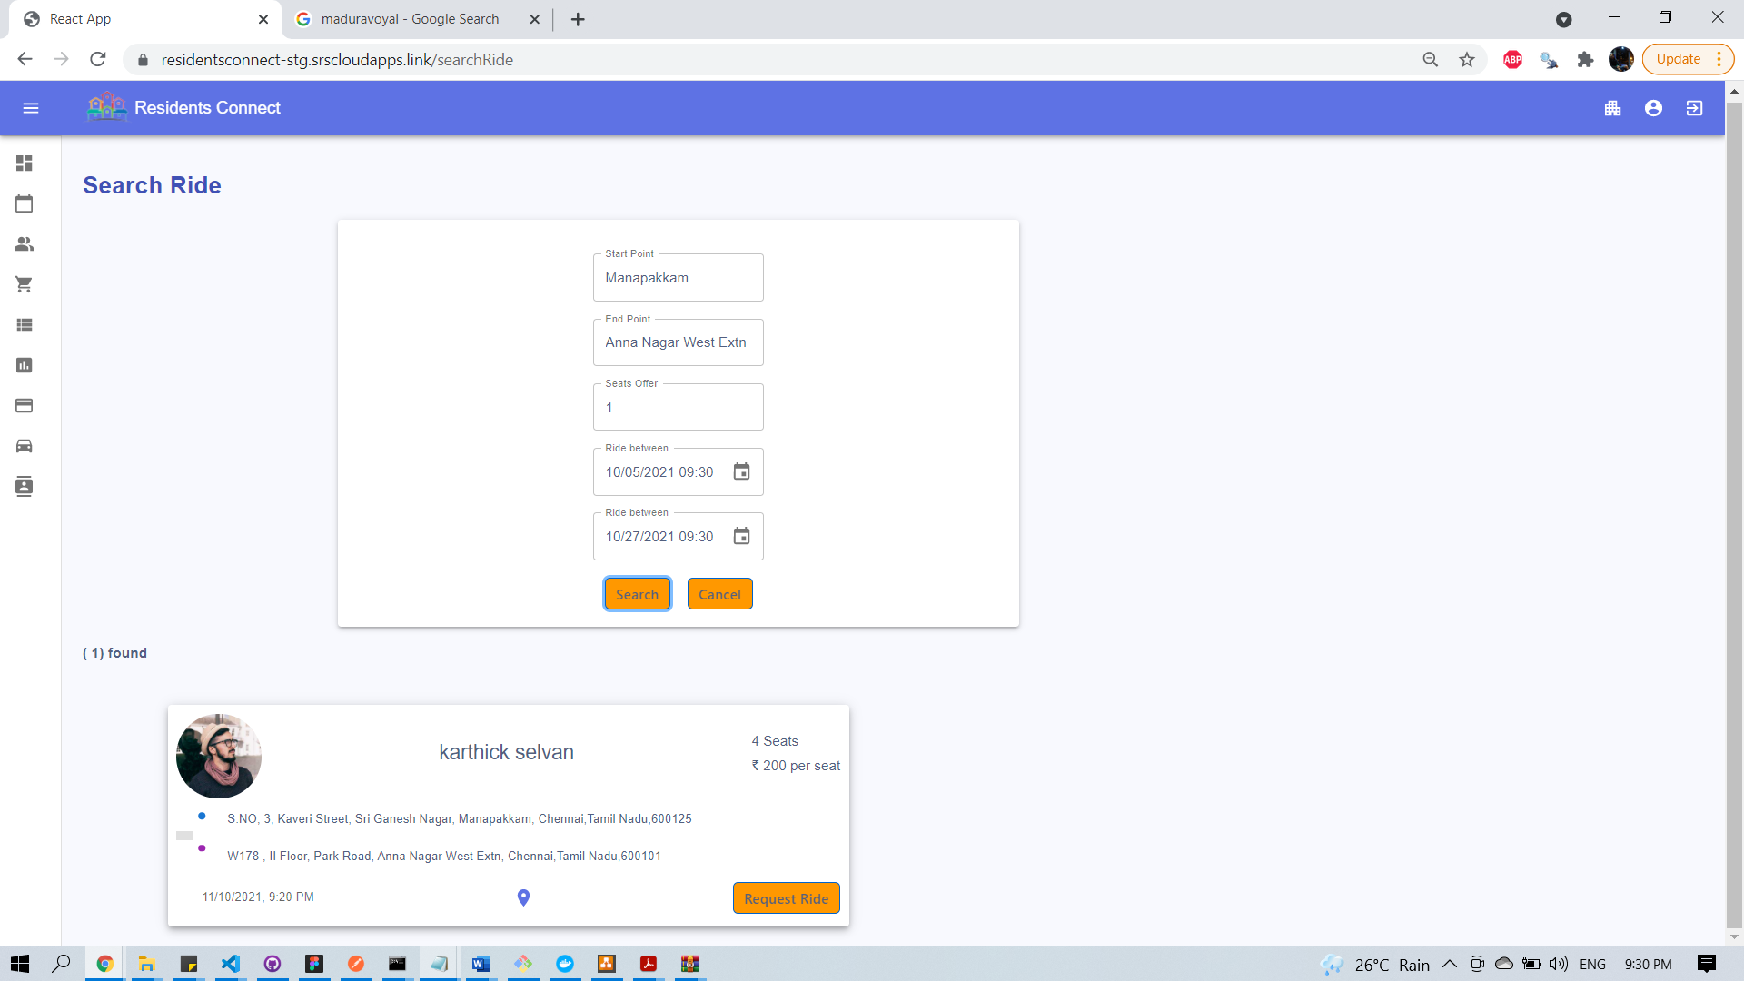

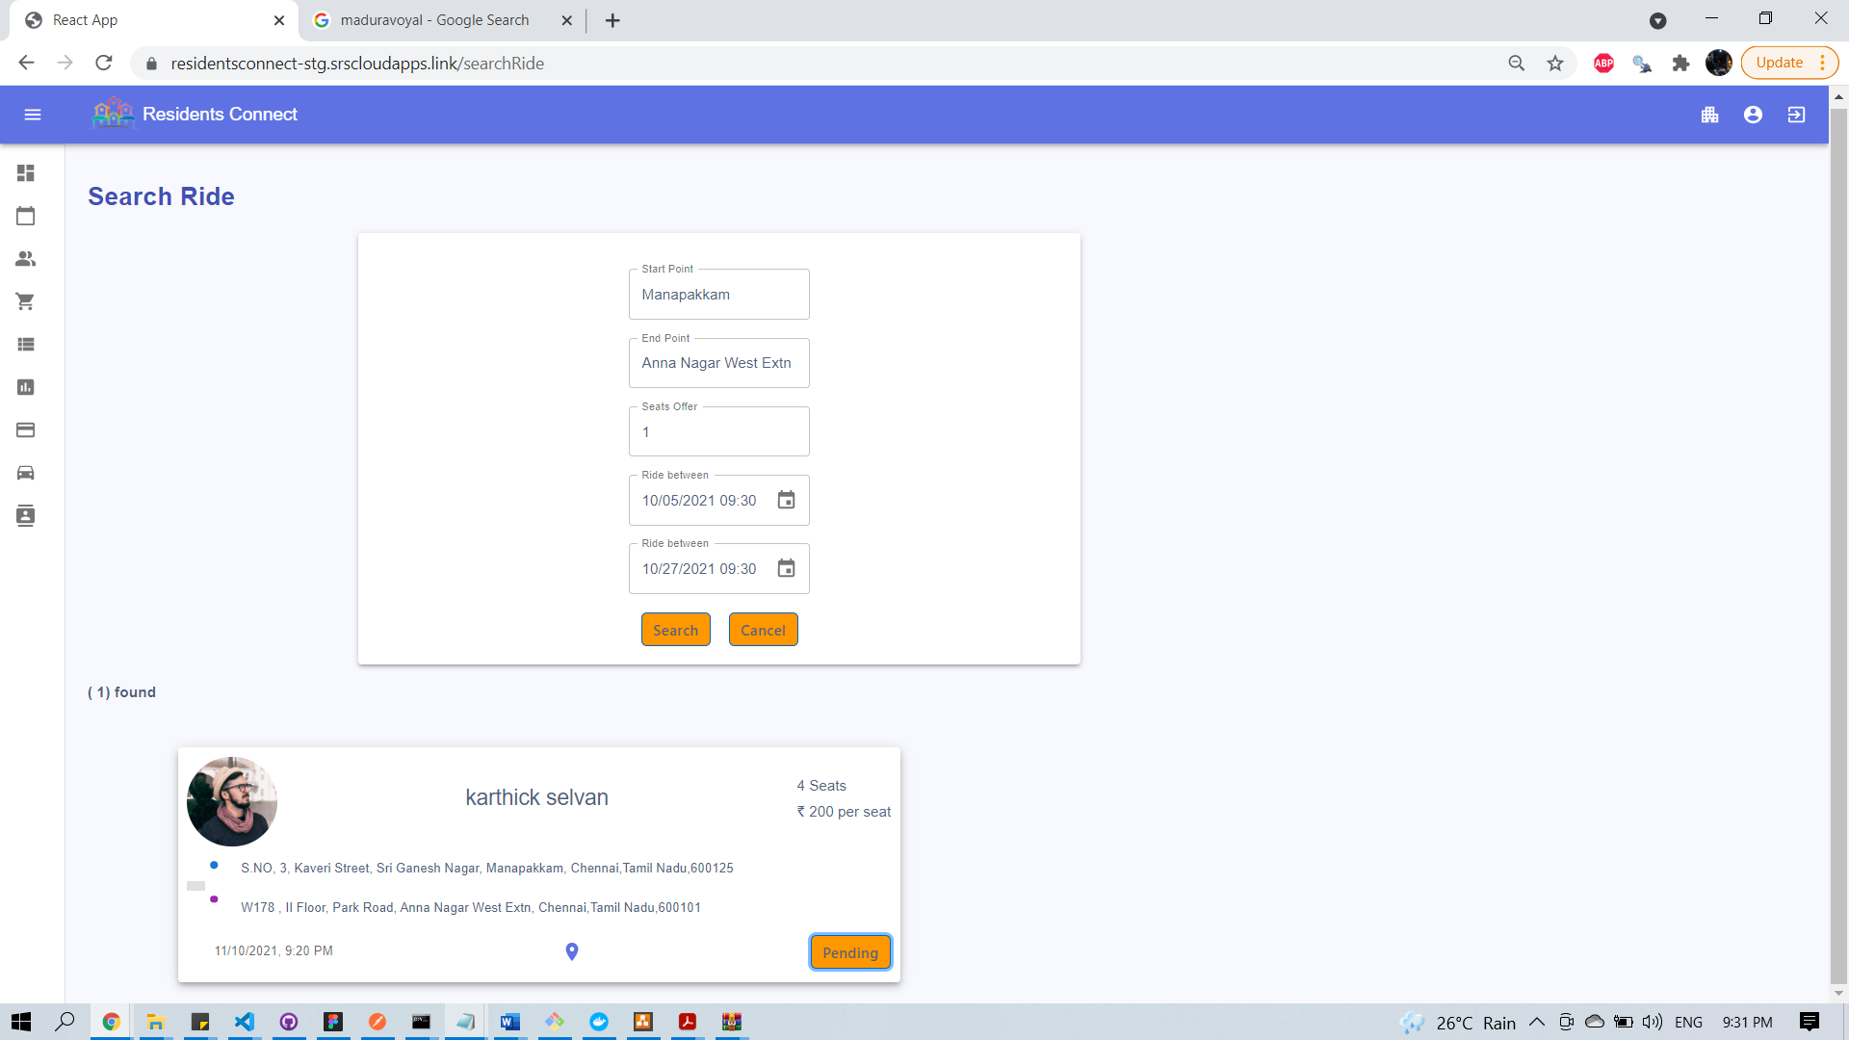

View Your Ride Request – Ride request raised by you. Ride owner can accept/reject request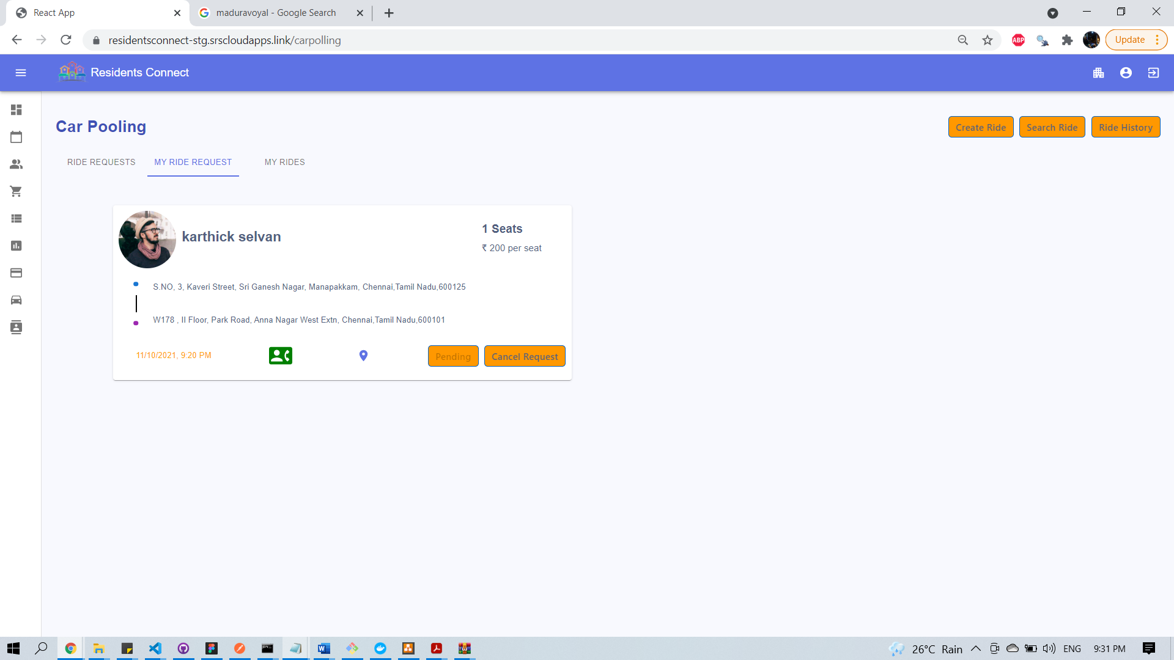

View Received requests, received for your rides (you are the owner of the ride). Ride owner can approve/reject ride

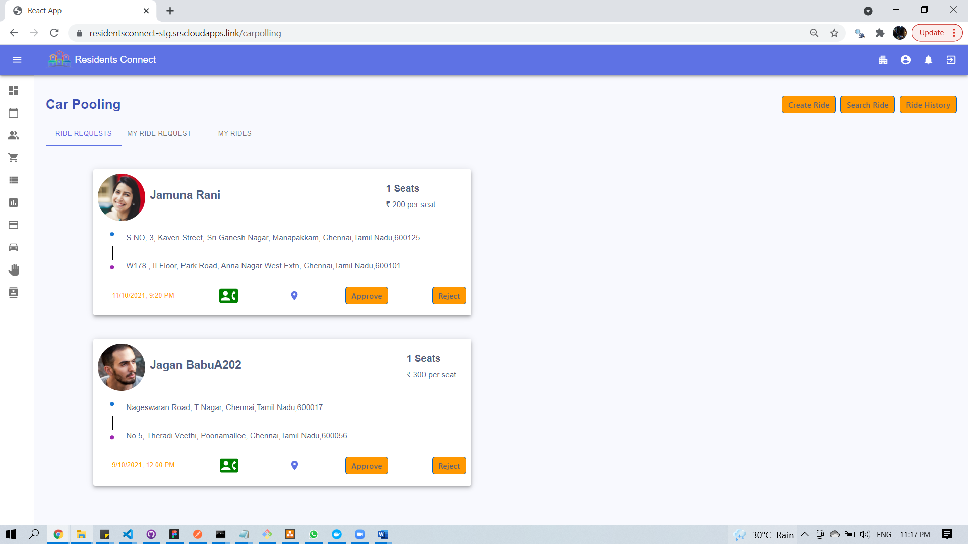

Ride History:

Cancelled/Closed rides of yours are shown here

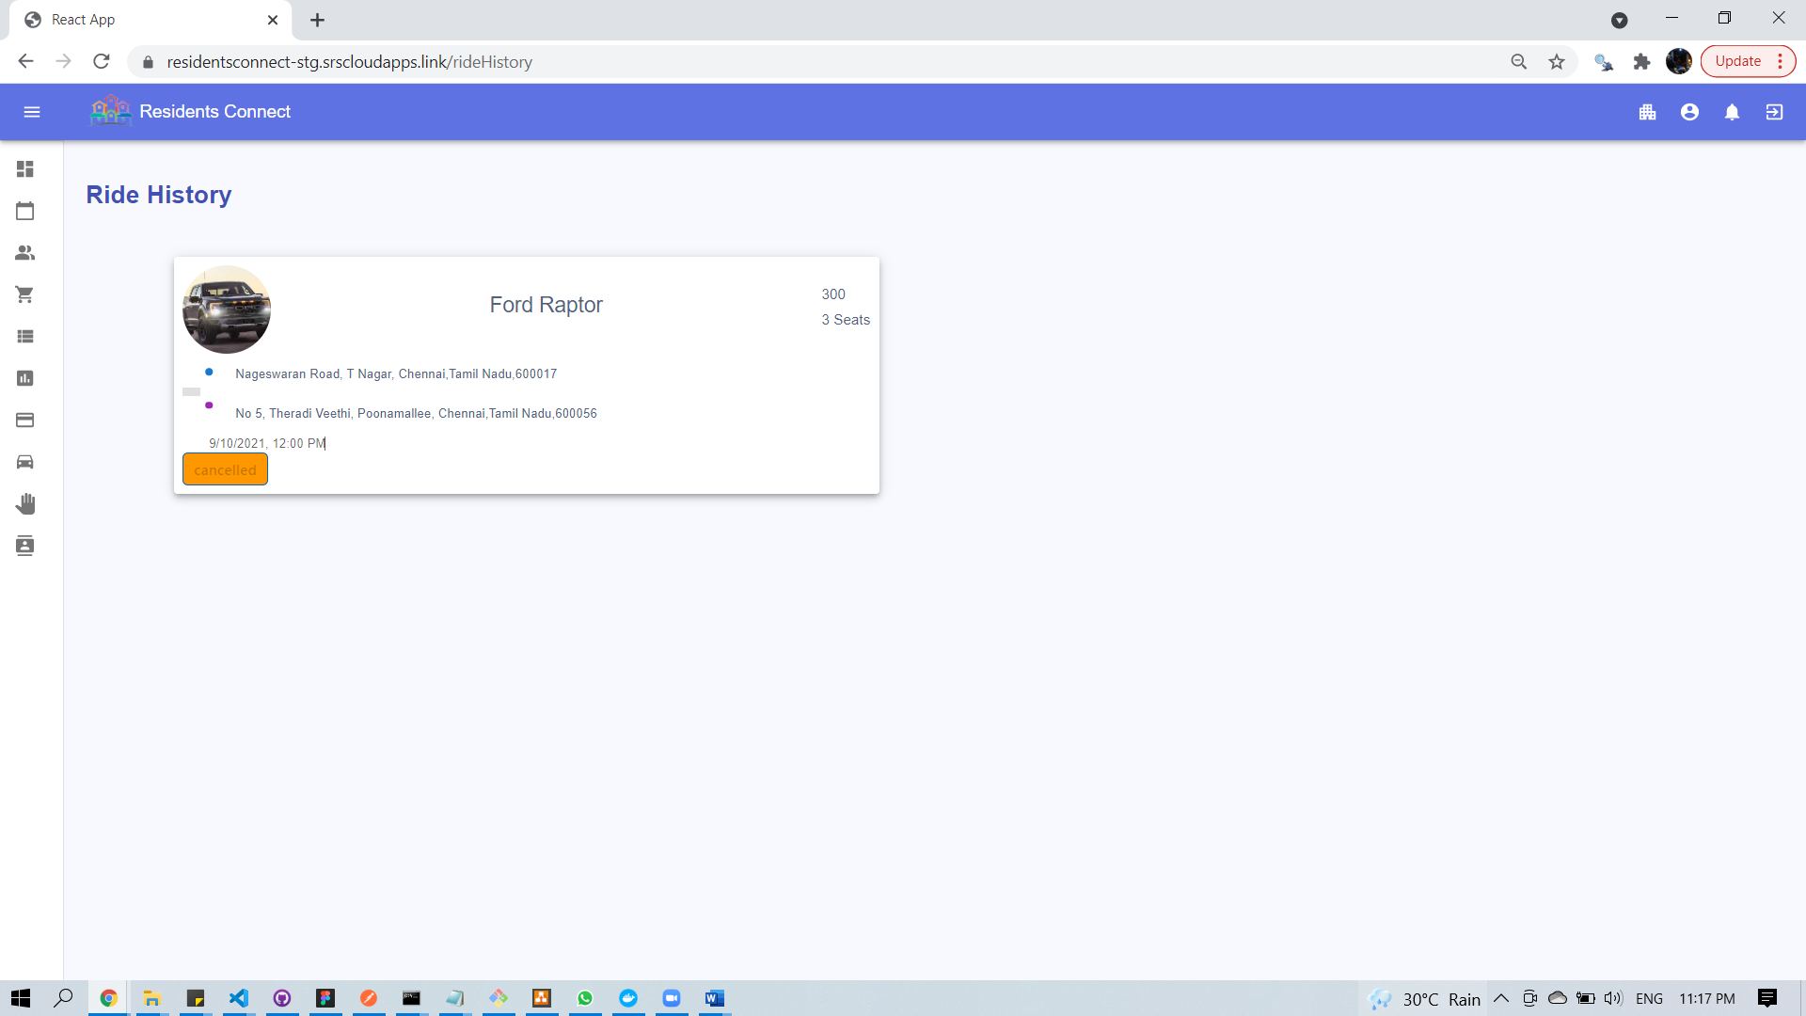

### 15.2.13 Chat Rooms

Create chatroom

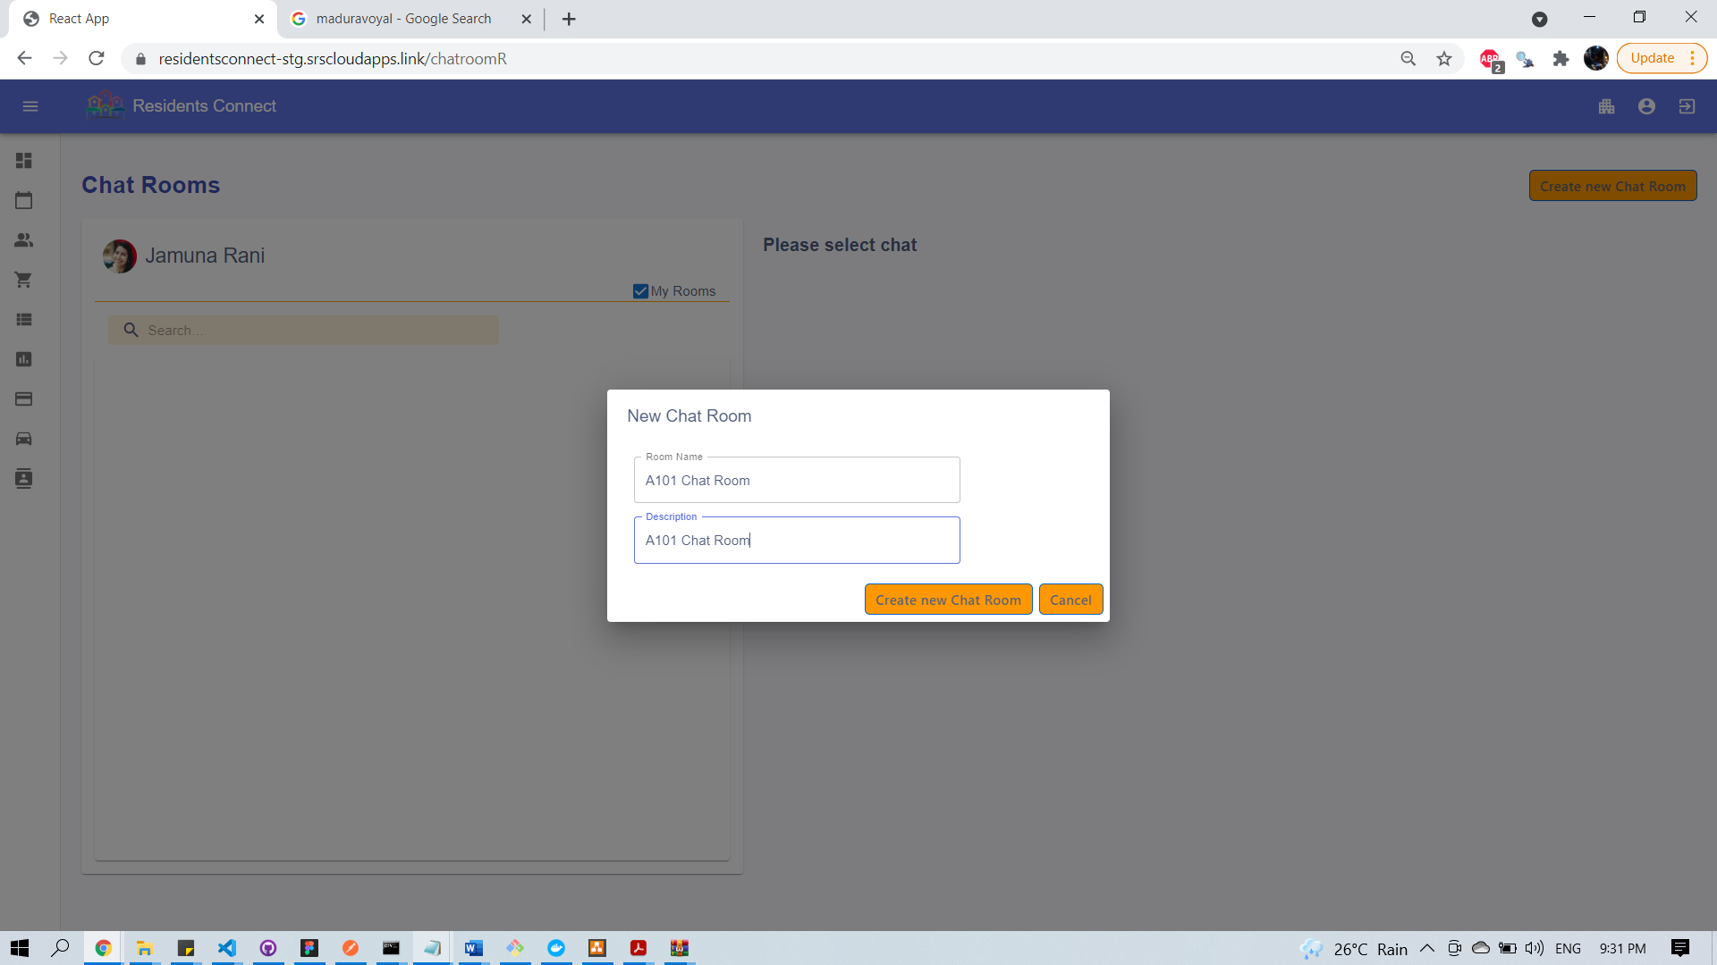

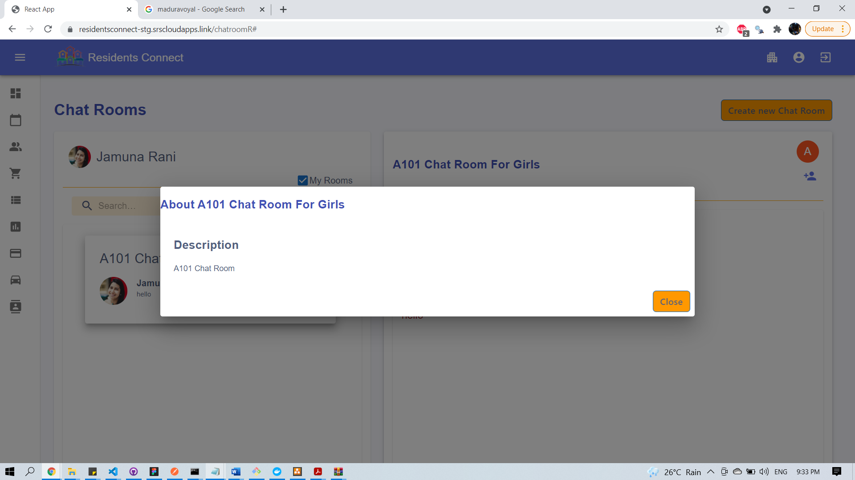

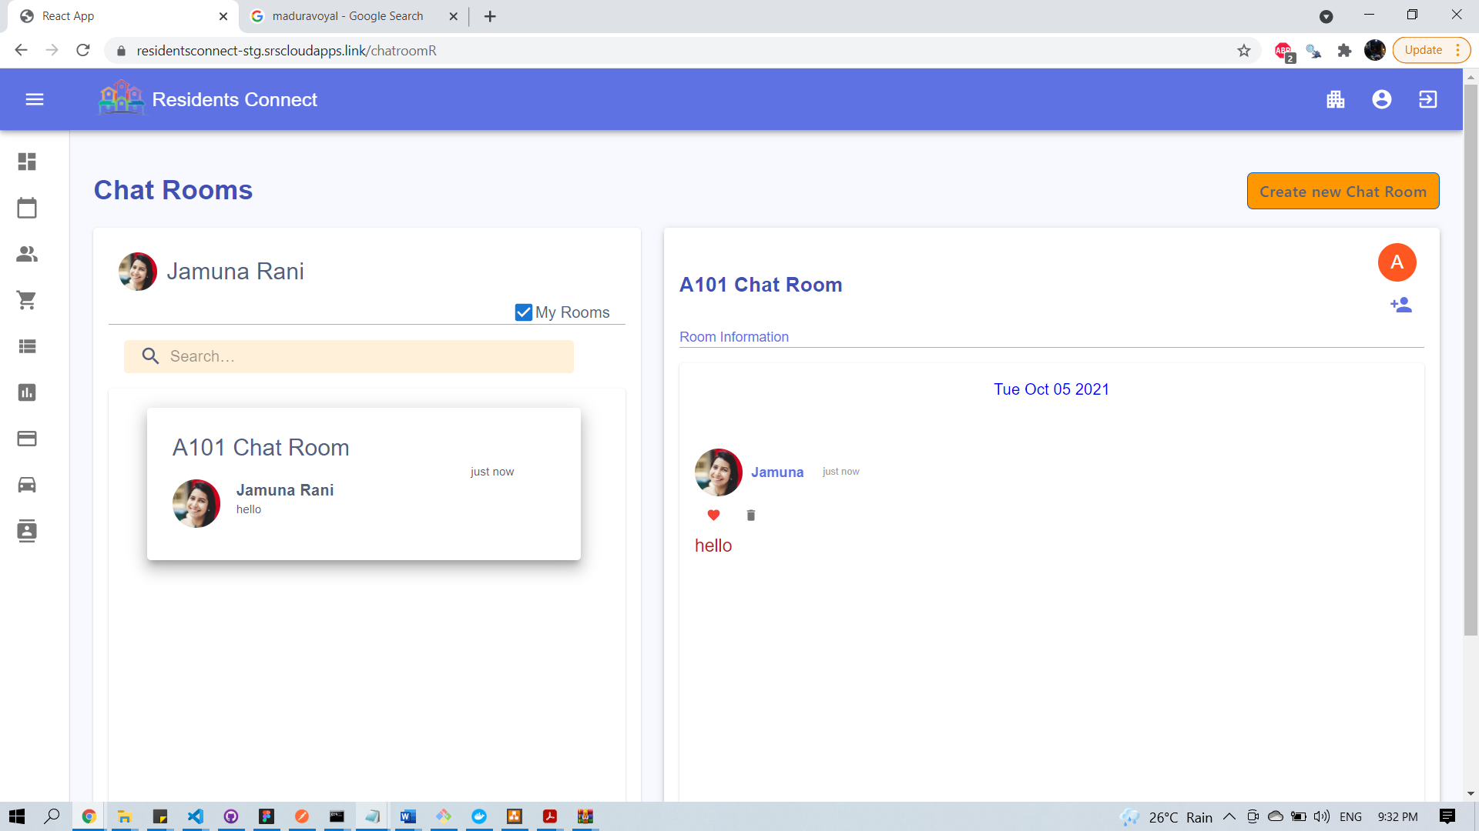

Edit Chat Room Details

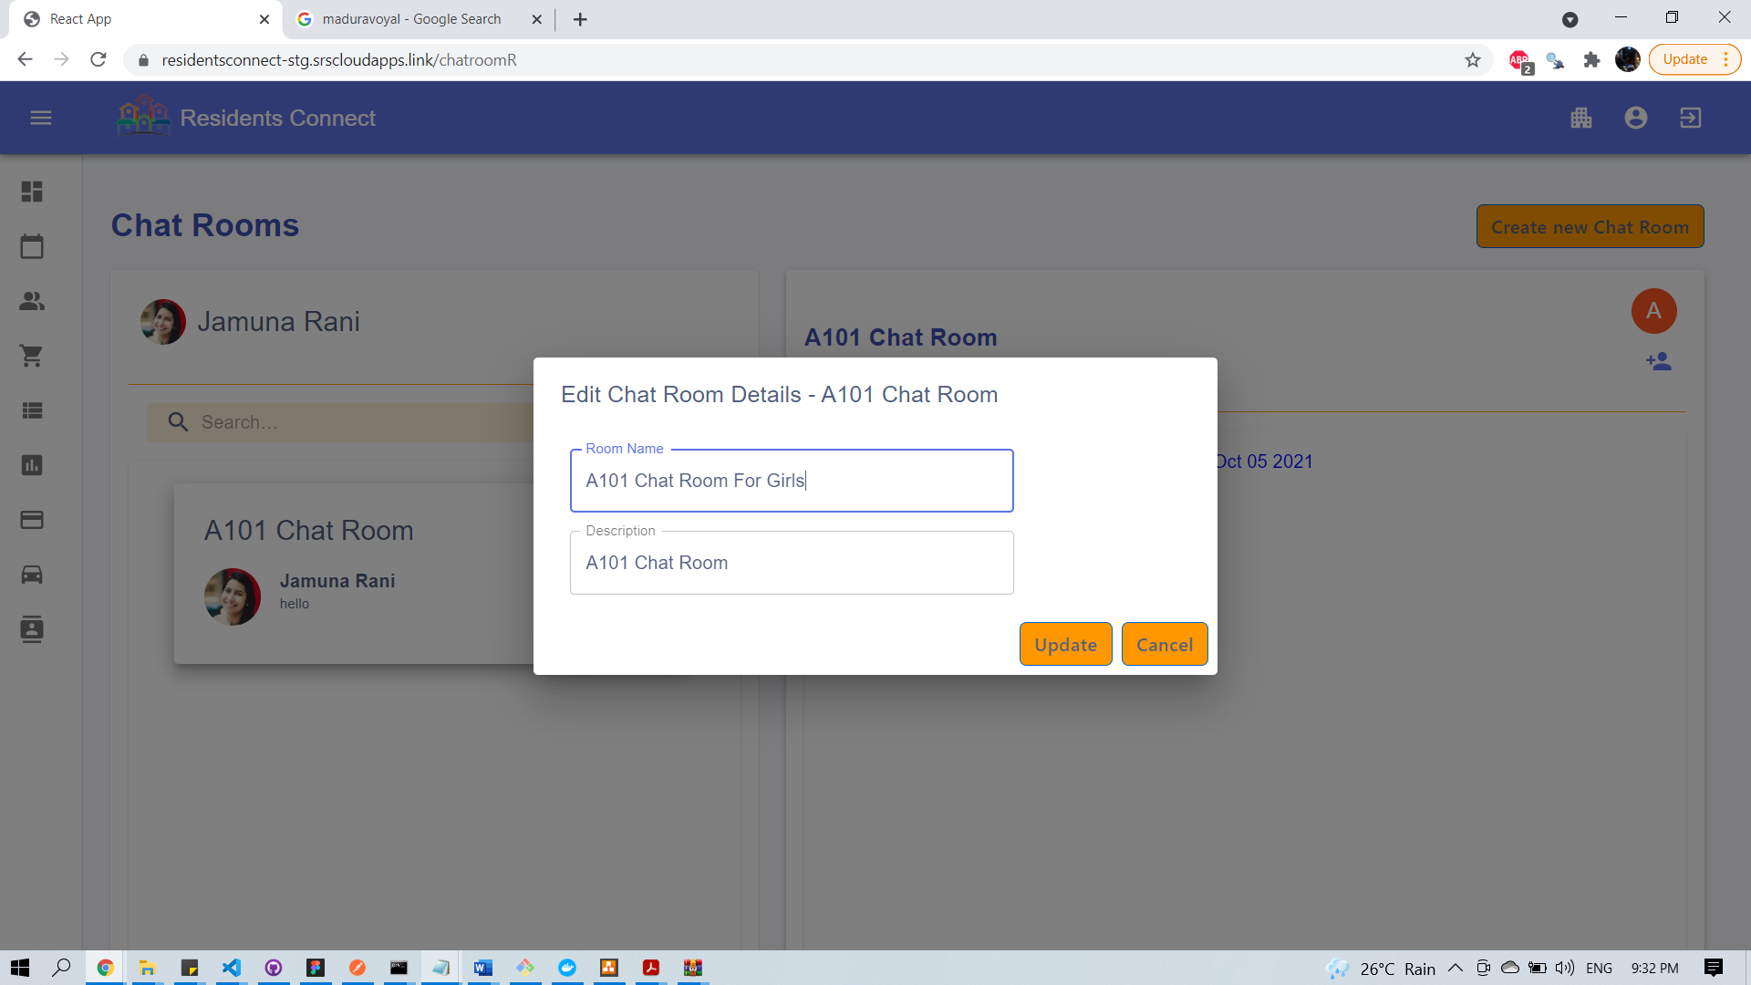

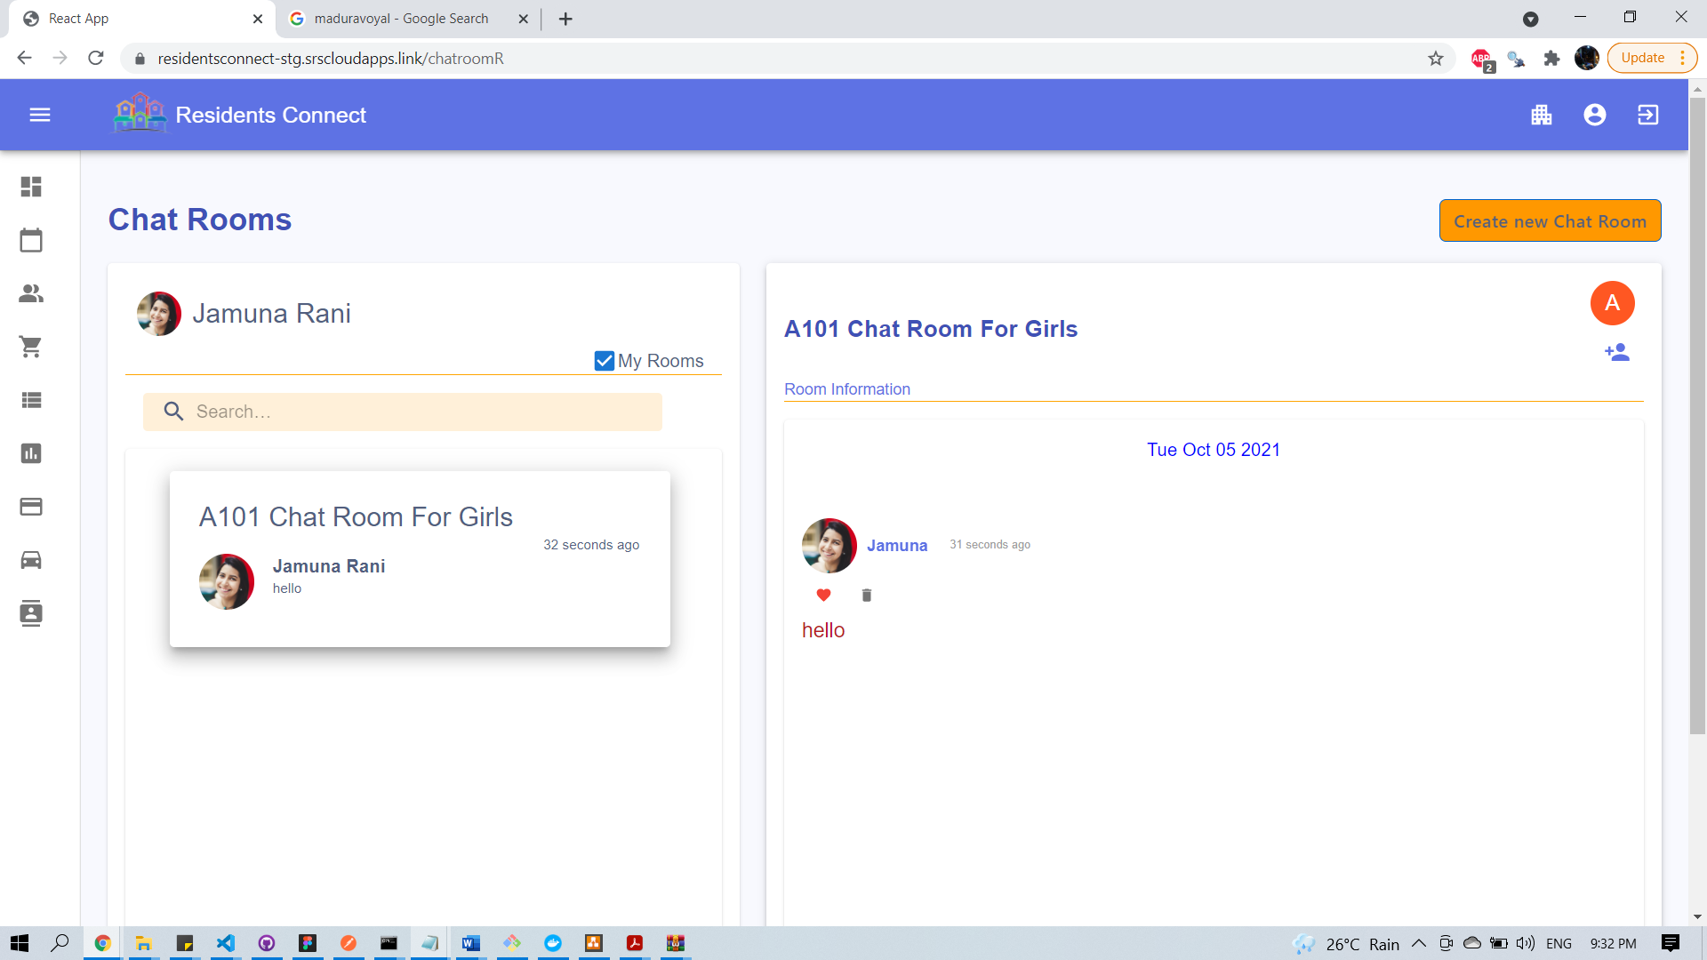

Filter Chatroom

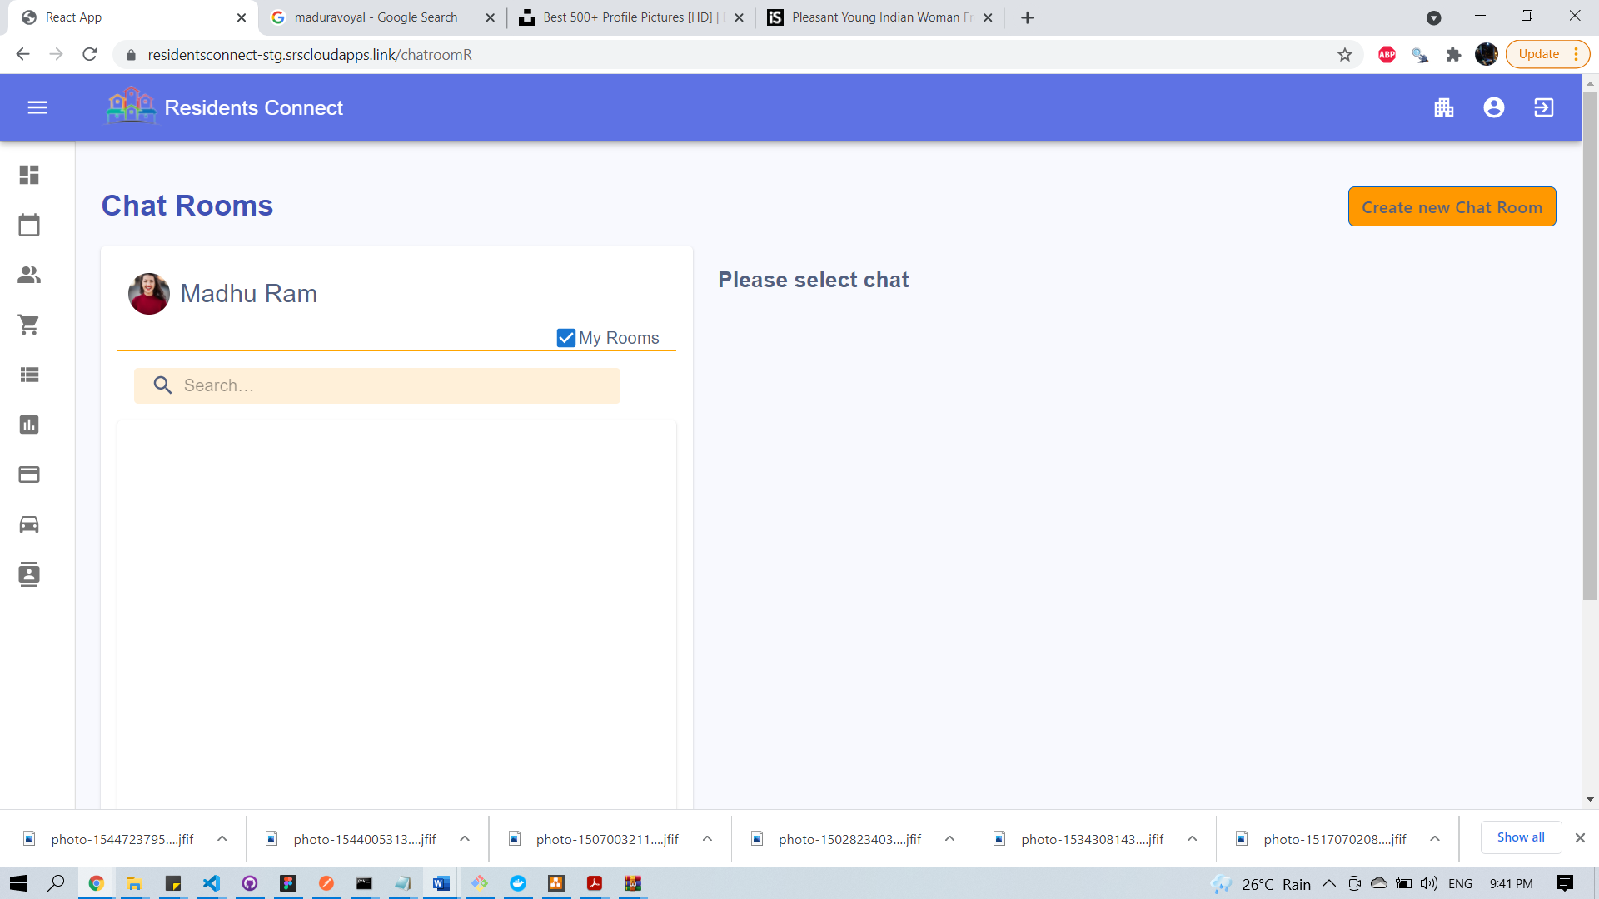

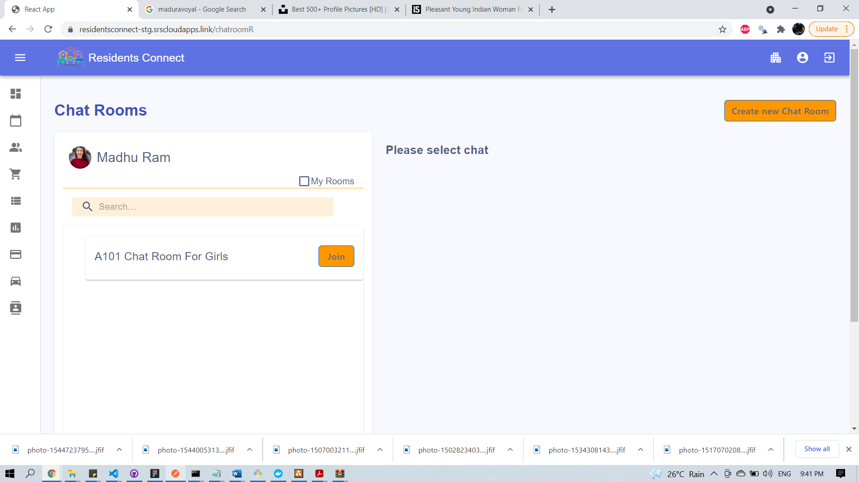

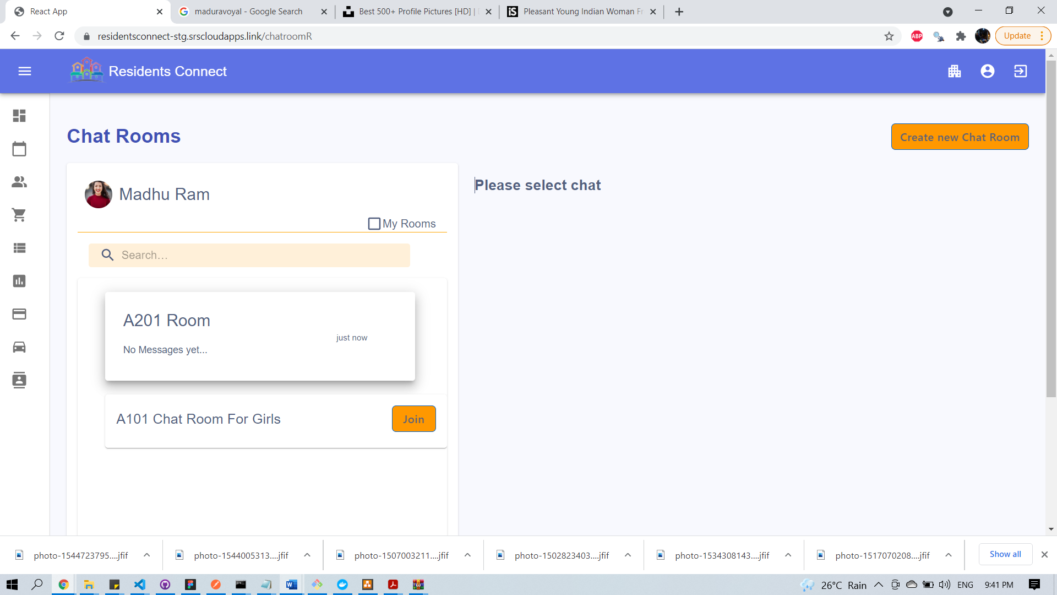

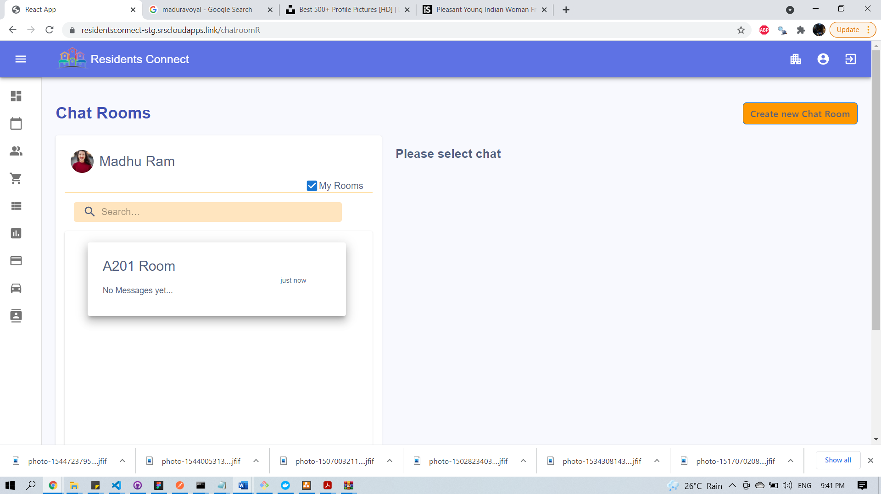

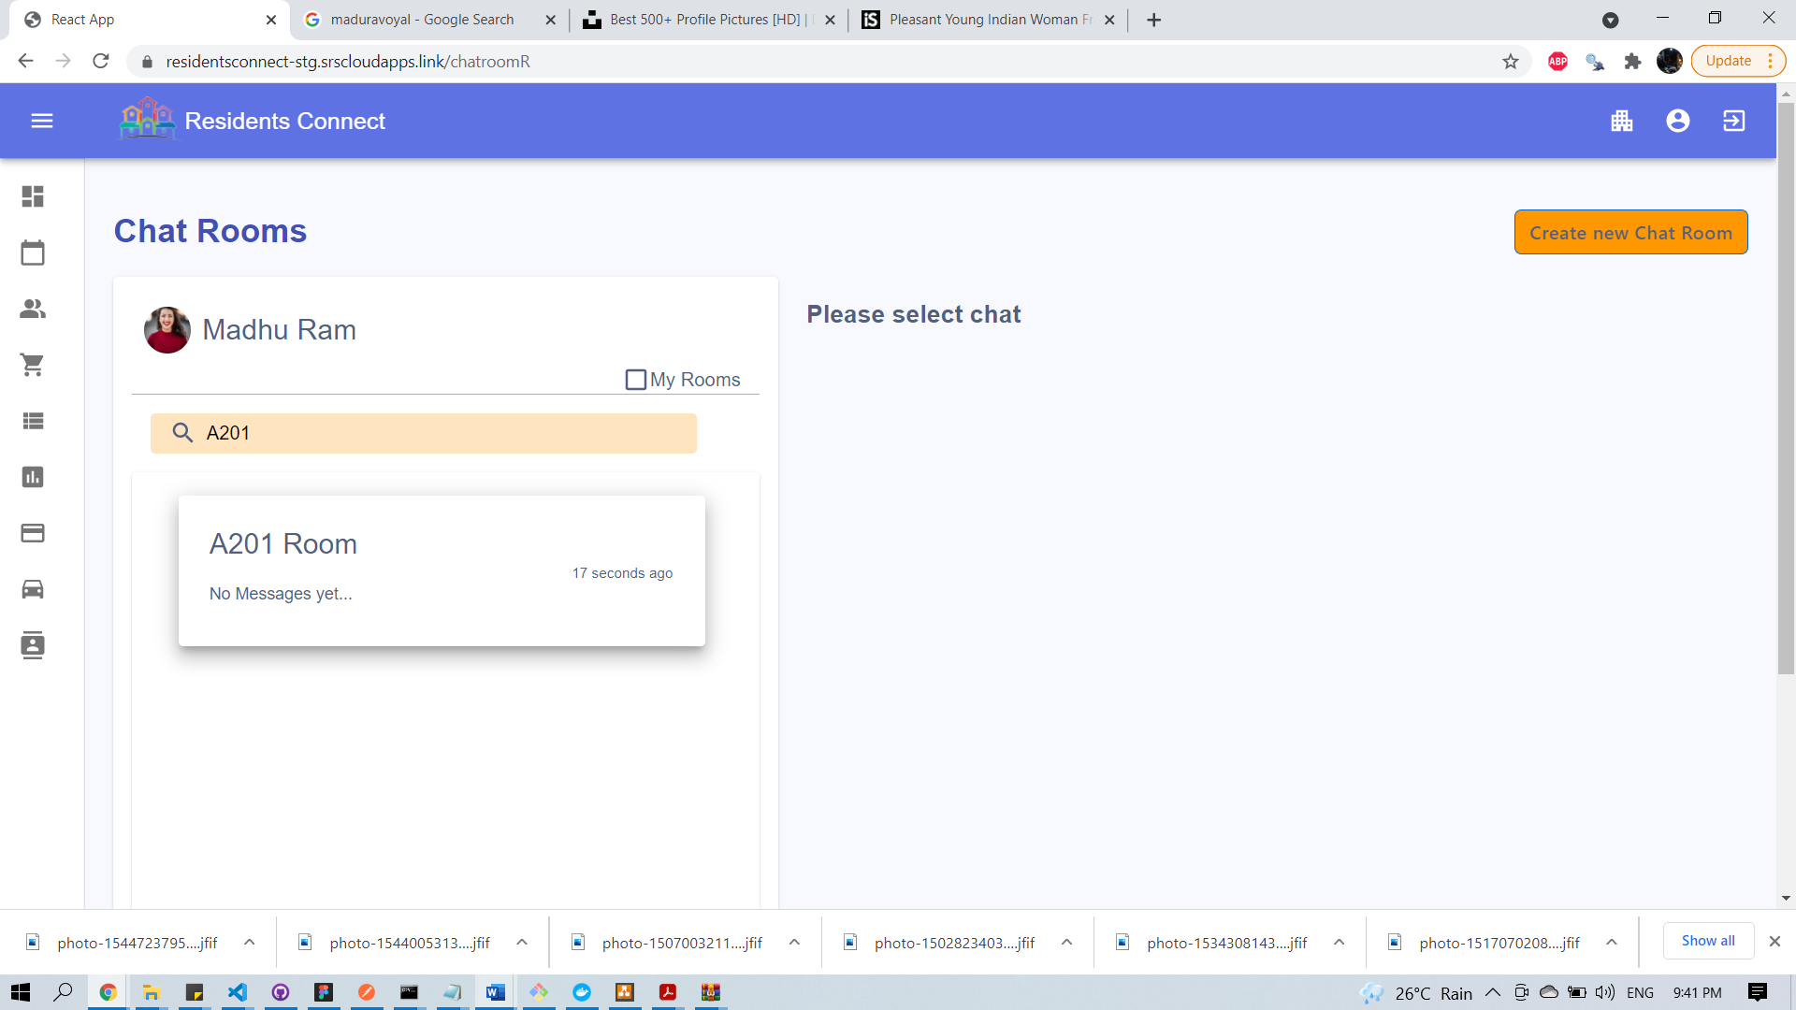

Join Request to Chat Room

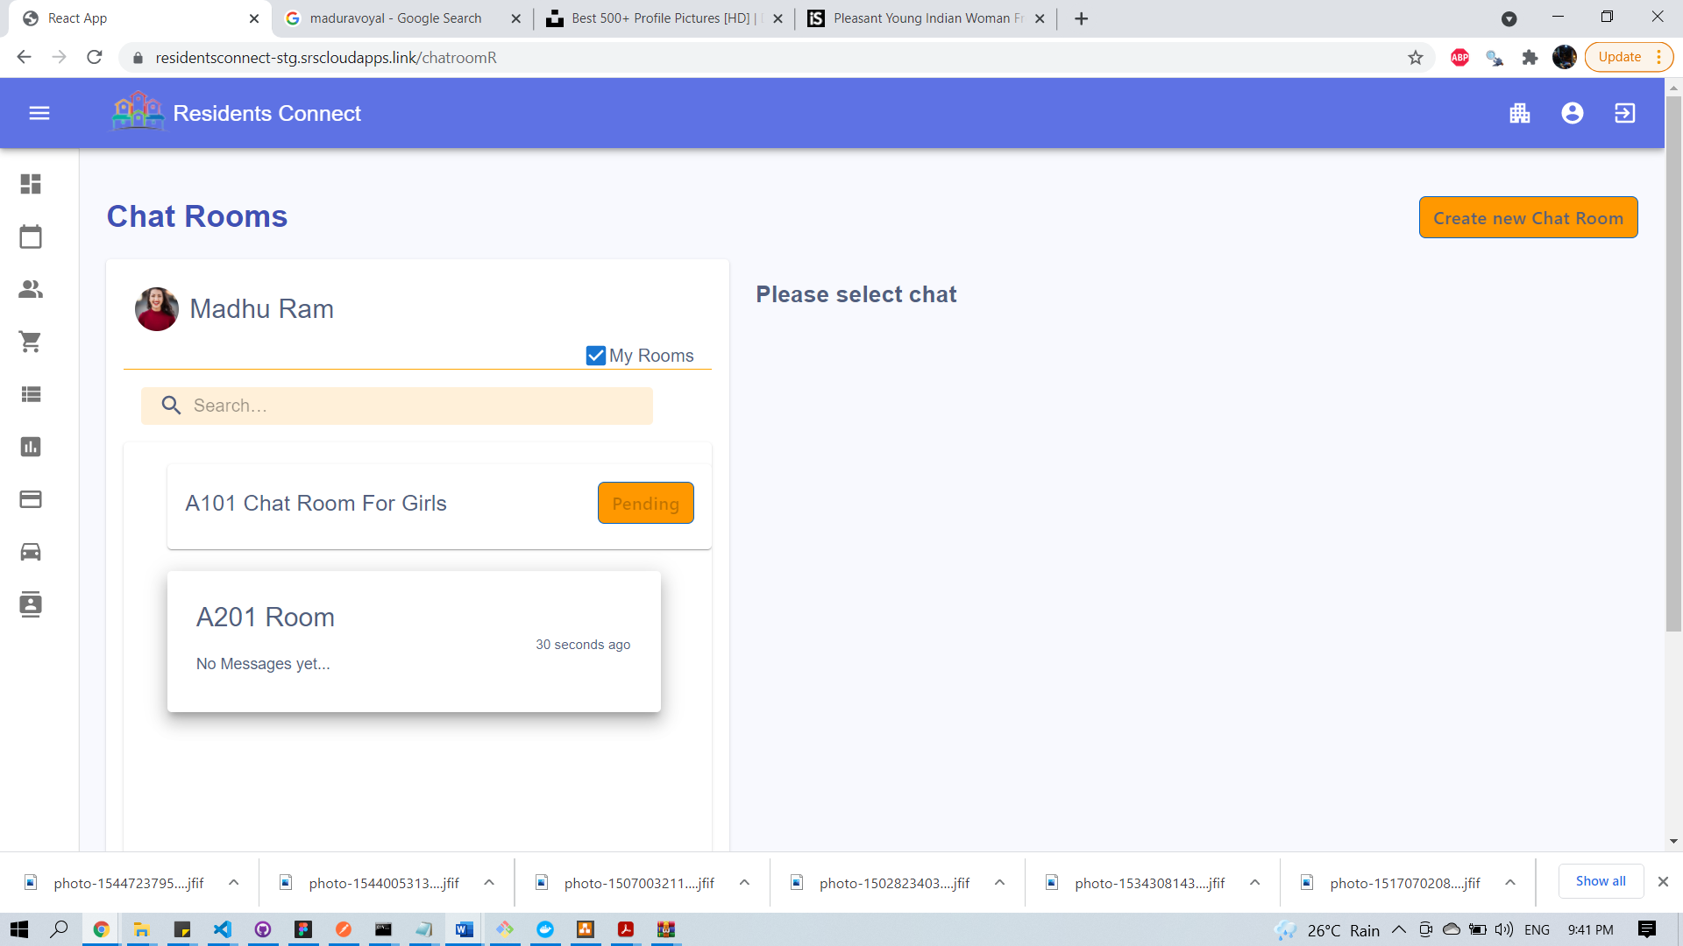

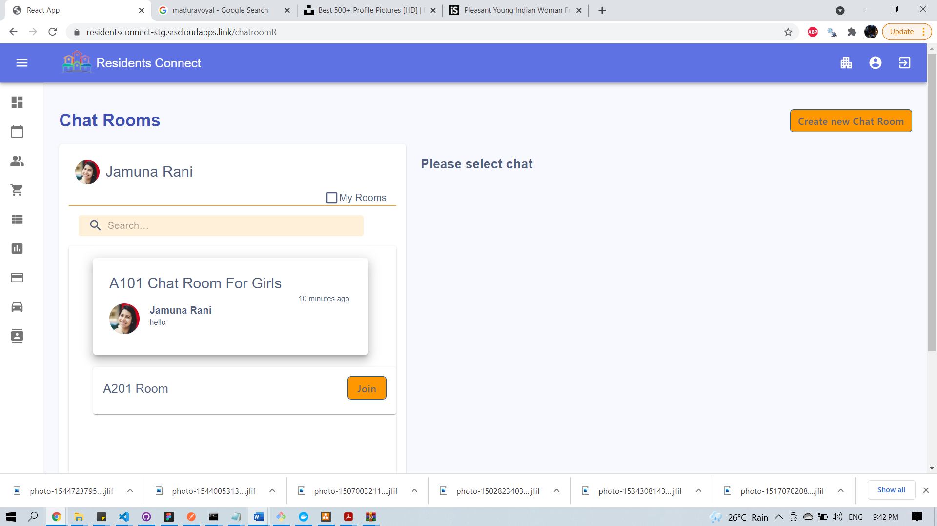

Approve Request

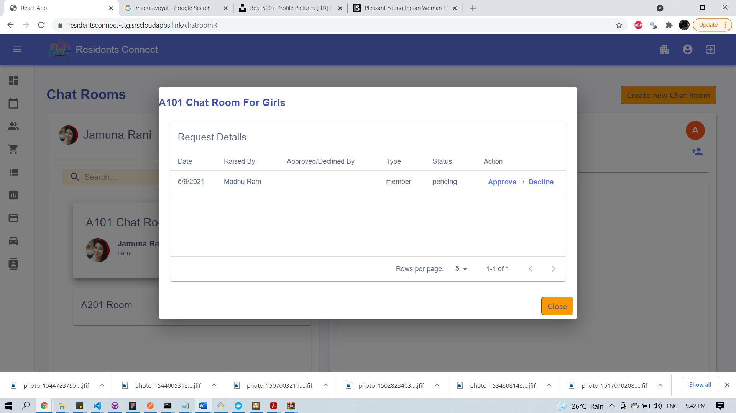

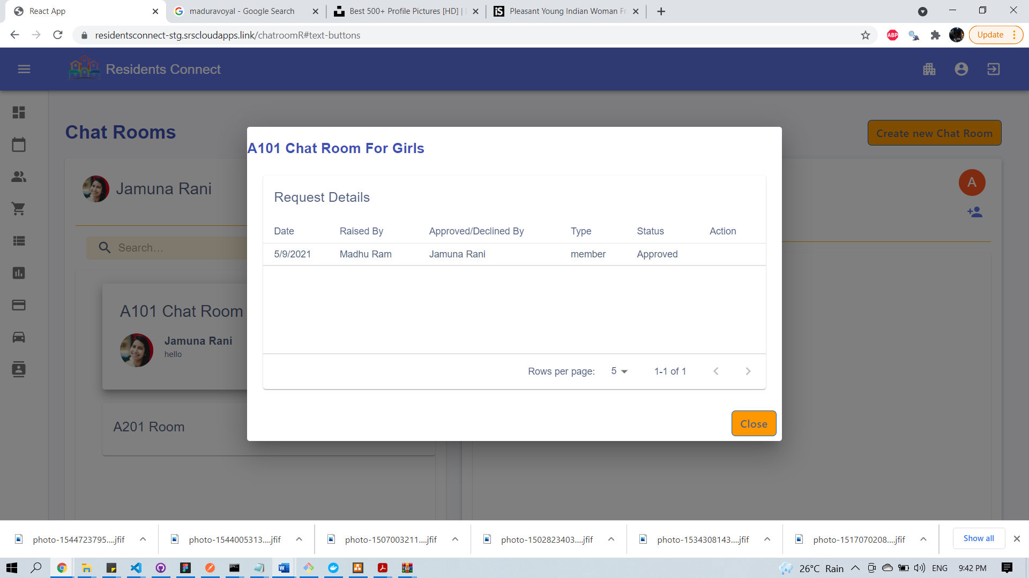

After Approval

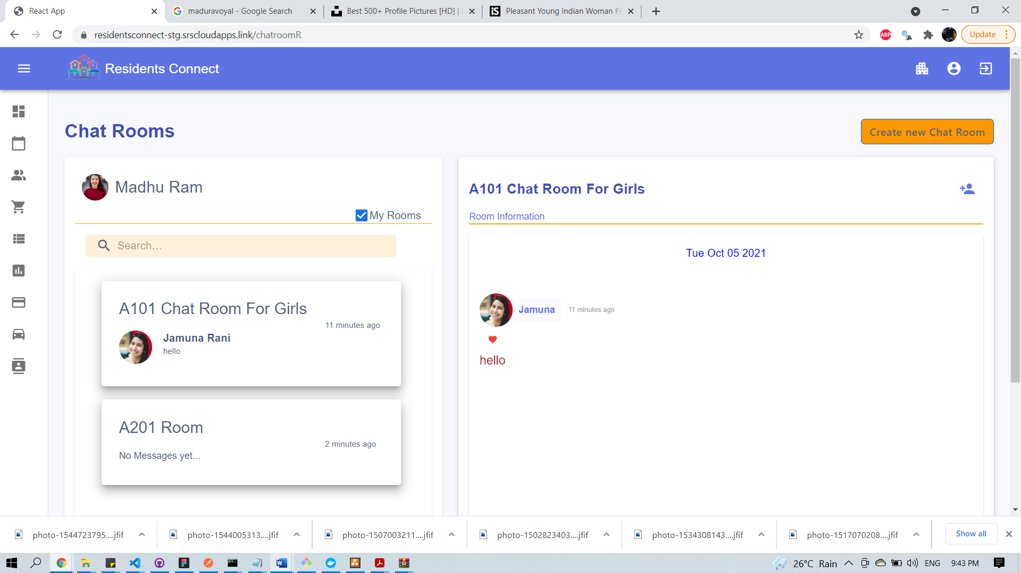

# 16. Scope of improvements

Below services are not implement in this version which would be implement in upcoming versions.

1. Visitors Management
2. Events Management
3. Contact Details
4. Facility Booking
5. Maintenance Requests

# 17. Conclusions and/or Recommendations

As many apartments communities are present in Tier-1 and Tier -2 cities. Due to their busy life, it would be difficult to interact with our neighbours. This application closes gap between our neighbours and create healthy body between people.

# 18. References

<https://firebase.google.com/docs>

<https://developer.mozilla.org/en-US/docs/Learn/Server-side/Express_Nodejs/mongoose>

<https://mongoosejs.com/docs/>

<https://developers.google.com/maps/documentation/javascript/examples/directions-waypoints>

# 19. Appendices

## 19.1 Deployment of microservices:

Step by step procedure to deploy microservices is mentioned in below document.

<https://onedrive.live.com/edit.aspx?resid=235D3E543FF15E65!10580&ithint=file%2cdocx&authkey=!APt3QrDm-gO3A0o>

## 19.2 CICD Pipeline:

In below document, we have explained step by step guide to create CICD pipeline for frontend and backend

<https://1drv.ms/u/s!AmVe8T9UPl0j0lkoWAXdhT0VtikQ?e=1O1Eqp>

# 20. Checklist

Check list of items for the Final report

1. Is the Cover page in proper format? Y / N
2. Is the Title page in proper format? Y / N
3. Is the Certificate from the Mentor in proper format? Has it been signed? Y / N
4. Is Abstract included in the Report? Is it properly written? Y / N
5. Does the Table of Contents page include chapter page numbers? Y / N
6. Does the Report contain a summary of the literature survey? Y / N
   1. Are the Pages numbered properly? Y / N
   2. Are the Figures numbered properly? Y / N
   3. Are the Tables numbered properly? Y / N
   4. Are the Captions for the Figures and Tables proper? Y / N
   5. Are the Appendices numbered? Y / N
      1. Does the Report have Conclusion / Recommendations of the work? Y / N
      2. Are References/Bibliography given in the Report? Y / N
      3. Have the References been cited in the Report? Y / N
      4. Is the citation of References / Bibliography in proper format? Y / N